GETTING PHOTOS OF YOUR VOLUNTEERING ACTIVITIES
STUDENT-LED VOLUNTEERING PROGRAMME

We encourage Project Leaders to get photos of their volunteering activities. This is a great way to help you communicate the nature of your Student-Led Project. It is also useful for us, as we’re always looking for photos for our annual report and webpages.

You can take photographs yourself and send them to us.

PHOTO PERMISSION
In order to use photos, we need permission from the people in the pictures.

You and your volunteers will have indicated whether you give permission when you filled out your registration forms.

If you work with other adults, please ask them to complete the permission form.

If you work with children or young people under the age of 16, you will need to get parental permission. Alternatively, the school or organisation you work with may have already got permission slips - it may be worth checking.

You’ll find sample forms on the next few pages.

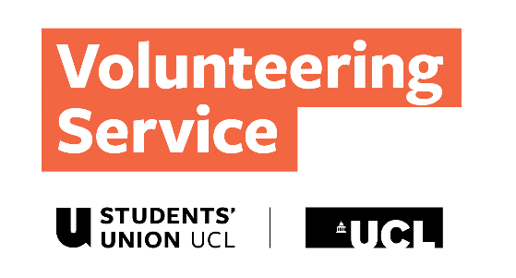
Publication of Personal Information – Form for Clients (Adults) Staff and Students
NAME OF ACTIVITY/EVENT/PROJECT:

DATE:

UNIVERSITY COLLEGE LONDON

25 Gordon St, Kings Cross, London WC1H 0AY

020 7679 7862

Volunteering Service

The Volunteering Service would like to publish your photograph and identify you on our webpages and in our Annual Report. We may also wish to use this on our social media platforms and in any future publicity material that we produce. In order to do this we need your written permission, so please fill in your details below. If at any time you decide that you would prefer us to withdraw your photograph from the webpages, please inform us in writing and we will arrange to remove it within five working days or if you would prefer us not to use it in any publications please inform us in writing and we will note that it is not to be used in future.

Your Name | I wish for my picture to be used in Volunteering Service publicity.  Please tick ()  YES or NO |  | Signature

Your Name | I wish for my picture to be used in Volunteering Service publicity.  Please tick ()  YES or NO |  | Signature

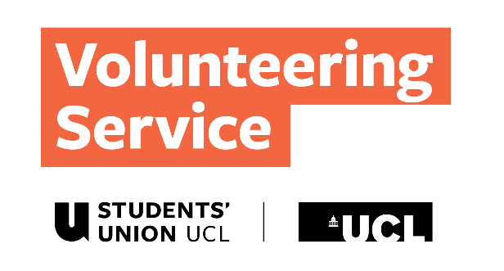
Publication of Personal Information – Form for Clients (Children)
NAME OF ACTIVITY/EVENT/PROJECT:

DATE:

UNIVERSITY COLLEGE LONDON

25 Gordon St, Kings Cross, London WC1H 0AY

020 7679 7862

The Volunteering Service

The Volunteering Service would like to publish your child’s photograph and identify them on our webpages and in our Annual Report. We may also wish to use this on our social media platforms and in any future publicity material that we produce. In order to do this, we need your written permission, so please fill in your child’s details below. If at any time you decide that you would prefer us to withdraw your child’s photograph from the webpages, please inform us in writing and we will arrange to remove it within five working days or if you would prefer us not to use it in any publications please inform us in writing and we will note that it is not to be used in future.
Name of parent / guardian | I wish for my picture to be used in Volunteering Service publicity.  Please tick ()  YES or NO |  | Child’s name | Signature of parent / guardian

Name of parent / guardian | I wish for my picture to be used in Volunteering Service publicity.  Please tick ()  YES or NO |  | Child’s name | Signature of parent / guardian

