TeamUCL Access Statement

Volleyball Club

Contents
- Club Statement
- Travel to the venue
- Venue map
- Accessible features at the venue
- Additional information

Club Statement

Thank you for taking an interest in our club. We are committed to making UCL an inclusive community and supporting all disabled students taking part in our activity. Our Welfare Officer has been trained in Disability Inclusion and Etiquette Training. We have completed this form to try and support you joining us to take part in the sport we all love. Our club is a brilliant place to meet new people and create life long friendships.

If any of this information is unclear or you would like more information on other venues or activities are club get up to, please email me, the Club President.

We look forward to welcoming you into our club.
Kind regards,

Caorie Millerd
Club President

Travel
University of East London SportsDock is accessible using all modes of transport. Click here for the Tfl Accessible Tube Map

Underground/Overground
The quickest route that to SportsDock from UCL Main Campus for wheelchair users uses a combination of bus, tube and the DLR.
The DLR is a fully accessible public transport network with step-free access into all stations and level access from platform to train at every station.
- Gallions Reach station (DLR) is the nearest station to the facility and is just 6-minute (0.3 mile) walk away.
- Cyrpus station (DLR) is also close with only a 7 minute (0.4 mile) walk.
There are no tube stations near the facility.
In order to get to Gallions Reach DLR station from UCL Main Campus:
- Take the bus or tube (Northern Line from Goodge Street) to Waterloo Station.
- Take the jubilee line to Canning Town.
- From Canning Town take the DLR to Gallions Reach or Cyprus station.
All of the stations mentioned above are wheelchair accessible.

Buses
All Transport for London (TFL) bus routes are wheelchair accessible and have clearly marked priority seats for people with limited mobility. On most buses the wheelchair ramp is positioned at the exit door and there is one wheelchair user place on each bus. The main bus stops close to UEL SportsDock facility are located on Royal Albert Way and Woolwich Manor Way.
Several bus routes pass close to the facility including the 474 which goes from Manor Road (near Canning Town) to Manor Park Station, and the 262 which goes from East Beckton to Stratford.

Taxis
All London Style ’Black Cabs’ are wheelchair accessible and can provide a suitable alternative to the bus or car. Black cabs can be hailed (stopped) in the street however you may prefer to book a cab to travel to or from the facility.
There are several cab companies operating in London including,
Computer Cab: Tel: 020 8033 9918
The London Black Cab Company: 078 8534 9994
London Black Taxis: 020 3984 4515/ 020 3004 4953
Uber Taxis also provide Wheelchair Accessible Vehicles (WAV). To book Download the Uber app and create your account (unless you already have one) then choose the ‘uberWAV’ option on the slider at the bottom of the screen and follow the instructions.
The designated drop off point is located in front of the main entrance to the SportsDock facility. This offers level access into the facility.
Full information on bus taxi and tube travel in London for disabled people can be found at https://tfl.gov.uk/transport-accessibility/?cid=transportaccessibility

Parking
There is on-site parking with designated accessible parking spaces (does not require prior booking and are given on a first come first serve basis). There are 6 of these designated spaces. Parking is free for Blue Badge holders.
The nearest designated bay is 15m (16yd 1ft) from the main entrance. The furthest designated bay is 24m (26yd 9in) from the main entrance.
The route from the car park to the entrance is accessible to a wheelchair user with assistance. Assistance may be required because there is / are slopes/ramps.

Accessible features at the venue

Accessible Toilets
There are 2 wheelchair accessible toilets located inside the facility by the main changing rooms.
All the wheelchair accessible toilets are unisex and the toilet doors all open outwards. A key is not required to use these facilities and the toilets lock via a twist lock. The dimensions of the accessible toilet are 201cm x 218cm (6ft 7in x 7ft 2in). Floor manoeuvring space is clear in the accessible toilet and there is a lateral transfer space to one side of the toilet. The lateral transfer space is 132cm (4ft 4in).
. The wheelchair accessible toilets are also fitted with appropriate height mirrors, hand dryers and coat hooks and pull cord emergency alarms.
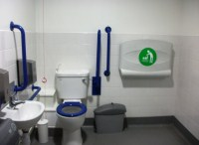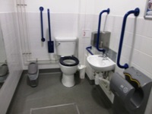

Non accessible Toilets
There are standard male & female toilets in the main standard changing rooms. These toilets contain cubicles with grab rails fitted and doors that open outwards.
There are also standard toilets available in the Fitness Centre changing rooms, plus outside the Fitness Centre, on the first floor and in the changing rooms on the second floor.
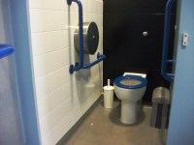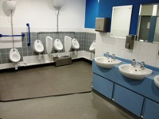

Changing Places Toilet Facility
The Changing Places Toilet (CPT) is located by the Fitness Centre changing rooms. The facility is 44m (48yd 4in) from the main entrance. There is not level access to the facility.
The dimensions of the CPT facility are 272cm x 397cm (8ft 11in x 13ft 5in). The facility changing bench height is fixed and free standing. The facility hoist is powered overhead. The overhead hoist covers all areas in cubicle and the sling is attached to the hoist by hook and loop. The toilet in the CPT facility is peninsular. The transfer space on the right as you face the toilet is 66cm (2ft 2in). Wall mounted and drop-down rails are available and are on either side as you face the toilet. The facility also includes a sink, disposal facilities, non-slip flooring and a pull cord emergency alarm.
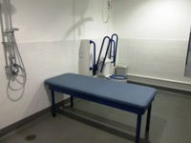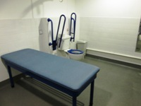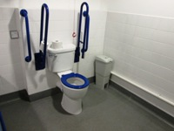

Tactile Guidance Pathway
None.

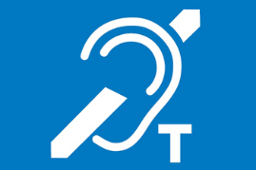
Hearing Induction Loop
There is a hearing induction loop situated inside the facility. These are indicated by signage. The system is a fixed loop and the staff are trained to use the system.

BSL User at training/Venue
A member of staff trained in BSL skills is not generally on duty. This service can be requested.

Contact
There is not a specific disability-related team at this venue, however you can contact the facility using these details:
Address: SPORTSDOCK, University Way, Beckton, London, E16 2RD
Phone: 020 8223 6888
Email: sportsdock@uel.ac.uk

