The constitution of the Students’ Union UCL

UCL Surgical Society

Name

The name of the society shall be the Students’ Union UCL Surgical Society.

The society shall be affiliated to Students’ Union UCL.

Statement of Intent

The constitution, regulations, management and conduct of the society shall abide by all Students’ Union UCL Policy, and shall be bound by the Students’ Union UCL Memorandum and Articles of Association and Byelaws, the Club and Society Regulations and the Club and Society Procedures and Guidance, laid out in “how to guides”.

The club/society stresses that it abides by Students’ Union UCL Equal Opportunities Policies, and that club/society regulations pertaining to membership of the club/society or election to management of the club/society shall not contravene this policy.

The Club and Society Regulations can be found at the following website:

www.studentsunionucl.org

The Society Committee

President

The President’s primary role is laid out in section 5.7 of the Club and Society Regulations.

Treasurer

The Treasurer’s primary role is laid out in section 5.8 of the Club and Society Regulations.

3.3. Welfare Officer

The welfare officer’s primary role is laid out in section 5.9 of the Club and Society Regulations.
Channel for society members and committee members to get in touch for help with any issues at all related to the society. Also in charge of committee well-being.

Additional committee members

Vice-President: Kien Hang
Secretary: Amit Bhudia
Shadowing Co-ordinator: Victoria Nagi
Academic Co-ordinator: Vikram Rajan
Media Co-ordinators: Sakina Lakda & Anshul Aich
Community Outreach Officer: TBC
Welfare Officer: Gabriele Kurpyte
Clinical Skills Co-ordinators: Nicole Tay and Emma Lloyd

We also have a Chair in charge of events for each Surgical Specialty. These events are overseen and run in conjunction with the society President.

Specific job details of additional committee members:

Vice president: Director of the annual flagship conference, assists the president with the running of society events.

Secretary:
- Shall carry out the role of maintaining the membership database and be in charge of the Society e-mail account – both to respond to queries and inform members of relevant Society news and events.
- Compiling the weekly bulletin and taking minutes at committee meetings.
- Organising the "Freshers' Scrub's Party" in collaboration with the RUMS committee, as well as social events for all committee members to meet.
Shadowing Co-ordinator: Ensure the smooth running of our shadowing scheme for UCL Medical Students.
Academic Co-ordinator: Ensure our tutorials for medical students are organised and managed smoothly.
Media Co-ordinators: Manage our society’s social media to make sure that it is run correctly and appropriately.
Community Outreach Officer: Opportunity to help people outside of the university, most likely in the form of external talks.
Clinical Skills Co-ordinators: Ensure that Clinical Skills sessions are run safely with the correct equipment and risk management protocols in place, as well as ensuring the presence of Professional trainers (Doctors) to oversee the running of these sessions.

Management of the club/society shall be vested in the club/society committee which shall endeavour to meet regularly during term time (excluding college reading weeks) to organise and evaluate the club/society activities.

The committee members will perform the roles as described in section 5 of the Students’ Union UCL Club and Society Regulations.

Committee members are elected to represent the interests and well-being of club/society members and are able to be held to account. If club/society members are not satisfied by the performance of their representative officers they may call for a motion of no-confidence in line with the Students’ Union UCL Club and Society Regulations.

Terms, Aims and Objectives

The club/society shall hold the following as its aims and objectives.

The club/society shall strive to fulfil these aims and objectives in the course of the academic year as its commitment to its membership.

The core activities of the society shall be:
- Lectures by speakers on topics relating to surgical careers/current affairs/ethics.
- Selected surgical specialty talks and workshops, sorted by each surgical specialty chair in co-operation with the Society President.
- Basic Suturing Workshops & Advanced Suturing Workshops.
- Shadowing Scheme affiliated with UCLH, Royal Free Hospital, The Whittington Hospital, and Great Ormond Street Hospital.
- The International Undergraduate & Foundation Surgery Conference 2021 (iNUGSC)

In addition, the club/society shall also strive to organise other activities for its members where possible:
- Tutorials for Medical Students
- Clinical Examinations Practice Circuits
- External Widening Participation Talks

This constitution shall be binding on the club/society officers and shall only be altered by consent of two-thirds majority of the full members present at a society general meeting. Activities Network Executive shall approve any such alterations.

This constitution has been approved and accepted as the Constitution for the Students’ Union UCL Surgical Society. By signing this document the President and Treasurer have declared that they have read and abide by the Students’ Union UCL Clubs and Societies Regulations.

President name: Maria Georgi Treasurer name: Kristie Leung
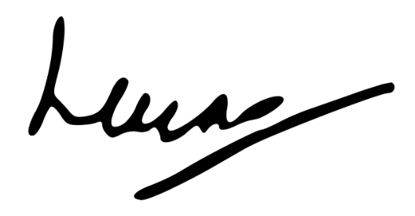
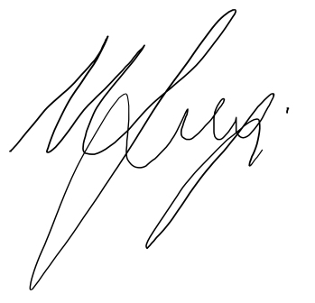

President signature Treasurer signature

