The Constitution of Students’ Union UCL

UCL MUSIC SOCIETY

Name

The name of the club/society shall be Students’ Union UCL Music Society.

The club/society shall be affiliated to Students’ Union UCL.

Statement of Intent

The constitution, regulations, management and conduct of the club/society shall abide by all Students’ Union UCL policy, and shall be bound by the Students’ Union UCL Memorandum & Articles of Association, Byelaws, Club and Society Regulations and the club and society procedures and guidance – laid out in the ‘how to guides’.

The club/society stresses that it abides by Students’ Union UCL Equal Opportunities Policies, and that club/society regulations pertaining to membership of the club/society or election to the club/society shall not contravene this policy.

The Club and Society Regulations can be found on the following webpage: http://studentsunionucl.org/content/president-and-treasurer-hub/rules-and-regulations.

The Society Committee

President

The president’s primary role is laid out in section 5.7 of the Club and Society Regulations.
Is ultimately responsible for the Society and UCOpera, websites, as well as other related IT services, such as Officer’s email accounts. Direct management of these services may be

transferred to a designated society member, who possesses

required competencies.

Treasurer

The treasurer’s primary role is laid out in section 5.8 of the Club and Society Regulations.

Welfare Officer

The welfare officer’s primary role is laid out in section 5.9 of the Club and Society Regulations.

Additional Committee Members

Vice President

Shall support the President in the organisation of society activities, as needed;

Shall be responsible for the ordering of all society merchandise;

Shall assist the president in society communications, aiding with email writing and taking responsibility for society social media accounts Shall support the President in the organisation of society activities, as needed; Shall support the President in the organisation of society activities, as needed;

Shall be responsible for taking minutes at meetings;

In the absence of the society President or Treasurer shall represent the society at relevant board meetings.

Opera Manager

Shall be the primary point of contact for all professional components of UCOpera, the Opera committee and the Union. It is therefore required that they attend the relevant Union Boards;

Shall be responsible overall for the production f UCOpera and shall oversee all activities concerning and leading up to the production itself;

Shall ensure regular Opera committee meetings are held in the first and second terms of the academic year in which the Opera will be performed. The Opera Manager shall chair the meetings of the Opera committee;

Shall ensure timelines are drawn up outlining progress for the forthcoming production. These will detail deadlines for budget sponsorship, fundraising, advertising etc.;

Shall liaise with the Union and Theatre Coordinator regularly to update on progress;

Shall appoint Society members to fulfil roles within the Opera committee; and shall delegate the role of communications with UCOpera Friends to an appointed committee member, as well as creating roles for Assistant Producer, Press Liaison, and Publications and Social Media Officer;

Shall work in conjunction with the President to annually review the five-year agreement with the Union for use of UCL-provided theatre for the opera.

Orchestra Managers

Shall represent the UCL Symphony Orchestra at the Students’ Union UCL Welcome Fair and encourage student participation;

Shall organise auditions, in conjunction with the President, for positions in the UCL Symphony Orchestra early in Term 1 in the academic year and shall ensure that all available positions are filled;

Shall be the primary point of communication between members of the UCL Symphony Orchestra, the Society committee, and the Music Director;

Shall be responsible for physically setting up (chairs, music stands etc.) and dismantling all Society rehearsals and performances involving members of the UCL Symphony Orchestra;

Shall be responsible for all sheet music used in Society rehearsals and performances involving members of the UCL Symphony Orchestra, and shall manage the hire and distribution of this sheet music;

Shall provide refreshments to members of the UCL Symphony Orchestra during breaks in Society rehearsals;

Shall represent the UCL Symphony Orchestra at Opera Committee meetings;

Shall organise flyering trips for UCOpera for members of the UCL Symphony Orchestra.

Chorus Managers

Shall represent the UCL Symphony Chorus at the Students’ Union UCL Welcome fair and encourage student participation;

Shall organise auditions, in conjunction with the President, for soloist positions where and when they arise;

Shall be the primary point of communication between members of the UCL Symphony Chorus, the Society committee, and the Music Director;

Shall be responsible for physically setting up and dismantling all Society rehearsals and performances involving members of the UCL Symphony Chorus;

Shall be responsible for all sheet music used in Society rehearsals and performances involving members of the UCL Symphony Chorus, and shall manage the hire and distribution of this sheet music;

Shall provide refreshments to members of the UCL Symphony Chorus during breaks in Society rehearsals;

Shall ensure all UCL Symphony Chorus rehearsals have a suitable rehearsal pianist booked;

Shall represent the UCL Symphony Chorus at Opera Committee meetings;

Shall organise flyering trips for UCOpera for members of the UCL Symphony Chorus.

Chamber Choir Manager

Shall represent the UCL Chamber Choir at the Students’ Union UCL Welcome fair and encourage student participation;

Shall organise auditions for positions in the UCL Chamber Choir, in conjunction with the President, early in Term 1 in the academic year;

Shall be the primary point of communication between members of the UCL Chamber Choir, the Society committee, and the Music Director;

Shall be responsible for physically setting up and dismantling all Society rehearsals and performances involving members of the UCL Chamber Choir;

Shall be responsible for all sheet music used in Society rehearsals and performances involving members of the UCL Chamber Choir, and shall manage the hire and distribution of this sheet music;

Shall provide refreshments to members of the UCL Chamber Choir during breaks in Society rehearsals;

Shall ensure all UCL Symphony Chorus rehearsals have a suitable rehearsal pianist booked.

Concert Band Managers

Shall represent the UCL Concert Band at the Students’ Union UCL Welcome fair and encourage student participation;

Shall be the primary point of communication between members of the UCL Concert Band and the Society committee;

Shall be responsible for leading the consultation process when a new conductor is required;

Shall be responsible for physically setting up (chairs, music stands etc.) and dismantling all Society rehearsals and performances involving members of the UCL Concert Band;

Shall be responsible for all sheet music used in Society rehearsals and performances involving members of the UCL Concert Band, and shall manage the hire and distribution of this sheet music;

Shall be responsible for finding a suitable external venue for concerts when necessary, in conjunction and consultation with the President and Treasurer;

Shall provide refreshments to members of the UCL Concert Band during breaks in Society rehearsals;

Shall be responsible for organising concerts for the UCL Concert Band.

String Orchestra Managers

Shall represent the UCL String Orchestra at the Students’ Union UCL Welcome fair and encourage student participation;

Shall be the primary point of communication between members of the UCL String Orchestra and the Society committee;

Shall be responsible for leading the consultation process when a new conductor is required;

Shall be responsible for physically setting up (chairs, music stands etc.) and dismantling all Society rehearsals and performances involving members of the UCL String Orchestra;

Shall be responsible for all sheet music used in Society rehearsals and performances involving members of the UCL String Orchestra, and shall manage the hire and distribution of this sheet music;

Shall be responsible for finding a suitable external venue for concerts when necessary, in conjunction and consultation with the President and Treasurer;

Shall provide refreshments to members of the UCL String Orchestra during breaks in Society rehearsals;

Shall be responsible for organising concerts for the UCL String Orchestra.

A Cappella Manager

Shall represent the UCL A Cappella Group at the Students’ Union UCL Welcome fair and encourage student participation;

Shall be the primary point of communication between members of the UCL A Cappella Group and the Society committee;

Shall be responsible for physically setting up (chairs, music stands etc.) and dismantling all Society rehearsals and performances involving members of the UCL A Cappella Group;

Shall be responsible for all sheet music used in Society rehearsals and performances involving members of the UCL A Cappella Group, and shall manage the hire and distribution of this sheet music;

Shall be responsible for finding a suitable external venue for concerts when necessary, in conjunction and consultation with the President and Treasurer;

Shall provide refreshments to members of the UCL A Cappella Group during breaks in Society rehearsals;

Shall be responsible for organising concerts for the UCL A Cappella Group.

Social Secretary

Shall be responsible for organising several social events for Society members throughout the academic year; specifically, the Welcome Party early in Term 1; after-parties following concerts given by ensembles within the Society; and a series of events following Opera performances in the final week of Term 2 in the adamic year;

Shall be responsible for organising the official UCOpera after-party following the final UCOpera performance and theatre get-out on the Saturday of the last week of Term 2. This event is specifically for UCOpera cast and crew, and Society members past and present.

Volunteering Coordinator

The elected Welfare Officer shall also take on the role of Volunteering Coordinator

Shall organise volunteering projects to take place, at least one in Term 1, and one in Term 2;

Shall alert Society members of regular volunteering opportunities;

Shall be the main point of contact between the Society and the Volunteering Services Unit.

Publicity Officer

Shall follow the rules of UCL in regards to publicity as seen here; http://studentsunionucl.org/uclu-club-and-society-publicity-statement

Shall be responsible for the distribution of all Society publicity in conjunction with the Society committee;

Shall design publicity for all groups within the Society given appropriate notice before needed;

Shall be responsible for creating social media content for the Vice-President to put online;

Shall regularly liaise with the UCL marketing Team and ensure all Society events are promoted in the What’s On guide;

Shall work with the Web Officer to ensure relevant publicity reaches the UCL Music Society and UCOpera websites

Management of the club/society shall be vested in the club/society committee which will endeavour to meet regularly during term time (excluding UCL reading weeks) to organise and evaluate club/society activities.

The committee members shall perform the roles as described in section 5 of the Students’ Union UCL Club and Society Regulations.

Committee members are elected to represent the interests and well-being of club/society members and are accountable to their members. If club/society members are not satisfied by the performance of their representative officers they may call for a motion of no-confidence in line with the Students’ Union UCL Club and Society Regulations.

Terms, Aims and Objectives

The club/society shall hold the following as its aims and objectives:

To provide as many people as possible with a wide variety of opportunities to get involved with music performance and to encourage appreciation of music.
This shall be achieved through:

The running of a range of ensembles, some choral and some instrumental, some of which are auditioned and the rest of which are not, to cater for people at any stage of musical development;

To promote events and ensembles run by the Society, both within the UCL student community and outside of it;

The maintenance of an email mailing list consisting of Society members and non- members. This mailing list shall be used to publicise and promote Society events and also other opportunities to get involved in music;

The promotion of opportunities to get involved in music through events of other societies affiliated to Student’s Union UCL;

The promotion of opportunities to get involved in music through the UCL Chamber Music Club;

The promotion of opportunities to get involved in music through the UCL Union Volunteering Services Unit;

The promotion of student ticket offers to music events and performances in London, for example the Student Pulse Concerts.

The club/society shall strive to fulfil these aims and objectives in the course of the academic year as its commitment to its membership.

The core activities of the club/society shall be:
Every ensemble within the Society shall rehearse once a week, (except Reading Weeks), with the exception of the UCL Chamber Choir which will rehearse approaching performances. Further rehearsals, for example during the week of a performance, may be called at the discretion of the ensemble conductor and the Society committee. The ensembles within the Society are:

UCL Symphony Orchestra: This is an auditioned ensemble. Auditions are held early in Term 1. Instrumentation, sections and the size of the ensemble are determined by the requirements of the repertoire and the number of auditionees;

UCL Symphony Chorus: This ensemble is non-auditioned, and it caters for singers of any standard. The size of the ensemble is only dependent upon the number of people who want to be in it;

UCL Chamber Choir: This is an auditioned ensemble. Auditions are held early in Term 1. The size of the ensemble is determined by the requirements of the repertoire and the number of auditionees;

UCL Concert Band: This ensemble is non-auditioned and it caters for woodwind, brass and percussion players of any standard. The size of the ensemble is only dependent upon the number of people who want to be in it;

UCL String Orchestra: This ensemble is non-auditioned, and it caters for string players of any standard. The size of the ensemble is only dependent upon the number of people who want to be in it;

UCL A Capella: This is an auditioned ensemble. Auditions are held early in Term 1. The size of the ensemble is determined by the requirements of the repertoire and the number of auditionees.

Auditions will be held every year for the selection of the members of the UCL Symphony Orchestra, UCL Chamber Choir and UCL A Capella. These will take place early in Term 1 after the Welcome Fair. No individual will be considered for a position in any of the ensembles without an audition unless there is a shortage of that particular instrument or voice and unless both the ensemble manager/s and the Music Director are satisfied with the candidate’s abilities. Should they wish to be a member of any of these ensembles again, all previous members must re-audition every year to account for the intake of new students and to ensure that the ensembles are the best they can be. All committee members must also re-audition. A member of the committee shall be in attendance in all of the auditions.

The ensembles within the Society shall perform a series of concerts throughout the academic year, organised by the Society committee. The programme for each of these concerts shall be decided by the President in conjunction with the conductor of the ensemble, but only following consultation with the Society membership. Suggestions for repertoire shall be accepted from any member of the Society. All suggestions shall be seriously considered, and every effort made to accommodate members’ requests. The general concert schedule should run as follows:

Term 1:
UCL Symphony Orchestra and Chorus concert – external venue
UCL Chamber Choir concert involving a reduced UCL Symphony
Orchestra – external venue if no suitable internal venue is available,
UCL Concert Band concert – external UCL venue if no suitable internal venue is available
UCL String Orchestra Concert – external UCL venue if no suitable internal venue is available
UCL Symphony Orchestra and Chorus concert – external venue
UCL A Cappella – external UCL venue if no suitable internal venue is available

Term 2:
UCL Chamber Choir concert involving a reduced UCL Symphony Orchestra – internal UCL venue
UCL Concert Band concert – external UCL venue, as long as break- even is achieved in the first term concert
UCL String Orchestra concert – external UCL venue as long as break- even is achieved in the first term concert
UCL A Cappella – external UCL venue as long as break-even is achieved in the first term concert

This schedule is subject to change at the discretion of the President and the ensemble manager(s) and conductor. It must be observed that there is a limit to the number of concerts alongside the Opera (see below), which the Music Director is contracted to engage in;

UCOpera production in the Bloomsbury Theatre or an alternative provided by the Union in the final week of Term 2. This will involve the UCL Symphony Orchestra and the UCL Symphony Chorus, performing alongside no more than 4 professional soloists. There will be some ‘student soloist’ positions available, for which the Society will hold auditions.

In addition, the club/society shall also strive to organise other activities for its members where possible:

UCL Chamber Choir concert – a repeated concert at 2 external venues as part of the London Festival of Contemporary Church Music (we are usually asked to take part in this event, though this is at the discretion of the event organisers);

As part of the Society’s relationship with the UCL Chamber Music Club, members of the Society are offered the opportunity to perform in one concerts in the Club’s series, one in Term 1;

A series of social events throughout the academic year. These include the Welcome Party at the beginning of Term 1, concert after-parties, and larger social events to promote inter- and intra-society friendships. These events are the responsibility of the Social Secretary on the Society committee;

The chance to participate in volunteering through a Volunteering project chosen by the Volunteering Coordinator and the President in Term 2.

This constitution shall be binding on the club/society officers, and shall only be altered by consent of two-thirds majority of the full members present at a club/society general meeting. The Activities Zone shall approve any such alterations.

This constitution has been approved and accepted as the Constitution for the Students’ Union UCL Music Society. By signing this document the president and treasurer have declared that they have read and abide by the Students’ Union UCL Club and Society Regulations.

President name: | Michele Chan
President signature:
Date: | 14/06/2020
Treasurer name: | Maya Banerjee
Treasurer signature: | 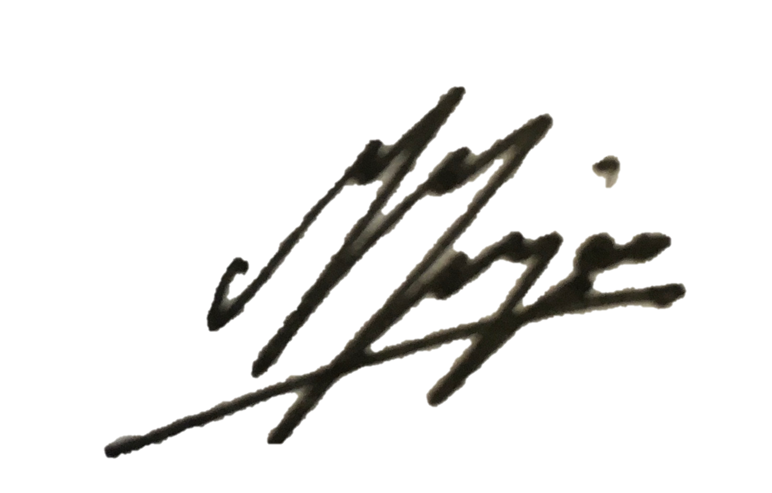
Date: | 19/06/2020

