The constitution of the Students’ Union UCL Museums Society

Name

The name of the society shall be the Students’ Union UCL Museums Society.

The society shall be affiliated to Students’ Union UCL.

Statement of Intent

The constitution, regulations, management and conduct of the society shall abide by all Students’ Union UCL Policy, and shall be bound by the Students’ Union UCL Memorandum and Articles of Association and Byelaws, the Club and Society Regulations and the Club and Society Procedures and Guidance, laid out in “how to guides”.

The society stresses that it abides by Students’ Union UCL Equal Opportunities Policies, and that society regulations pertaining to membership of the society or election to management of the society shall not contravene this policy.

The Club and Society Regulations can be found at the following website:

www.studentsunionucl.org

The Society Committee

President

The President’s primary role is laid out in section 5.7 of the Club and Society Regulations.

Treasurer

The Treasurer’s primary role is laid out in section 5.8 of the Club and Society Regulations.

Welfare Officer

The Welfare Officer’s primary role is laid out in section 5.9 of the Club and Society Regulations.

Secretary

The Secretary shall hold office from the day after the end of term 3 until the last day of term 3 in the following academic year and shall be responsible for the recording of the meeting minutes as well as sending out weekly newsletter to the society’s mailing list.

Community Outreach Officer

The Community Outreach Officer shall hold office from the day after the end of term 3 until the last day of term 3 in the following academic year and shall be bound by the responsibilities outlined by the Students’ Union UCL Policy.

Management of the society shall be vested in the club/society committee which shall endeavour to meet regularly during term time (excluding college reading weeks) to organise and evaluate the society activities.

The committee members will perform the roles as described in section 5 of the Students’ Union UCL Club and Society Regulations.

Committee members are elected to represent the interests and well-being of society members and are able to be held to account. If society members are not satisfied by the performance of their representative officers they may call for a motion of no-confidence in line with the Students’ Union UCL Club and Society Regulations.

Terms, Aims and Objectives

The society shall hold the following as its aims and objectives.

- To provide a friendly and inclusive environment for all members of society regardless of their ability or disability; background; gender or sexual identity ; race or ethnicity; or religion. This will be in accordance with the Union’s ByeLaw 1.7 on equal opportunities
- To provide the opportunity to visit Museums and Galleries around London within a social context, allowing for collective exploration of the city and the chance to discover new topics of interest
- To offer opportunities to meet individuals whom work in the museum sector, and so providing our members with the means to ask questions should they be interested in this as a career choice.

The society shall strive to fulfil these aims and objectives in the course of the academic year as its commitment to its membership.

The core activities of the society shall be:

Trips to Museums and Galleries around the London area

Events wherein members are invited to listen to a guest speaker or take part in a workshop regarding working within the Museum Sector

In addition, the society shall also strive to organise other activities for its members where possible:

- Social events to allow members to mingle in a relaxed environment

This constitution shall be binding on the society officers and shall only be altered by consent of two-thirds majority of the full members present at a society general meeting. Activities Network Executive shall approve any such alterations.

This constitution has been approved and accepted as the Constitution for the Students’ Union UCL Museums Society. By signing this document the President and Treasurer have declared that they have read and abide by the Students’ Union UCL Clubs and Societies Regulations.

President name ___Niansheng Niu (Nelson) [Interim President]____
Treasurer name ---Jacinta Yee Li Ting---

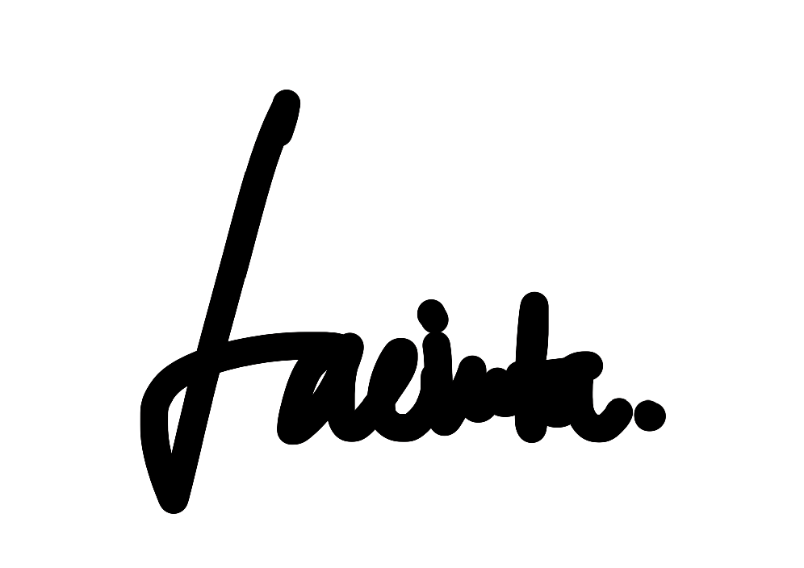
President signature Treasurer signature

