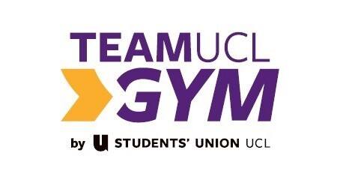


TeamUCL Gym Facility Rules

- Proper attire, as determined by the TeamUCL Gym Team Management, must be worn in the facility – this includes not being topless in the fitness areas or studios.

- Members are requested to wear appropriate and clean footwear in the fitness areas and no bare feet.

- Bags are prohibited on the gym floor – please put bags in the lockers provided.

- Members are kindly requested to be considerate, wiping down and returning equipment to its place after use.

- Please only use liquid chalk and be prepared to clean up after yourself.

- Mobile phone usage should be kept to a minimum and members may only take photos or film using mobiles phones on the gym floor with written consent from management. Members are however able to utilise any studio space which is not in use for filming, however all phone usage is prohibited in changing rooms.

- The last entry is thirty minutes before closing. Entry after this point will not be granted.

- Please do not consume food in the gym. If you wish to eat, Bloomsbury Theatre Café is situated on the ground floor.

- Do not enter TeamUCL Gym under the influence of alcohol or drugs.

- Pets are not allowed onsite at TeamUCL Gym – only service dogs are allowed.

- Smoking is not permitted anywhere in the Club (this includes the use of E - Cigarettes).

Code of Conduct
TeamUCL gym in partnership with TeamUCL have created these Rules for the mutual enjoyment of all users. We are also dedicated to providing a harassment-free experience for everyone, regardless of gender, gender identity and expression, age, sexual orientation, disability, physical appearance, body size, race, ethnicity, religion (or lack thereof), or technology choices. We do not tolerate harassment in any form and reserve the right to revoke access due to any misconduct.

Your Opinion Matters
Members are encouraged to give feedback, whether good or bad. This can be done by either emailing the team on teamuclgym.su@ucl.ac.uk or by speaking to the reception team, both of which will ensure it makes its way to the right person in order to respond.

