
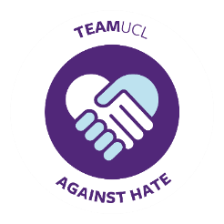
TeamUCL Against Hate Pledge
As a club participating in the TeamUCL Against Hate campaign, we pledge to lead the UCL sports community by:
- Taking active steps to prevent all forms of bullying, harassment, and discrimination, on the basis of any of the protected characteristics.
- Actively promoting equity and inclusion within our club and TeamUCL.
- Actively developing talent from underrepresented groups within our club and the wider TeamUCL community.

This extends to the following protected characteristics:
- Age
- Disability
- Pregnancy and Maternity
- Marriage or Civil Partnership
(in employment only)
- Sex
- Sexual Orientation
- Gender Reassignment
- Religion or Belief
- Race
  - Culture
  - Immigration Status
  - Hair

Protecting Students
- The club and its members commit to a ‘No Bystander’ approach to any form of bullying, harassment or discrimination, as defined here, by UCL policy.
- The club will have clear and well-advertised reporting mechanisms and procedures to help them respond to any incidents of bullying, discrimination, or harassment.
- The Committee will report issues of bullying, discrimination, and harassment to The Union in a timely fashion.

Supporting Students
- The club, its committee and its members will create a friendly and welcoming atmosphere for all students, regardless of identity.
- The club will take into account the needs of members from all backgrounds and consider any cultural differences when planning their activity, to ensure it is inclusive.
- The club commits to creating and executing a yearly Inclusion Plan.
- The Welfare Officer will make themselves known to the entire club and be easily contactable by members for support and guidance.
- The Welfare Officer and President will inform their club and committee of all relevant Students’ Union UCL and TeamUCL guidelines on equity and inclusion, and actively consider incorporating them within their club.
- The club will fulfil its commitments to the three TeamUCL Campaigns listed below:
Club:
President Name:
President Signature:
Date:

TeamUCL Campaigns

By signing the TeamUCL Against Hate Pledge, you are also committing to take specific actions to support the three campaigns listed below:

Pride in TeamUCL
Diversity in TeamUCL
Zero Tolerance in TeamUCL

Section 1: Pride in TeamUCL

The Club
- The club pledges to tackle Homo-, Bi- and Trans-Phobia and lead the UCL sports community in welcoming all persons regardless of their sexual orientation or gender identity
- The club will seek to educate its members on Students’ Union UCL’s Trans Inclusion in Sport Guidelines, and engage with Pride in TeamUCL during LGBTQ+ History Month.
- The club will appoint a Pride in Sport Representative to lead these activities
- The club will support members to safely access changing room spaces that they feel is most appropriate to them.

The Representative
- The promotion of this role within your club should encourage individuals who identify as LGBTQ+ to put themselves forward
- The representative will make themselves known to the entire club and be easily contactable by members for support and guidance
- The representative’s contact details will be made fully available for all club members
- Where the representative is not the club’s Welfare Officer, they will support this Officer to ensure that all relevant protected characteristics are considered in the club’s decision making
  - In particular, the representative must ensure that their club and committee are aware of their National Governing Body’s guidelines on trans participation.

Club:
Representative Name:
Representative Signature:
Date:

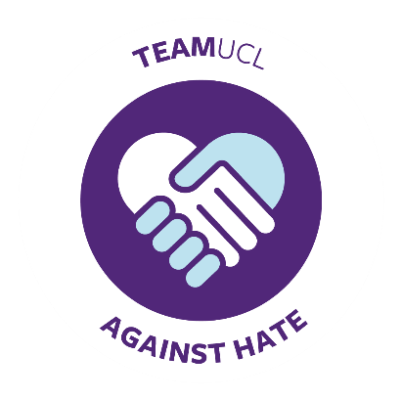


Section 2: Diversity in TeamUCL

The Club
- The club pledges to tackle all forms of racist or xenophobic behaviour, including microaggressions, and lead the UCL sports community in welcoming all persons regardless of their race, religion, or cultural background
- The club will actively create opportunities to engage students from underrepresented cultural groups in their activity and engage with TeamUCL activity during Black History Month
- The club with work to have impact in this area past Black History Month, using events and online promotional resources, and leveraging partnerships with TeamUCL Clubs, cultural and faith societies, UCL and Student’s Union UCL staff teams, and external groups.
- The club will appoint a Diversity in TeamUCL Representative to lead these activities

The Representative
- The promotion of this role within your club should encourage individuals who identify as a PoC to put themselves forward
- The representative’s contact details will be made fully available for all club members
- The representative will make themselves known to the entire club and be easily contactable by members for support, guidance, and signposting
- Where the representative is not the club’s Welfare Officer, they will support this Officer to ensure that all relevant protected characteristics are considered in the club’s decision making
Club:
Representative Name:
Representative Signature:
Date:


Section 3: Zero Tolerance in TeamUCL

The Club:
- The club commits to the creation of a zero-tolerance environment towards sexual and gender-based violence and misconduct.
- The club will actively promote the value of Consent internally, and participate in any relevant TeamUCL Campaigns
- The club Welfare Officer will be the club’s ‘Representative’ and lead these activities

The Representative
- Each year, the representative will attend the Active Bystander and Tackling Sexual Violence training sessions, and distribute this information to their club in an accessible format, to remain eligible for a Zero Tolerance in TeamUCL Impact Level
- The representative’s contact details will be made fully available for all club members
- The representative will make themselves known to the entire club and be easily contactable by members for support and guidance
- The Representative will educate the Committee and club members on consent, as defined here, UCL’s Prevention of Bullying, Harassment and Sexual Misconduct Policy and these accompanying definitions
- The Representative will make every reasonable effort to ensure 50% overall club attendance of the Active Bystander online module and Tackling Sexual Violence training each year

Club:
Welfare Officer Name:
Welfare Officer Signature:
Date:


