The Constitution of Students’ Union UCL

URBAN FARMERS SOCIETY

Name

The name of the club/society shall be Students’ Union UCL Urban Farmers Society.

The club/society shall be affiliated to Students’ Union UCL.

Statement of Intent

The constitution, regulations, management and conduct of the club/society shall abide by all Students’ Union UCL policy, and shall be bound by the Students’ Union UCL Memorandum & Articles of Association, Byelaws, Club and Society Regulations and the club and society procedures and guidance – laid out in the ‘how to guides’.

The club/society stresses that it abides by Students’ Union UCL Equal Opportunities Policies, and that club/society regulations pertaining to membership of the club/society or election to the club/society shall not contravene this policy.

The Club and Society Regulations can be found on the following webpage: http://studentsunionucl.org/content/president-and-treasurer-hub/rules-and-regulations.

The Society Committee

President
    - Be the primary point of contact between the Union and UCL Urban Farmers.
    - Outline and maintain the vision of UCL Urban Farmers.
    - Ensure that the society remains an inclusive and welcoming environment open to any individual interested in the society’s events.

Organise and attend gardening sessions and events.

Treasurer
3.2.1 Be responsible for completing the relevant grant application forms for UCL Urban Farmers.
3.2.2 Provide the president with regular reports in the financial affairs of UCL Urban Farmers.

3.2.3 Be responsible for managing the funds of UCL Urban Farmers and ensuring that all expenses are accounted for.
3.2.4 Organise and attend regular gardening sessions and events.

Welfare Officer
3.3.1 Be responsible for the welfare and engagement of members in the society.
3.3.2 Support the president in organising social events or workshops for the farm.
3.3.3 Organise and attend regular gardening sessions and events.

Communications Officer

3.4.1 Be responsible for running the society’s Instagram page, including posts and replying to messages.
3.4.2 Ensuring that members are informed about any changes in gardening sessions or practices at the farm.
3.4.3 Organise and attend regular gardening sessions and events.

3.5 Management of the club/society shall be vested in the club/society committee which will endeavour to meet regularly during term time (excluding UCL reading weeks) to organise and evaluate club/society activities.

The committee members shall perform the roles as described in section 5 of the Students’ Union UCL Club and Society Regulations.

Committee members are elected to represent the interests and well-being of club/society members and are accountable to their members. If club/society members are not satisfied by the performance of their representative officers they may call for a motion of no-confidence in line with the Students’ Union UCL Club and Society Regulations.

Terms, Aims and Objectives

The club/society shall hold the following as its aims and objectives.

The club/society shall strive to fulfil these aims and objectives in the course of the academic year as its commitment to its membership.

The core activities of the club/society shall be:
- Weekly meetings at the farm with specific growing/farming projects in mind – Members will sow seeds, plant, water plants, turn and sift compost in compost bins, collect produce, observe biodiversity…
- Maintaining the farm in a good state – Members will keep the space in shape, whether that be by painting and/or fixing structures (shed, greenhouse, beds, fence, signs), raking fallen leaves or cleaning the ponds.
- Trips to urban farms in London – this allows members to discover different types of farming in a city, to learn, exchange and get inspired.

In addition, the club/society shall also strive to organise other activities for its members where possible:

Social events for members, including food and drinks.

Meetings with environment-driven groups/societies from within UCL and other universities, as networking events.
- Workshops to learn more about gardening or related activities
- Collaborating with other UCL environment-driven groups/societies to organize events and raise awareness on environment-related topics.
- Opportunities to get involved in decision-making and support to the Union, Sustainable UCL and UCL estates in development and implementation of sustainability campaigns such as #PlasticFreeUCL and Sustainable Food working group.

This constitution shall be binding on the club/society officers, and shall only be altered by consent of two-thirds majority of the full members present at a club/society general meeting. The Activities Executive shall approve any such alterations.

This constitution has been approved and accepted as the Constitution for the Students’ Union UCL Urban Farmers Society. By signing this document the president and treasurer have declared that they have read and abide by the Students’ Union UCL Club and Society Regulations.

President name: | Yi Xi Kang
President signature:
Date: | 5/10/2022
Treasurer name: | Yvonne Tran
Treasurer signature: | 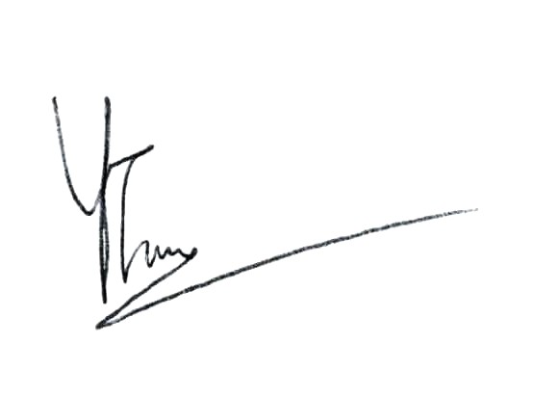
Date: | 5/10/2022

