UCL HISTORY SOCIETY JOURNAL INSPO

Preface:

The historical examination of *traditions, superstitions and myths* offers a fascinating window into the ways human societies have understood the world around them, constructing meaning and passing on cultural knowledge across generations. From the ancient mythologies of gods and heroes to everyday customs and faiths, they shape how communities navigate life, death and everything in between. This theme displays the richness and complexity of the intrinsic human imagination and experience. It seeks to explain the unknown, find order amongst chaos and express collective fears, hopes and values. Within this Autumnal Issue we invite you to explore this theme in a season of long nights and ancient traditions such as Halloween, Diwali, Mabon, Rosh Hashanah, Moon Festival and Christmas.

This volume will bring together a range of interdisciplinary perspectives that examine the enduring power of *traditions, superstitions and myths* in shaping all aspects of life. We invite our contributors to explore these themes within diverse historical contexts - how mythological narratives have reinforced political authority, how superstitions have shaped daily practices and rituals, and how traditions have both preserved and adapted cultural identities. We would like individuals to try to unpack the meanings embedded in cultural practices and investigate their ongoing relevance in both the past and the present.

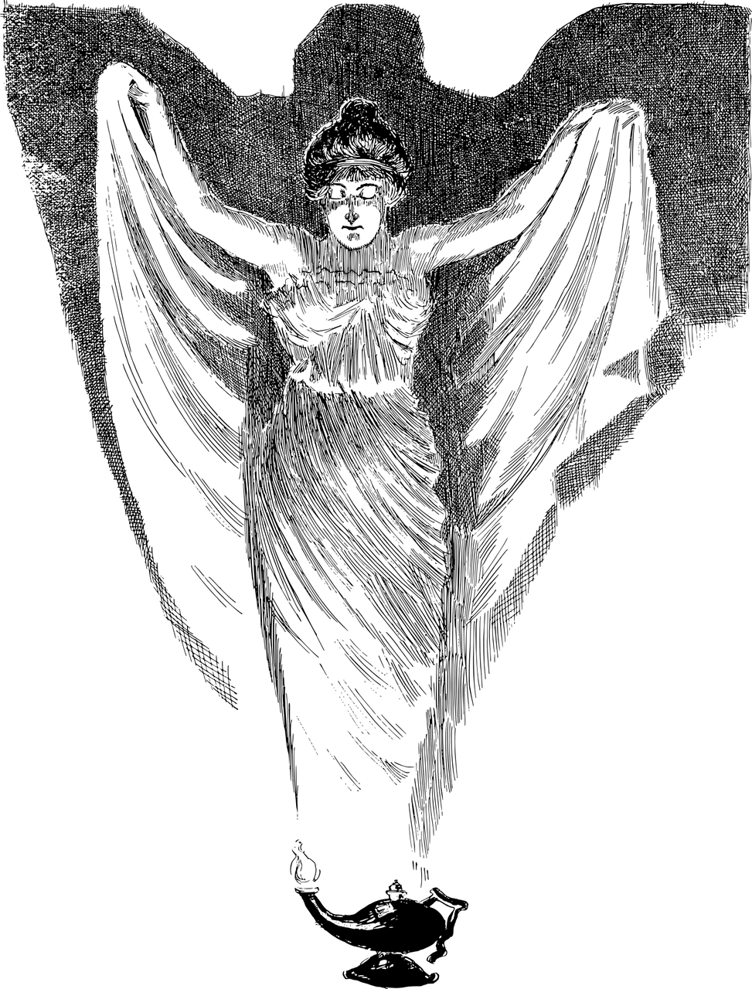

Photo credit: Gordon Johnson from Pixabay

As we engage with these themes, it is pertinent to understand that *traditions, superstitions and myths* are not static relics of the distance past, rather they are evolving and reshaped by forces of modernisation and continuous cultural exchange.

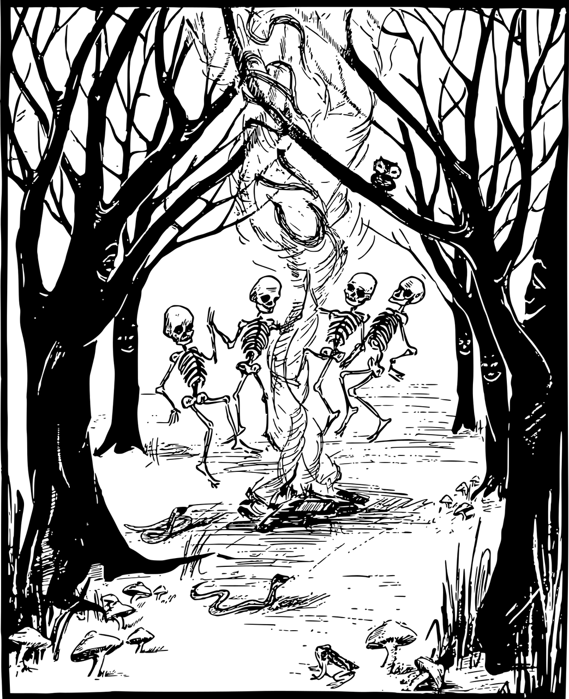

Photo credit: Gordon Johnson from Pixabay

We hope that this collection will deepen our understanding of the human connections between belief, practice and identity and inspire new questions surrounding the roles that *traditions, superstitions and myths* play in shaping the human experience.

**Specifications:**

* Please aim for between 400 – 1,000 words
* Referencing:
  + Past and present formatting (similar to usual academic essay formatting).
* A ‘further reading’ add on is recommended but not compulsory.