The Constitution of Students’ Union UCL
UCL Men’s Rugby Football Club

Name

1.1 The name of the society shall be the Students’ Union UCL Men’s Rugby Football Club.
1.2 The society shall be affiliated to Students’ Union UCL.

Statement of Intent

2.1 The constitution, regulations, management and conduct of the society shall abide by all Students’ Union UCL Policy, and shall be bound by the Students’ Union UCL Memorandum and Articles of Association and Byelaws, the Club and Society Regulations and the Club and Society Procedures and Guidance, laid out in “how to guides”.
2.2 The club/society stresses that it abides by Students’ Union UCL Equal Opportunities Policies, and that club/society regulations pertaining to membership of the club/society or election to management of the club/society shall not contravene this policy.
2.3 The Club and Society Regulations can be found at the following website: www.studentsunionucl.org.

The Society Committee

President
3.1 The president’s primary role is laid out in section 5.7 of the Club and Society Regulations.
3.2 You may add specific details to the job description of your president if you wish.
Treasurer
3.3 The treasurer’s primary role is laid out in section 5.8 of the Club and Society Regulations.
3.4 You may add specific details to the job description of your treasurer if you wish.
Additional committee members
Welfare Secretary
3.5 The welfare secretary’s primary role is in pastoral care and safeguarding for all club members. This is in a training and match context as well in club social activities. Whilst all members are encouraged to speak openly with each other, the welfare secretary is a designated member with which confidential conversations and chats about all round wellbeing (not limited to ‘rugby-relevant’) are actively encouraged.
3.6 Management of the club/society shall be vested in the club/society committee which shall endeavour to meet regularly during term time (excluding college reading weeks) to organise and evaluate the club/society activities.
3.7 The committee members will perform the roles as described in section 5 of the Students’ Union UCL Club and Society Regulations.
3.8 Committee members are elected to represent the interests and well-being of club/society members and are able to be held to account. If club/society members are not satisfied by the performance of their representative officers they may call for a motion of no- confidence in line with the Students’ Union UCL Club and Society Regulations.

Terms, Aims and Objectives

4.1 The club/society shall hold the following as its aims and objectives.
4.2 The club/society shall strive to fulfil these aims and objectives in the course of the academic year as its commitment to its membership.
4.3 The core activities of the society shall be:
▪ Compete in BUCS league and cup competitions for Rugby Union
▪ Compete in BUCS league and cup competitions for Rugby Sevens
▪ Compete in the London Varsity Series for Rugby Union
▪ Train in Rugby Union and strength and conditioning to prepare for, and enable optimum performance in, competitive matches
4.4 In addition, the club/society shall also strive to organise other activities for its members where possible:
▪ Opportunities to raise money and commit other charitable acts to contribute to society as a club
▪ Opportunities to get together as a club in a social context in and around UCL to broaden social involvement, relations and enjoyment at UCL.
4.5 This constitution shall be binding on the club/society officers and shall only be altered by consent of two-thirds majority of the full members present at a society general meeting. Activities Network Executive shall approve any such alterations.
4.6 This constitution has been approved and accepted as the Constitution for the Students’ Union UCL Men’s Rugby Football Club. By signing this document the president and treasurer have declared that they have read and abide by the Students’ Union UCL Clubs and Societies Regulations.
President name: | Philip Bauer
President signature: | 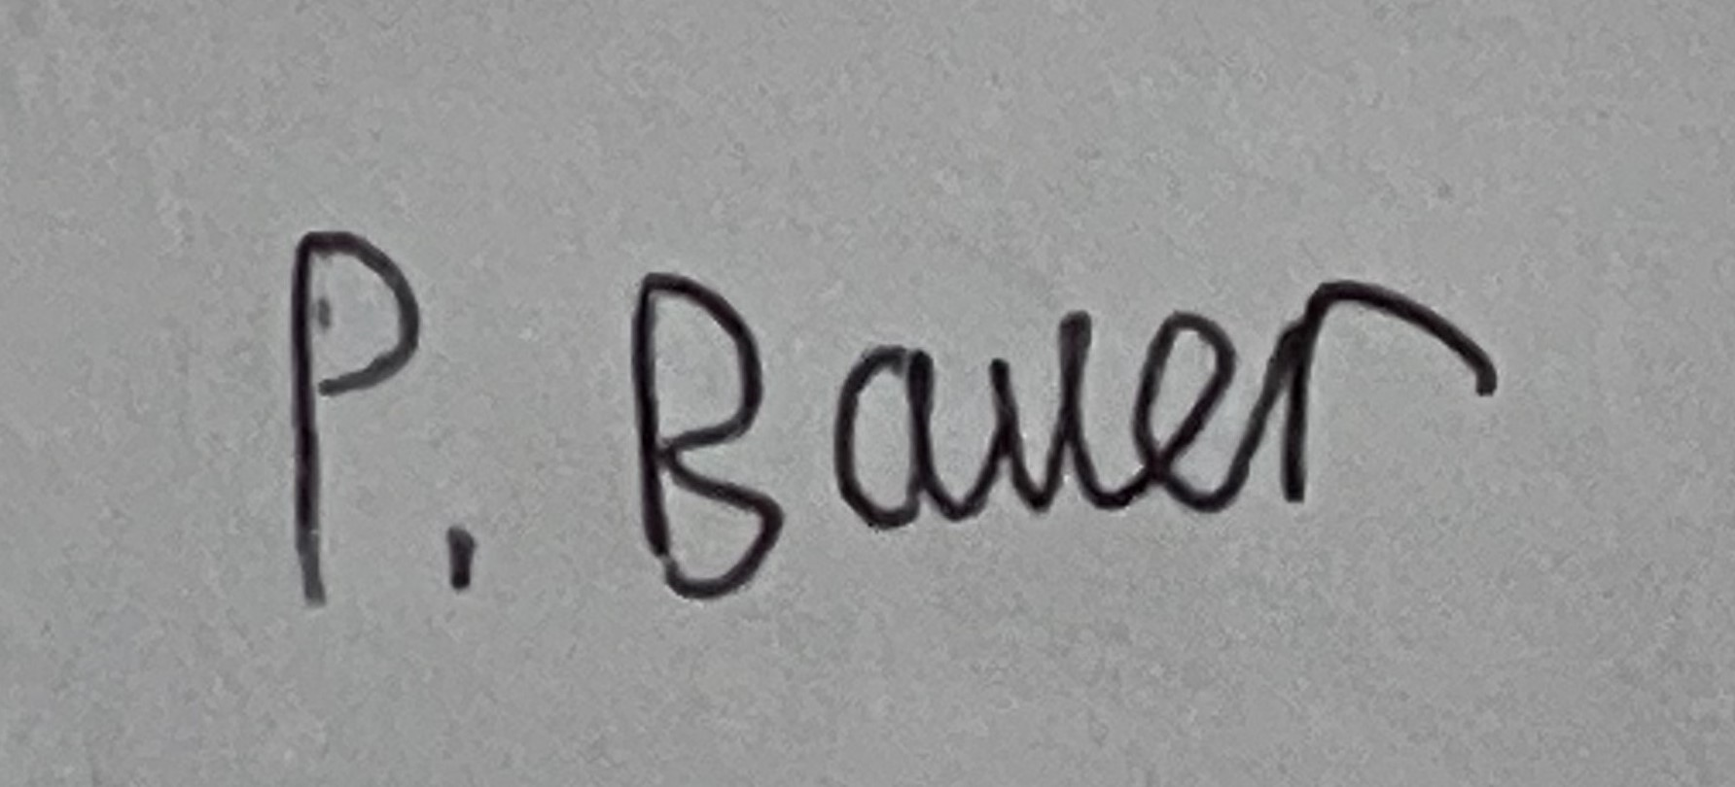
Date: | 29/06/23
Treasurer name: | Alexander Kandelaki
Treasurer signature: | 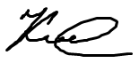
Date: | 29/06/23

