The Constitution of Students’ Union UCL

Georgian Society

Name

The name of the society shall be Students’ Union UCL Georgian Society

The Georgian Society shall be affiliated to Students’ Union UCL.

Statement of Intent

The constitution, regulations, management and conduct of the Georgian Society shall abide by all Students’ Union UCL policy, and shall be bound by the Students’ Union UCL Memorandum & Articles of Association, Byelaws, Club and Society Regulations and the club and society procedures and guidance – laid out in the ‘how to guides’.

The Georgian Society stresses that it abides by Students’ Union UCL Equal Opportunities Policies, and that Georgian Society regulations pertaining to membership of the Georgian Society or election to the Georgian Society shall not contravene this policy.

The Club and Society Regulations can be found on the following webpage: http://studentsunionucl.org/content/president-and-treasurer-hub/rules-and-regulations.

The Society Committee

President

The president’s primary role is laid out in section 5.7 of the Club and Society Regulations. The president shall act in the best interests of the UCL Georgian Society and ensure that Georgian culture is well-represented.

Treasurer

The treasurer’s primary role is laid out in section 5.8 of the Club and Society Regulations.

Welfare Officer

The welfare officer’s primary role is laid out in section 5.9 of the Club and Society Regulations.

Additional Committee Members

Social Secretary

The social secretary's primary role will be organising social events: reaching to relevant societies, organisations and institutions for cooperation. In case of the position’s vacancy the responsibilities are transmitted to the President.

Communications Manager

The Communications Manager's primary responsibility will be managing the society's social media (WhatsApp Chat, Instagram, Facebook, LinkedIn) and newsletter. In case of the position’s vacancy the responsibilities are transmitted to the President.

Management of the Georgian Society shall be vested in the Georgian Society committee which will endeavour to meet regularly during term time (excluding UCL reading weeks) to organise and evaluate society activities.

The committee members shall perform the roles as described in section 5 of the Students’ Union UCL Club and Society Regulations.

Committee members are elected to represent the interests and well-being of the Georgian society members and are accountable to their members. If society members are not satisfied by the performance of their representative officers they may call for a motion of no-confidence in line with the Students’ Union UCL Club and Society Regulations.

Terms, Aims and Objectives

The Georgian society shall hold the following as its aims and objectives.

The Georgian society shall strive to fulfil these aims and objectives in the course of the academic year as its commitment to its membership.

The core activities of the Georgian Society shall be:

4.3.1. Formal events (in person and/or online), including lectures, possibly with external speakers.
4.3.2. Social events, including film screenings, food and alcohol tasting events and pub quizzes.

In addition, the Georgian society shall also strive to organise other activities for its members where possible:
4.4.1. Visits to relevant sites in London or elsewhere.

4.4.2. Georgian language workshops
4.4.3. Georgian Dance classes.
4.4.4. Collaborations with relevant cultural societies and institutions, both outside of UCL and within.

This constitution shall be binding on the Georgian society officers and shall only be altered by consent of two-thirds majority of the full members present at a society general meeting. The Activities Executive shall approve any such alterations.

This constitution has been approved and accepted as the Constitution for the Students’ Union UCL Georgian Society. By signing this document the president and treasurer have declared that they have read and abide by the Students’ Union UCL Club and Society Regulations.

President name: | Mariam Vekua
President signature: | 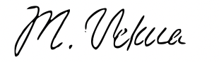
Date: | 15/06/2023
Treasurer name: | Sergi Kavtaradze
Treasurer signature: | 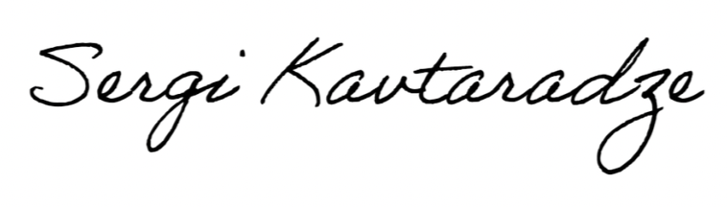
Date: | 14/06/2023

