The Constitution of Students’ Union UCL

Era Journal

Name

The name of the club/society shall be Students’ Union UCL Era Journal

The club/society shall be affiliated to Students’ Union UCL.

Statement of Intent

The constitution, regulations, management and conduct of the club/society shall abide by all Students’ Union UCL policy, and shall be bound by the Students’ Union UCL Memorandum & Articles of Association, Byelaws, Club and Society Regulations and the club and society procedures and guidance – laid out in the ‘how to guides’.

The club/society stresses that it abides by Students’ Union UCL Equal Opportunities Policies, and that club/society regulations pertaining to membership of the club/society or election to the club/society shall not contravene this policy.

The Club and Society Regulations can be found on the following webpage: http://studentsunionucl.org/content/president-and-treasurer-hub/rules-and-regulations.

The Society Committee

President

The president’s primary role is laid out in section 5.7 of the Club and Society Regulations.
3.2 It is the president’s responsibility to to maintain the core values of Era Journal, which are as follows:

3.2.1 To ensure Era Journal’s content and membership are representative of and accessible to all of UCL’s student community.

3.2.2 To promote and nurture student talent at UCL.

3.2.3 To provide opportunities to students for publication in a journal of cultural relevance and artistic integrity.

Treasurer

The Treasurer’s primary role is laid out in section 5.8 of the Club and Society Regulations.

Welfare Officer

The Welfare Officer’s primary role is laid out in section 5.9 of the Club and Society Regulations.

Additional Committee Members

All committee members, including additional committee members will maintain Era Journal’s core values, as outlined in

Co-Editors in Chief

Co-Editors-in-Chief will be voted into their respective positions at the Society’s AGM.

Subsection Editors

Subsection Editors will be appointed after the AGM by the incoming committee.

Management of the club/society shall be vested in the club/society committee which will endeavour to meet regularly during term time (excluding UCL reading weeks) to organise and evaluate club/society activities.

The committee members shall perform the roles as described in section 5 of the Students’ Union UCL Club and Society Regulations.

Committee members are chosen to represent the interests and well-being of club/society members and are accountable to their members. If club/society members are not satisfied by the performance of their representative officers they may call for a motion of no-confidence in line with the Students’ Union UCL Club and Society Regulations.

Terms, Aims and Objectives

The core activities of the club/society shall be:

Online presence
4.1.1.a – To maintain the integrity of the society’s online journal
4.1.1.b – To update the website and streamline section headings
    - Print Publications
4.1.2.a – To produce two print publications a year
4.1.2.b – To produce physical advertising, flyers, smaller publications, collected works from students.
4.1.3 Create Merchandise
4.1.3.a – To design and produce merchandise in accordance with the Student Union guidelines, including but not limited to hoodies, t-shirts, mugs, bags and pens. Merchandise will be sold to contribute to the costs of print publications and maintenance of the online website.
4.1.4 Seek external cooperation with Era Journal
4.1.4.a – To seek sponsorship to fund events and competitions

In addition, the club/society shall also strive to organise other activities for its members where possible:

Work Events
Writing workshops, ideas forums, open submissions, meet the team days, fundraising events

4.2.2 Social Events
Showcase print editions, UCL creative talent, meet each other, promote the journal

4.2.3 Talks
To host external speakers to give talks to Era Journal members

This constitution shall be binding on the club/society officers, and shall only be altered by consent of two-thirds majority of the full members present at a club/society general meeting. The Activities Executive shall approve any such alterations.

This constitution has been approved and accepted as the Constitution for the Students’ Union UCL Club/Society Name. By signing this document the president and treasurer have declared that they have read and abide by the Students’ Union UCL Club and Society Regulations.

President name: | Thomas Coleman
President signature: | 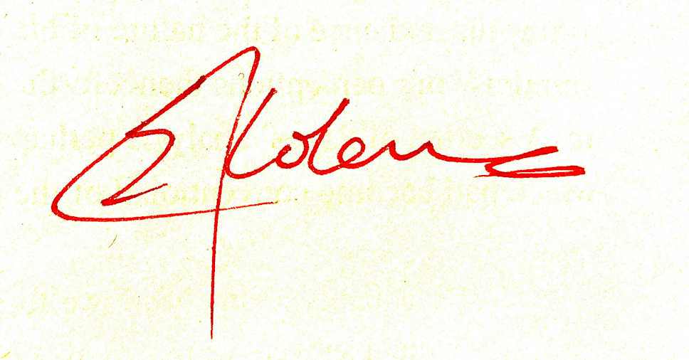
Date: | 30/06/2023
Treasurer name: | Samuel Newton
Treasurer signature: | 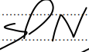
Date: | 30/06/2023

