The Constitution of Students’ Union UCL Diplomacy Society

1. Name
1.1. The name of the club/society shall be Students’ Union UCL Diplomacy Society.
1.2. The club/society shall be affiliated to Students’ Union UCL.

2. Statement of Intent
2.1. The constitution, regulations, management and conduct of the club/society shall abide by all Students’ Union UCL policy, and shall be bound by the Students’ Union UCL Memorandum & Articles of Association, Byelaws, Club and Society Regulations and the club and society procedures and guidance – laid out in the ‘how to guides’.
2.2. The club/society stresses that it abides by Students’ Union UCL Equal Opportunities Policies, and that club/society regulations pertaining to membership of the club/society or election to the club/society shall not contravene this policy.
2.3. The Club and Society Regulations can be found on the following webpage:
http://studentsunionucl.org/content/president-and-treasurer-hub/rules-and-regulations.

3. The Society Committee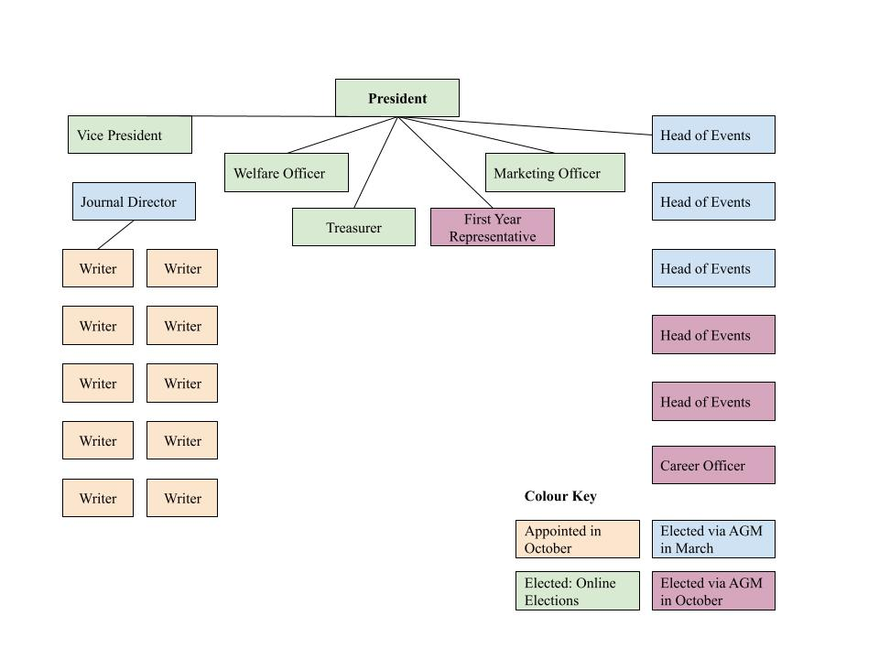
Figure 1: Committee structure and election timeframes

President
3.1. The president’s primary role is laid out in section 5.7 of the Club and Society Regulations.
3.1.1. The President’s role within the Diplomacy Society shall include:
3.1.1.1. Coordinating and managing the committee,
3.1.1.2. Facilitating and chairing meetings,
3.1.1.3. Training and providing support to the heads of events, the journal team, and the secretary
3.1.1.4. Organizing events and inviting speakers
3.1.1.5. Acting as the medium for members and the diplomatic institution to interact and facilitate internships and networking,
3.1.1.6. Maintaining the network created by the society through means including but not limited to
3.1.1.6.1. Sending annual paper cards and introductory emails to embassy contacts to facilitate further collaboration,
3.1.1.6.2. Adding contacts of speakers to a common log shared with the committee,
3.1.1.6.3. Liaising with other societies throughout the year.
3.1.2. The President is to ensure that the network created by the society is maintained and continues to expand as the years come.

Treasurer
3.1 The Treasurer’s role primary role is laid out in section 5.8 of the Club and Society Regulations.
3.1.1 The Treasurer’s role within the Diplomacy Society shall include:
3.1.1.1 Ensuring the funds for events and activities are approved and paid in a timely manner,
3.1.1.2 Being the primary point of contact with the union,
3.1.1.3 Reimbursing all expenses by society committee members related to running events
3.1.1.4 Maintaining and managing society funds and making sure all the events fall within the society budget,
3.1.1.4.1 The committee is recommended to maintain a balance of £500 in its non-grant account by the end of each year,
3.1.1.5 Sourcing external funding and applying for society sponsorships,
3.1.1.6 Substituting the president in case of emergency or their resignation,

Welfare Officer
3.2 The welfare officer’s primary role is laid out in section 5.9 of the Club and Society Regulations.
3.2.1 The Welfare Officer’s role shall include:
3.2.1.1 Organizing a fresher’s ball/social event in the beginning of each Year
3.2.1.2 Organizing monthly dinners for the members of society,
3.2.1.3 Organizing pub crawls and receptions with other University of 3.2.1.4 London diplomacy and international relations-oriented societies,
3.2.1.5 Working with the treasurer to set social event budgets.

Additional Committee Members

Head of Events
3.3 The primary role for head of events is to organise talks, dinners, and any other activities related to international relations, diplomacy, and politics.
3.3.1 Head of Events Responsibilities shall include:
3.3.1.1 Attending training in the beginning of the year,
3.3.1.2 Scouting and planning potential events and activities that are suggested by the committee or members,
3.3.1.3 Ensuring that the logistics and the participation for the events are settled,
3.3.1.4 Maintaining a database of contacts for the society.

Vice President
3.4 The Vice President’s primary role is to promote events, manage email communications, as well as to facilitate the smooth running of society affairs through organizational and administrative support.
3.4.1 The Vice President’s role within the Diplomacy Society shall include:
3.4.1.1 Keeping minutes of meetings, and creating assignment lists in the end of each meeting
3.4.1.2 Following up with all committee members and the progress of their tasks
3.4.1.3 Checking and responding to emails regularly
3.4.1.4 Sending weekly newsletters to society’s membership,

The Diplomat Journal Director
3.5 The Diplomat Journal Director’s main role shall be to run the society’s journal, The Diplomat, manage and appoint journalists and video editors, promote the journal.
3.5.1 The Diplomat Journal Director’s role shall include:
3.5.1.1 Appointing 10 journal writers in September or October (the number shall vary based on journal’s demands) adhering to the following conditions:
3.5.1.2 The process of appointment shall be transparent and run through applications,
3.5.1.3 The president and treasurer shall approve the appointments,
3.5.1.4 The journal and the video editing team shall be chosen based on their skills, experiences, and motivations.
3.5.1.5 Setting out an agenda for the journal publications in September,
3.5.1.6 Coordinating article/video topics ad approve ideas as to guarantee diverse and relevant journal/channel content
3.5.1.7 Organising social events for the journal team in coordination with the welfare officer
3.5.1.8 Edit the journal and ensure timely issues,

First Year Representative
3.6 The First Year Representative’s primary role is to facilitate communication between first year students and the committee reflecting their interests, concerns and suggestions,
3.6.1 The first year representative’s role shall include
3.6.1.1 Advertising society events to first year students
3.6.1.2 Assisting with organising events and, if necessary, planning events independently
3.6.1.3 Sourcing feedback from first year and any other society members,
3.6.1.3.1 Assisting the president with any general society tasks

Career Officer
3.7 The Career Officer’s primary role is to provide students with career advice and opportunities through events, activities and other sources of information
3.7.1 The career officer’s role shall include
3.7.1.1 Planning career-related events
3.7.1.2 Circulating information on career opportunities through our social media
3.7.1.3 Partnering with different organizations to provide internship schemes to our members

Marketing Officer
3.8 The Marketing Officer’s primary role is to create and manage the society’s social media pages
3.8.1 The marketing officer’s role shall include
3.8.1.1 Maintaining the society Facebook, Instagram, and Twitter pages with regular posts,
3.4.1.5 Designing publicity materials for events, promotions, and other campaigns,
3.4.1.6 Managing the official website of UCLU Diplomacy Society with regular event updates and journal issues.
3.7 Management of the club/society shall be vested in the club/society committee which will endeavour to meet regularly during term time (excluding UCL reading weeks) to organise and evaluate club/society activities.
3.8 The committee members shall perform the roles as described in section 5 of the Students’ Union UCL Club and Society Regulations.
3.9 Committee members are elected to represent the interests and well-being of club/society members and are accountable to their members. If club/society members are not satisfied by the performance of their representative officers they may call for a motion of no-confidence in line with the Students’ Union UCL Club and Society Regulations.

4 Officer Elections and Appointments
4.1 The procedures for Annual/Emergency General Meetings and elections are outlined in section 5.3 of the Club and Society Regulations
4.2 The Diplomacy Society shall host one Annual General Meeting in the end of the second semester, and one emergency general meeting in the beginning of the first semester in order to have an appointed committee before the beginning of the next academic year but also allow freshmen to participate in elections
4.3 The officers shall be elected through the following means
4.3.1 Three out of six head of events, first year representative, ad any other missing positions shall be elected at the Emergency General Meeting in September,
4.3.2 President, Treasurer, Welfare Officer shall be elected through online elections inn late second semester
4.3.3 Secretary, Journal Secretary, and three out of six heads of events shall be elected during the Annual General Meeting.
4.4 All of the journalists and editors shall be appointed by the Journal Secretary as outlined in section
3.6.1.1 of the constitution

No Confidence Motions and Resignations
- The procedures for resignations and officer removals are outlined in section 5.6 of the Club and Society
Regulations
  - A motion of no confidence may be called to remove any elected committee member at any point of the year by either a petition signed by at least 15% or 10 of the Full Members of the Club or Society
(whichever is the greater) or by a two-thirds majority vote at a Club or Society committee meeting
  - If a no-confidence motion is called then an EGM or online elections must be held to fill in the position of the removed officer
  - Journal writers and video editors may be removed and replaced by the journal secretary at any point of the year provided that the following conditions stand:
    - The removal is justified and communicated to the journalist in advance,
    - The journalist does not appeal the decision to the president,
    - The president and treasurer approve of the decision
  - Resignations by the principal officers (including president and treasurer) may be file a month in advance of the planned leave to allow for a more controlled transition

6 Terms, Aims and Objectives

6.1 The club/society shall hold the following as its aims and objectives.
6.2 The club/society shall strive to fulfil these aims and objectives in the course of the academic year as its commitment to its membership.
6.3 The core activities of the club/society shall be:
6.3.1 Dinner events with high profile diplomats and speakers,
6.3.2 Gatherings to discuss issues regarding Diplomacy,
6.3.3 Helping other individuals secure internships in governmental agencies or institutions,
6.3.4 Collaborations with Think Tanks and potential future employers,
6.3.5 Social events with other University of London diplomacy-related societies.
6.4 In addition, the club/society shall also strive to organise other activities for its members where possible.
6.5 This constitution shall be binding on the club/society officers, and shall only be altered by consent of two-thirds majority of the full members present at a club/society general meeting. The Activities Executive shall approve any such alterations.
6.6 This constitution has been approved and accepted as the Constitution for the Students’ Union UCL Diplomacy Society. By signing this document, the president and treasurer have declared that they have read and abide by the Students’ Union UCL Club and Society Regulations.
President name: | Sofia Calle Moreno
President signature: | 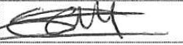
Date: | 03/07/2022
Treasurer name: | Laura Ionescu
Treasurer signature: | 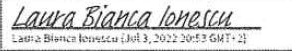
Date: | 03/07/2022

