Team UCL Access Statement

Handball Club

Contents
- Club Statement
- Travel to the venue
- Accessible features at the venue
- Additional information
- Venue map

Our Statement

Handball is one of the most exciting, friendliest and fastest growing sports in the UK, and since the London 2012 Olympics, interest in the game has soared!
Imagine a mix between basketball and football, and along with hints of rugby, you’re basically there. The sport allows you to develop a combination of accuracy, agility, speed and strength. Games last sixty minutes, are divided into two halves and teams are allowed unlimited substitutions. All of this makes handball the second fastest indoor sport after ice hockey!
Whether you are a complete beginner, a handball veteran or are just looking to get fit, we want to have you involved in our society!

We look forward to welcoming you into our club.
Kind regards,

__________________________________________
Club President

Travel
We train at Sommers Town Community Sports Centre which is easily accessible using all modes of transport. Click here for the Tfl Accessible Tube Map

Underground
Unfortunately, few of the underground or mainline railway stations around Emirates Stadium are fully wheelchair accessible.
However, some ambulant disabled supporters/visitors may be able to use them.
• Euston Road (Circle, Metropolitan and Hammersmith & City lines ) is the nearest tube station and is around an eight minute walk from the facility (step free)
• Mornington Crescent station (Northern line) and King´s cross station (Victoria, Piccadilly and Northern lines) are also near at 10 and 12 minutes walking respectively. King´s cross is wheelchair accessible and is about 5 minutes away by car or for ambulant disabled supporters and visitors.

Buses
All Transport for London (TFL) bus routes are wheelchair accessible and have clearly marked priority seats for people with limited mobility. On most buses the wheelchair ramp is positioned at the exit door and there is one wheelchair user place on each bus. The main bus stops close to Sommers Town Community Centre are located on Aldenham Street, Chenies Place and Chenies Place.
Several bus routes pass close to the centre including the 168 which goes from Dunton Road to South End Green, and the 253 which goes from Hackney Central Station to Euston Bus station and the 46 which goes from Paddington Station to St Bartholomew's Hospital.

Taxis
All London Style ’Black Cabs’ are wheelchair accessible and can provide a suitable alternative to the bus or car. Black cabs can be hailed (stopped) in the street however you may prefer to book a cab to travel to or from the facility.
There are several cab companies operating in London including,
Computer Cab: Tel: 020 8033 9918
The London Black Cab Company: 078 8534 9994
London Black Taxis: 020 3984 4515/ 020 3004 4953
Uber Taxis also provide Wheelchair Accessible Vehicles (WAV). To book Download the Uber app and create your account (unless you already have one) then choose the ‘uberWAV’ option on the slider at the bottom of the screen and follow the instructions. If you would prefer to book a mini cab, then there are several companies in Camden including.

There are no designated drop off/pick up point outside the facility. However, suggested drop off/ pick up points are outside Saint Francis House where one can then access step free into the facility with a wheelchair ramp.
The entrance on 134 Chalton St (NW1 1RX), gives step-free access to the south-west side of the facility.
Full information on bus taxi and tube travel in London for disabled people can be found at https://tfl.gov.uk/transport-accessibility/?cid=transportaccessibility

Parking
The facility is situated in a mainly residential area with extensive parking restrictions. Blue Badge holders can park in the surrounding roads in vacant residents parking bays. However, you should check to ensure the bay is not suspended due to event day parking restrictions around the centre. Please ensure that your Blue Badge and clock are clearly displayed. There are also a number dedicated Blue Badge bays in the vicinity of the facility, however, please be aware that some of the bays in the area are specifically for the use of a designated Blue Badge holder. Please check the Blue Badge parking signage carefully before parking.
There is two spots of specific designated accessible parking at the venue and these are located at the back of the venue with access being given by talking to reception. They are distributed on a first come first served basis.
The spaces are connected to the venue with ramps and access to an accessible elevator.

Accessible features at the venue

Accessible Toilets
There are 2 wheelchair accessible toilets located inside the facility. There is one for men and another for women both of these are fitted with toilet doors all open outwards. These toilets can be reached on the first floor by taking an accessible elevator and are next to the changing rooms and accessible showers.
Either a left or right transfer space is available in every wheelchair accessible toilet along with colour contrasted grab rails.
The wash hand basins all have lever type mixer taps. The wheelchair accessible toilets are also fitted with appropriate height mirrors, hand dryers and coat hooks and pull cord emergency alarms.

Non accessible Toilets
There are standard male & female toilets in the changing rooms on the second floor and on the ground floor. Every standard toilet block contains one cubicle suitable for ambulant disabled supporters.

Changing Places Toilet Facility
The Changing Places Toilet (CPT) is in on the first floor.
The dimensions of the CPT facility are 205cm x 410cm (6ft 9in x 13ft 5in). The facility includes a height adjustable changing bench (length 179cm- 5ft 10in), with shower attachment and a powered overhead hoist which covers all areas of the facility. The toilet in the CPT facility is peninsular. The transfer space on the left as you face the toilet is 60cm (1ft 11.5in) and on the right is 96cm (3ft 2in). Colour contrasted wall mounted and drop-down grab rails are fitted around the toilet. The facility also includes a sink, a privacy screen, non-slip flooring and a pull cord emergency alarm. Please note that slings are not provided by the facility.

Contact
Welfare Officer: Antonio Neves (abn042001@gmail.com/ +34603867495)
Contact of Somers Town Community Sports Centre: +442074194365

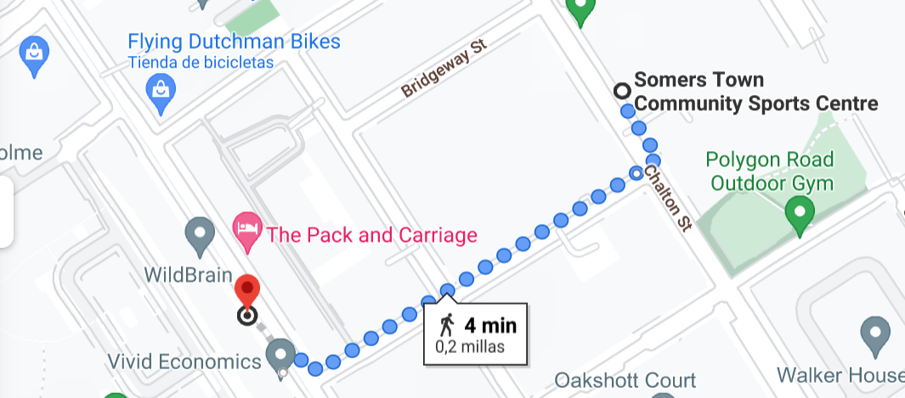
Come into the entrance disability ramps, for wheeklchair users, Lift for bathrooms and toilets, with shower and other facilities

