The Constitution of Students’ Union UCL

UCL Ghana Society

Name

The name of the club/society shall be Students’ Union UCL Ghana Society.

The club/society shall be affiliated to Students’ Union UCL.

Statement of Intent

The constitution, regulations, management and conduct of the club/society shall abide by all Students’ Union UCL policy, and shall be bound by the Students’ Union UCL Memorandum & Articles of Association, Byelaws, Club and Society Regulations and the club and society procedures and guidance – laid out in the ‘how to guides’.

The club/society stresses that it abides by Students’ Union UCL Equal Opportunities Policies, and that club/society regulations pertaining to membership of the club/society or election to the club/society shall not contravene this policy.

The Club and Society Regulations can be found on the following webpage: http://studentsunionucl.org/content/president-and-treasurer-hub/rules-and-regulations.

The Society Committee

President

The president’s primary role is laid out in section 5.7 of the Club and Society Regulations.

Treasurer

The treasurer’s primary role is laid out in section 5.8 of the Club and Society Regulations.

Welfare Officer

The welfare officer’s primary role is laid out in section 5.9 of the Club and Society Regulations.

.

Additional Committee Members

Promo Officer

Promote UCL Ghana Society and its events

Manage UCL Ghana society’s social media accounts

Help committee members’ organize events

Designing flyers and posters, promotional videos and create Facebook events.

Events Director

Support committee with event planning and creativity

Help Lead and ensure events are going according to plan and all resources are available

Work with promo officers and secretary to ensure all events are on the calendar, up to date and shared with members of the society.

Management of the club/society shall be vested in the club/society committee which will endeavour to meet regularly during term time (excluding UCL reading weeks) to organise and evaluate club/society activities.

The committee members shall perform the roles as described in section 5 of the Students’ Union UCL Club and Society Regulations.

Committee members are elected to represent the interests and well-being of club/society members and are accountable to their members. If club/society members are not satisfied by the performance of their representative officers they may call for a motion of no-confidence in line with the Students’ Union UCL Club and Society Regulations.

Terms, Aims and Objectives

The club/society shall hold the following as its aims and objectives.

The club/society shall strive to fulfil these aims and objectives in the course of the academic year as its commitment to its membership.

The core activities of the club/society shall be:

Meet and Greet
- Games nights
- Movie nights
- Karaoke and Quiz night
- Akan Twi language lessons
- Independence Day celebrations
- Book Club
- End of year BBQ/picnic

In addition, the club/society shall also strive to organise other activities for its members where possible:
- Intersociety debates and events
- Charity fundraising events
- Lifestyle Talks (e.g. Mental Health, Addiction, Depression)
- Volunteering

This constitution shall be binding on the club/society officers, and shall only be altered by consent of two-thirds majority of the full members present at a club/society general meeting. The Activities Zone shall approve any such alterations.

This constitution has been approved and accepted as the Constitution for the Students’ Union UCL Ghana Society . By signing this document the president and treasurer have declared that they have read and abide by the Students’ Union UCL Club and Society Regulations.

President name: | Maria Teresa Jones Sam
President signature: | 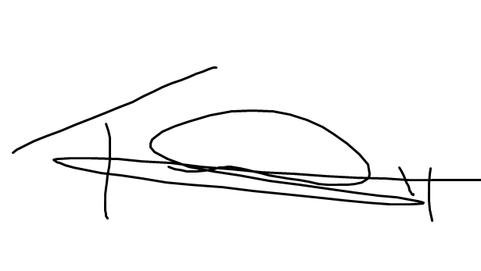
Date: | 21/06/2020
Treasurer name: | Cassandra Acquah
Treasurer signature:
Date: | 21/06/20

