The Constitution of Students’ Union UCL

Chinese A-share Society

Name

The name of the club/society shall be Students’ Union UCL Chinese A-share Society.

The club/society shall be affiliated to Students’ Union UCL.

Statement of Intent

The constitution, regulations, management and conduct of the club/society shall abide by all Students’ Union UCL policy, and shall be bound by the Students’ Union UCL Memorandum & Articles of Association, Byelaws, Club and Society Regulations and the club and society procedures and guidance – laid out in the ‘how to guides’.

The club/society stresses that it abides by Students’ Union UCL Equal Opportunities Policies, and that club/society regulations pertaining to membership of the club/society or election to the club/society shall not contravene this policy.

The Club and Society Regulations can be found on the following webpage: http://studentsunionucl.org/content/president-and-treasurer-hub/rules-and-regulations.

The Society Committee

President

The president’s primary role is laid out in section 5.7 of the Club and Society Regulations.

Treasurer

The treasurer’s primary role is laid out in section 5.8 of the Club and Society Regulations.

Welfare Officer

The welfare officer’s primary role is laid out in section 5.9 of the Club and Society Regulations.

Additional Committee Members

Additional Committee Role Title

Vice President – Assist the President with ad hoc tasks and co-lead the vision of the society

Head of Research – Draft A-share research reports, LinkedIn posts, and WeChat posts to educate society members

Head of Events – Organize the flagship trading event, society groupchat, and related tasks

Head of Marketing – Prepare marketing materials and enhance the layout of the research reports

Head of Recruiting – Recruit new members for the society

Head of Outreach – Contact sponsors and speakers on behalf of the society

Management of the club/society shall be vested in the club/society committee which will endeavour to meet regularly during term time (excluding UCL reading weeks) to organise and evaluate club/society activities.

The committee members shall perform the roles as described in section 5 of the Students’ Union UCL Club and Society Regulations.

Committee members are elected to represent the interests and well-being of club/society members and are accountable to their members. If club/society members are not satisfied by the performance of their representative officers they may call for a motion of no-confidence in line with the Students’ Union UCL Club and Society Regulations.

Terms, Aims and Objectives

The club/society shall hold the following as its aims and objectives.

The club/society shall strive to fulfil these aims and objectives in the course of the academic year as its commitment to its membership.

The core activities of the club/society shall be:

Annual Trading Events: Invite famous A-share traders to come and educate our society members and selected UCL students. These events’ duration will be around 2-3 days. There will also be a short-term trading contest in the end, in which the most profited attendee will win a prize.

Research meetings: Members of the society will be welcomed to regular research report discussion meetings. They will be encouraged to raise questions about our A-share research findings.

In addition, the club/society shall also strive to organise other activities for its members where possible:

Online Zoom speaker events: Regularly invite A-share traders to educate our society members and UCL students in general

This constitution shall be binding on the club/society officers, and shall only be altered by consent of two-thirds majority of the full members present at a club/society general meeting. The Activities Zone shall approve any such alterations.

This constitution has been approved and accepted as the Constitution for the Students’ Union UCL Chinese A-share Society By signing this document the president and treasurer have declared that they have read and abide by the Students’ Union UCL Club and Society Regulations.

President name: | Siyuan (Jonathan) Zhu
President signature: | 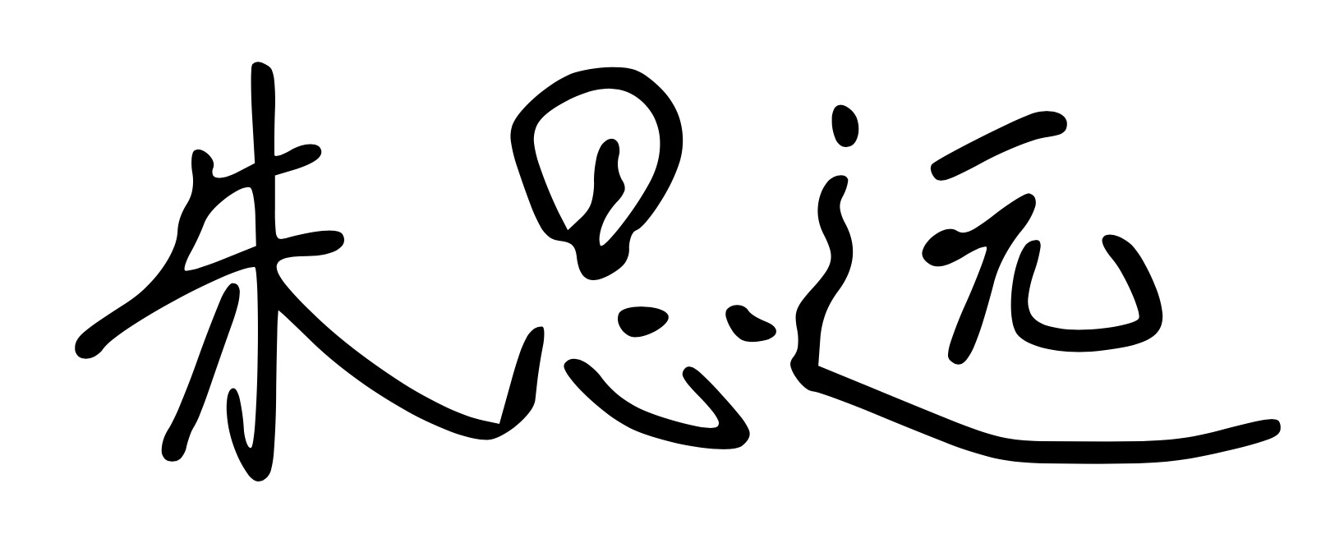
Date: | April 21st, 2021
Treasurer name: | Zixuan (Ivy) Ni
Treasurer signature: | Zixuan (Ivy) Ni
Date: | April 21st, 2021

