The constitution of the Students’ Union UCL

Bioethics and Medical Law Society

Name

The name of the society shall be the Students’ Union UCL: Bioethics and Medical Law Society.

The society shall be affiliated to Students’ Union UCL.

Statement of Intent

The constitution, regulations, management and conduct of the society shall abide by all Students’ Union UCL Policy, and shall be bound by the Students’ Union UCL Memorandum and Articles of Association and Byelaws, the Club and Society Regulations and the Club and Society Procedures and Guidance, laid out in “how to guides”.

The club/society stresses that it abides by Students’ Union UCL Equal Opportunities Policies, and that club/society regulations pertaining to membership of the club/society or election to management of the club/society shall not contravene this policy.

The Club and Society Regulations can be found at the following website:

www.studentsunionucl.org

The Society Committee

President

The President’s primary role is laid out in section 5.7 of the Club and Society Regulations.

You may add specific details to the job description of your President if you wish.

Treasurer

The Treasurer’s primary role is laid out in section 5.8 of the Club and Society Regulations.

You may add specific details to the job description of your Treasurer if you wish.

Additional committee members

Specific job details of additional committee members.
- Vice-president
  - To assist the president in the society’s duties
  - To attend to all the society’s correspondence
  - To keep the society website content up to date
  - To liaise between the committee and the society members
- Secretary
  - To keep the list of membership up to date
  - To meet with the Treasurer regularly to draft basic administrative reports
  - To keep the Constitution up to date
  - To record and distribute the minutes of the committee meetings
- Social and welfare officer
  - To watch over the wellness of the society’s members
  - To organise at least one social-variety event per term

Communications officer
  - To draft and distribute the society’s newsletter
  - To manage the society’s social media accounts
  - To publicise events
  - To manage all correspondence with the Union

Management of the club/society shall be vested in the club/society committee which shall endeavour to meet regularly during term time (excluding college reading weeks) to organise and evaluate the club/society activities.

The committee members will perform the roles as described in section 5 of the Students’ Union UCL Club and Society Regulations.

Committee members are elected to represent the interests and well-being of club/society members and are able to be held to account. If club/society members are not satisfied by the performance of their representative officers they may call for a motion of no-confidence in line with the Students’ Union UCL Club and Society Regulations.

Terms, Aims and Objectives

The club/society shall hold the following as its aims and objectives:
- To provide opportunities for UCL students to engage with current issues in Bioethics and Medical Law.
- To approach topics in a manner that emphasizes various contrasting perspectives.
- To generate a discussion that is open to all philosophical backgrounds.
- To provide an understanding of the Bioethics and Medical Law that is directly relevant to the way members will encounter the disciplines in their future work and day to day life.

The club/society shall strive to fulfil these aims and objectives in the course of the academic year as its commitment to its membership:
- To organise a wide range of events that allow members to gain basic notions in the many facets of Bioethics and Medical Law.
- To address current issues in the fields.

The core activities of the society shall be:
- Academic lecture events (at least 6 per year)
- Welfare social evenings (at least 3 per year)

In addition, the club/society shall also strive to organise other activities for its members where possible:
- Bioethics and Medical Law careers panels
- Yearly Bioethics and Medical Law conferences
- Book club

This constitution shall be binding on the club/society officers and shall only be altered by consent of two-thirds majority of the full members present at a society general meeting. Activities Network Executive shall approve any such alterations.

This constitution has been approved and accepted as the Constitution for the Students’ Union UCL Bioethics and Medical Law Society. By signing this document, the President and Treasurer have declared that they have read and abide by the Students’ Union UCL Clubs and Societies Regulations.

President name : Blanca Sanz-Magallón Treasurer name : Glenda Xu
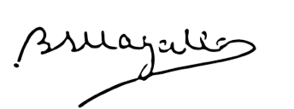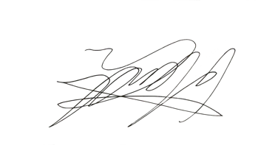

President signature ______________ Treasurer signature ______________

Date : June 22nd, 2020 Date : June 22nd, 2020

