STUDENTS' UNION UCL

The constitution of the Students' Union UCL Bhangra Society
- Name
  - The name of the society shall be the Students' Union UCL Bhangra Society
  - The society shall be affiliated to Students' Union UCL.
- Statement of Intent
  - The constitution, regulations, management and conduct of the society shall abide by all Students' Union UCL Policy, and shall be bound by the Students' Union UCL Memorandum and Articles of Association and Byelaws, the Club and Society Regulations and the Club and Society Procedures and Guidance, laid out in "how to guides".
  - The club/society stresses that it abides by Students' Union UCL Equal Opportunities Policies, and that club/society regulations pertaining to membership of the club/society or election to management of the club/society shall not contravene this policy.
  - The Club and Society Regulations can be found at the following website: www.studentsunionucl.org
- The Society Committee
President
  - The President's primary role is laid out in section 5.7 of the Club and Society Regulations.
Treasurer
  - The Treasurer's primary role is laid out in section 5.8 of the Club and Society Regulations.
Social Secretary
  - Regular socials accessible to all members
  - Responsible for organising the societies' Bhangra classes
Social Media Officer
  - Responsible for all social media relating to the society and team
  - Main point of contact for publicity for the society and the team
Welfare Officer
  - Signposting members of the society to university staff and services on campus
  - Represent all minority communities within the society
  - Overcome retrospective engagement
  - Management of the club/society shall be vested in the club/society committee which shall endeavour to meet regularly during term time (excluding college reading weeks) to organise and evaluate the club/society activities.
  - The committee members will perform the roles as described in section 5 of the Students' Union UCL Club and Society Regulations.
  - Committee members are elected to represent the interests and well-being of club/society members and are able to be held to account. If club/society members are not satisfied by the performance of their representative officers they may call for a motion of no-confidence in line with the Students' Union UCL Club and Society Regulations.
- Terms, Aims and Objectives
  - The club/society shall hold the following as its aims and objectives.
  - The club/society shall strive to fulfil these aims and objectives in the course of the academic year as its commitment to its membership.
  - The core activities of the society shall be:
    - To enter and compete in at least one national inter-university Bhangra competition
    - Host regular Bhangra classes for members and non-members throughout the year
    - Participate in productions at UCL and external events with exhibition performances
    - Organise social events, which promote and highlight Punjabi culture
  - In addition, the club/society shall also strive to organise other activities for its members where possible:
    - Collaborate with other societies at UCL to provide opportunites for members to participate in events and help raise the profile of the Bhangra Society
    - Involvement with charitable organisations to provide members with opportunities to volunteer and raise awareness by providing bhangra workshops as a form of fundraising and as an activity for fun and fitness
    - To invite professional dancers to teach Bhangra at the societies classes to provide members with further opportunities to learn Bhangra at a higher level and learn more about Punjabi culture
  - This constitution shall be binding on the club/society officers and shall only be altered by consent of two-thirds majority of the full members present at a society general meeting. Activities Network Executive shall approve any such alterations.
  - This constitution has been approved and accepted as the Constitution for the
Students' Union UCL Bhangra Society. By signing this document the President and Treasurer have declared that they have read and abide by the Students' Union UCL Clubs and Societies Regulations.
President name Treasurer name
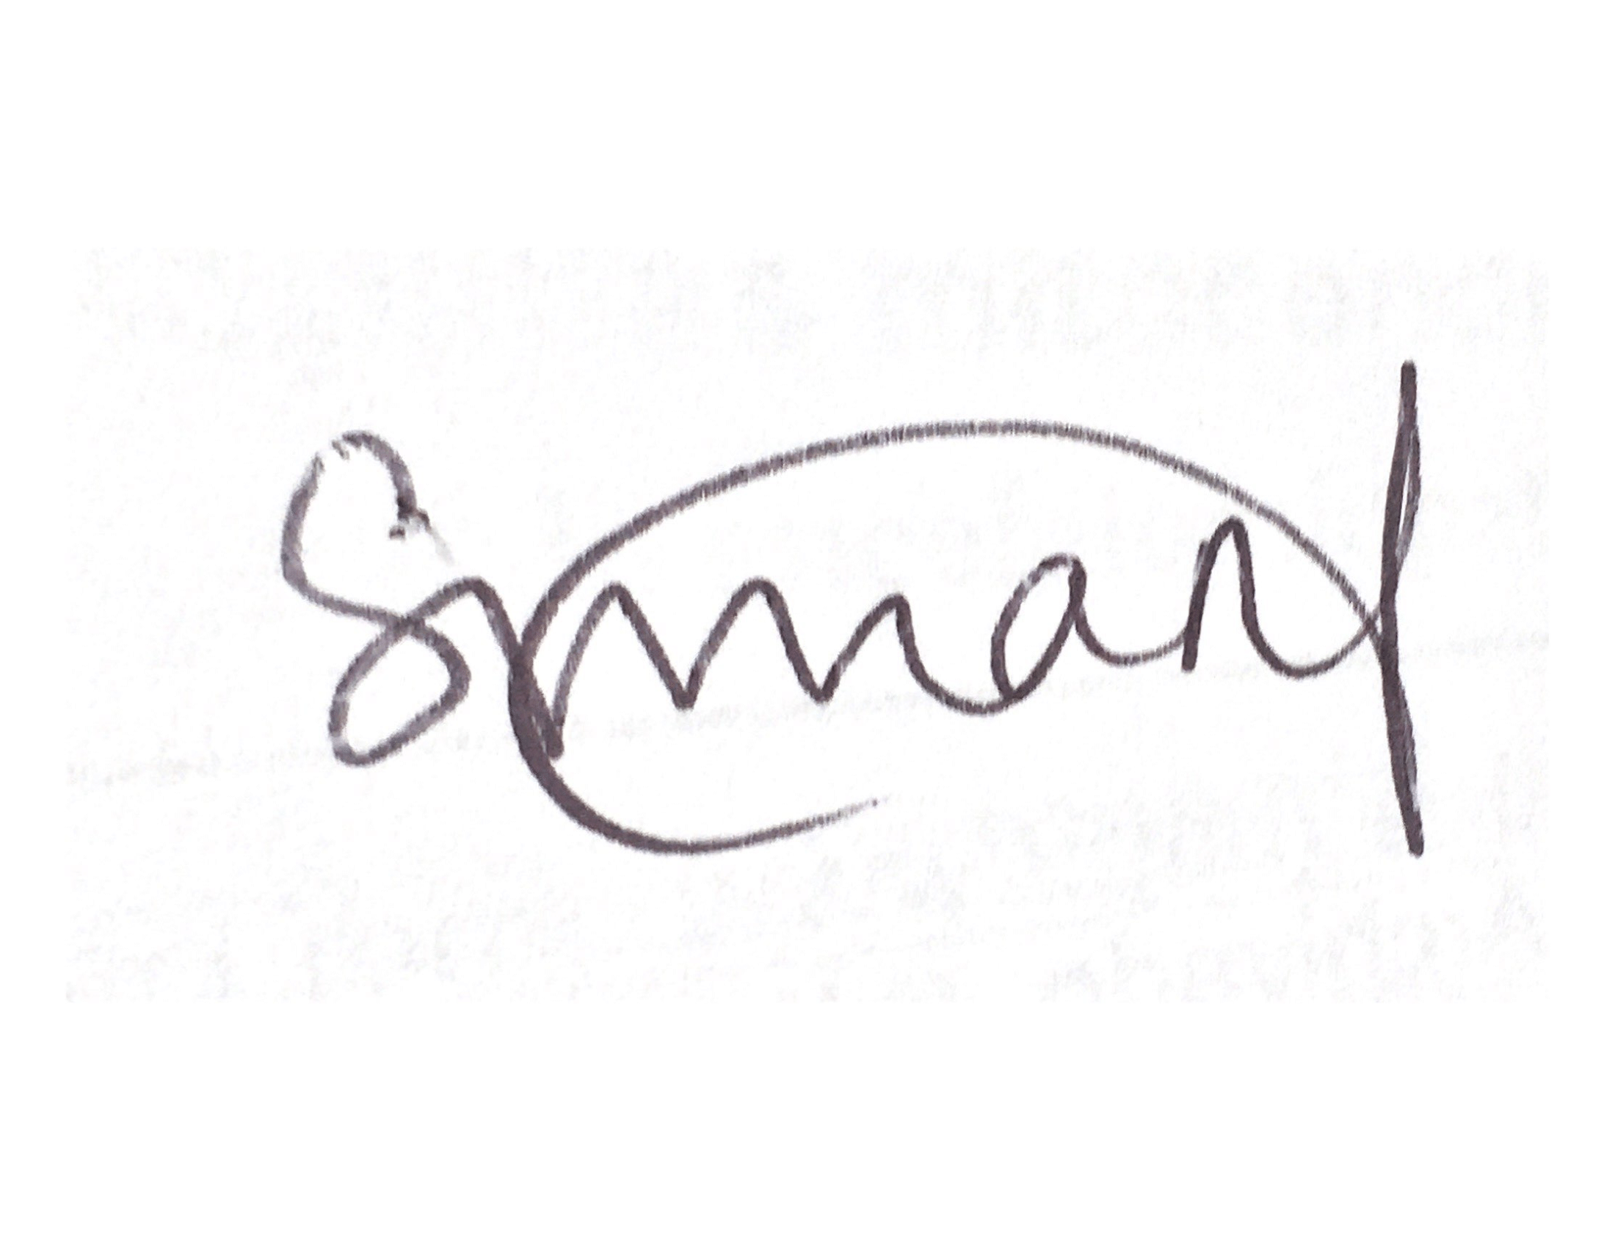
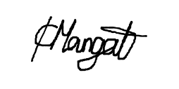
Kimrinjeet Mangat Simran Jolly
President signature Treasurer signature

