The Constitution of Students’ Union UCL

MEN’s BASKETBALL CLUB

Name

The name of the club/society shall be Students’ Union UCL Men’s Basketball

The club/society shall be affiliated to Students’ Union UCL.

Statement of Intent

The constitution, regulations, management and conduct of the club/society shall abide by all Students’ Union UCL policy, and shall be bound by the Students’ Union UCL Memorandum & Articles of Association, Byelaws, Club and Society Regulations and the club and society procedures and guidance – laid out in the ‘how to guides’.

The club/society stresses that it abides by Students’ Union UCL Equal Opportunities Policies, and that club/society regulations pertaining to membership of the club/society or election to the club/society shall not contravene this policy.

The Club and Society Regulations can be found on the following webpage: http://studentsunionucl.org/content/president-and-treasurer-hub/rules-and-regulations.

The Society Committee

President

The president’s primary role is laid out in section 5.7 of the Club and Society Regulations.

Treasurer

The treasurer’s primary role is laid out in section 5.8 of the Club and Society Regulations.

Welfare Officer

The welfare officer’s primary role is laid out in section 5.9 of the Club and Society Regulations.
Acts as support to address any personal or inter-personal conflicts or issues. Furthermore, ensures that all members of society are treated fairly and with respect. They should be able to direct members to the appropriate support services if needed.

Additional Committee Members

Vice President

Assists and aids in the undertakings of the President.

Social Secretary
Ensures the presence of weekly social activities as well as the spreading such information and details to the members of the society.

1st Team Captain
Maintains organization of weekly first team procedures.
Serves as first contact point with the coach, and the main distributor of information to the team.
Is involved in administrative procedures for BUCS competition.

1st Team Vice Captain
Assists and aids in the undertakings of the 1st Team Captain.

2nd Team Captain:
Maintains organization of weekly second team procedures.
Serves as first contact point with the coach, and the main distributor of information to the team.
Is involved in administrative procedures for all BUCS and LUSL competitions.

2nd Team Vice Captain:
Assists and aids in the undertakings of the 2nd Team Captain.

3rd Team Captain:
Maintains organization of weekly third team procedures.
Serves as first contact point with the coach, and the main distributor of information to the team.
Is involved in administrative procedures for all BUCS and LUSL competitions.

3rd Team Vice Captain:
Assists and aids in the undertakings of the 3rd Team Captain.

Management of the club/society shall be vested in the club/society committee which will endeavour to meet regularly during term time (excluding UCL reading weeks) to organise and evaluate club/society activities.

The committee members shall perform the roles as described in section 5 of the Students’ Union UCL Club and Society Regulations.

Committee members are elected to represent the interests and well-being of club/society members and are accountable to their members. If club/society members are not satisfied by the performance of their representative officers they may call for a motion of no-confidence in line with the Students’ Union UCL Club and Society Regulations.

Terms, Aims and Objectives

The club/society shall hold the following as its aims and objectives:
- To provide all male basketball players and enthusiasts with opportunities to practice the sport on a weekly basis, both competitively and socially, regardless of skill levels.
- To establish a serious competitive environment with the competence of a professional basketball club.
- To continue last year’s improvement in BUCS and LUSL competition, with goals for our 1st, 2nd, and 3rd Teams to compete in the upper half of their BUCS leagues and for the first to attempt to win LUSL, BUCS and London Varsity cup victories as they have in the past.
- To uphold strong values of sportsmanship in line with UCL’s code of conduct on and off the court.
- To increase society membership by 10-20%.
- To increase involvement by society members at large and to offer more avenues for society activities outside of competition.
- To establish greater coherence in game play through increased support of coaches and to increase training opportunities for our competitive teams.

The club/society shall strive to fulfil these aims and objectives in the course of the academic year as its commitment to its membership.

The core activities of the club/society shall be:

Weekly trainings for the 3 competitive teams.

Court time for our social members on weekends.

Matches in LUSL and BUCS throughout the year for all three competitive teams.

Weekly socials.

In addition, the club/society shall also strive to organise other activities for its members where possible:

Social and/or competitive tours.
- Volunteering opportunities.

This constitution shall be binding on the club/society officers, and shall only be altered by consent of two-thirds majority of the full members present at a club/society general meeting. The Activities Zone shall approve any such alterations.

This constitution has been approved and accepted as the Constitution for the Students’ Union UCL Men’s Basketball. By signing this document the president and treasurer have declared that they have read and abide by the Students’ Union UCL Club and Society Regulations.

President name: | Daryoush Chaharsough Shirazi
President signature: | 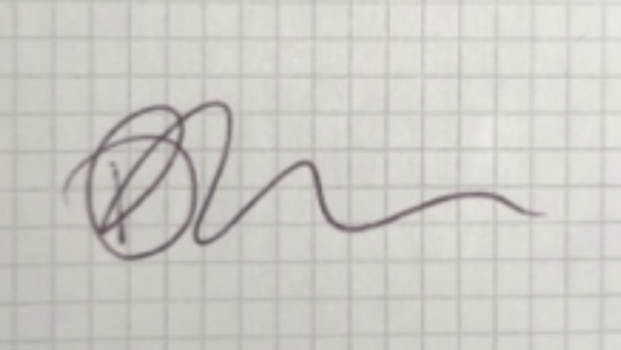
Date: | 10/07/20
Treasurer name: | Curtis Chen
Treasurer signature: | 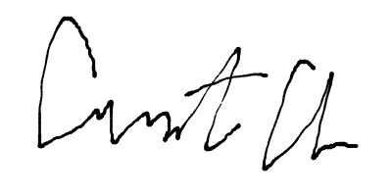
Date: | 10/07/2020

