The Constitution of Students’ Union UCL

Ahlul-Bayt Islamic Society

Name

The name of the club/society shall be Students’ Union UCL Ahlul-Bayt Islamic Society.

The club/society shall be affiliated to Students’ Union UCL.

Statement of Intent

The constitution, regulations, management and conduct of the club/society shall abide by all Students’ Union UCL policy, and shall be bound by the Students’ Union UCL Memorandum & Articles of Association, Byelaws, Club and Society Regulations and the club and society procedures and guidance – laid out in the ‘how to guides’.

The club/society stresses that it abides by Students’ Union UCL Equal Opportunities Policies, and that club/society regulations pertaining to membership of the club/society or election to the club/society shall not contravene this policy.

The Club and Society Regulations can be found on the following webpage: http://studentsunionucl.org/content/president-and-treasurer-hub/rules-and-regulations.

The Society Committee

President

The president’s primary role is laid out in section 5.7 of the Club and Society Regulations.

Treasurer

The treasurer’s primary role is laid out in section 5.8 of the Club and Society Regulations.

Welfare Officer

The welfare officer’s primary role is laid out in section 5.9 of the Club and Society Regulations.

Additional Committee Members

Any additional committee positions you have should be outlined in your constitution below.

Secretary
To take responsibility for taking and distributing minutes after meetings within the society and with external bodies. To monitor the email inbox and liaise any important communications back to the President, Treasurer and committee members. To take ownership of all emails sent out to the mailing list.

Vice President
To assist the President in all aspects. Be prepared to take a leadership role in the absence of the President or otherwise.

Interfaith Officer
Organise any events which involve or invite other faiths to attend. Ensure strong relations with other faith societies and promote unity in this respect.

Social Media Representatives
Keep all social media accounts of the society updated regularly. Set and aim to achieve monthly targets for growth on all social media platforms. Design and publicise posters for events on social media. Be responsible for responding to messages on social media account after liaising with the President and the rest of the committee if need be.

Weekly Events Coordinator
Organise topics and layout of weekly DKDCs (Dua Kumayl and Discussion Circle). Liaise with social media representatives to ensure maximum attendance.

Management of the club/society shall be vested in the club/society committee which will endeavour to meet regularly during term time (excluding UCL reading weeks) to organise and evaluate club/society activities.

The committee members shall perform the roles as described in section 5 of the Students’ Union UCL Club and Society Regulations.

Committee members are elected to represent the interests and well-being of club/society members and are accountable to their members. If club/society members are not satisfied by the performance of their representative officers they may call for a motion of no-confidence in line with the Students’ Union UCL Club and Society Regulations.

Terms, Aims and Objectives

The club/society shall hold the following as its aims and objectives.

The club/society shall strive to fulfil these aims and objectives in the course of the academic year as its commitment to its membership.

The core activities of the club/society shall be:

These are the activities that you will definitely carry out every academic year. The Union will only fund core activities.
4.3.1 Weekly DKDCs
4.3.2 Weekly DTWIs
4.3.3 Art of Faith Flagship Event
4.3.4 Charity dinner
4.3.5 Hungry for Justice campaign
4.3.6 Who Is Hussain campaign
4.3.7 Interfaith events
4.3.8 Socials
4.3.9 Roses for Peace campaign

In addition, the club/society shall also strive to organise other activities for its members where possible:

These are the activities that you would like to carry out every academic year if you can. The Union will support these activities but not fund them.
4.4.1 Sport tournaments
4.4.2 Workshops
4.4.3 Networking events
4.4.4 Collaborations with other societies

This constitution shall be binding on the club/society officers and shall only be altered by consent of two-thirds majority of the full members present at a club/society general meeting. The Activities Zone shall approve any such alterations.

This constitution has been approved and accepted as the Constitution for the Students’ Union UCL AhlulBayt Islamic Society. By signing this document the president and treasurer have declared that they have read and abide by the Students’ Union UCL Club and Society Regulations.

President name: | Syed Zammurd Abbas Tirmzi
President signature: | 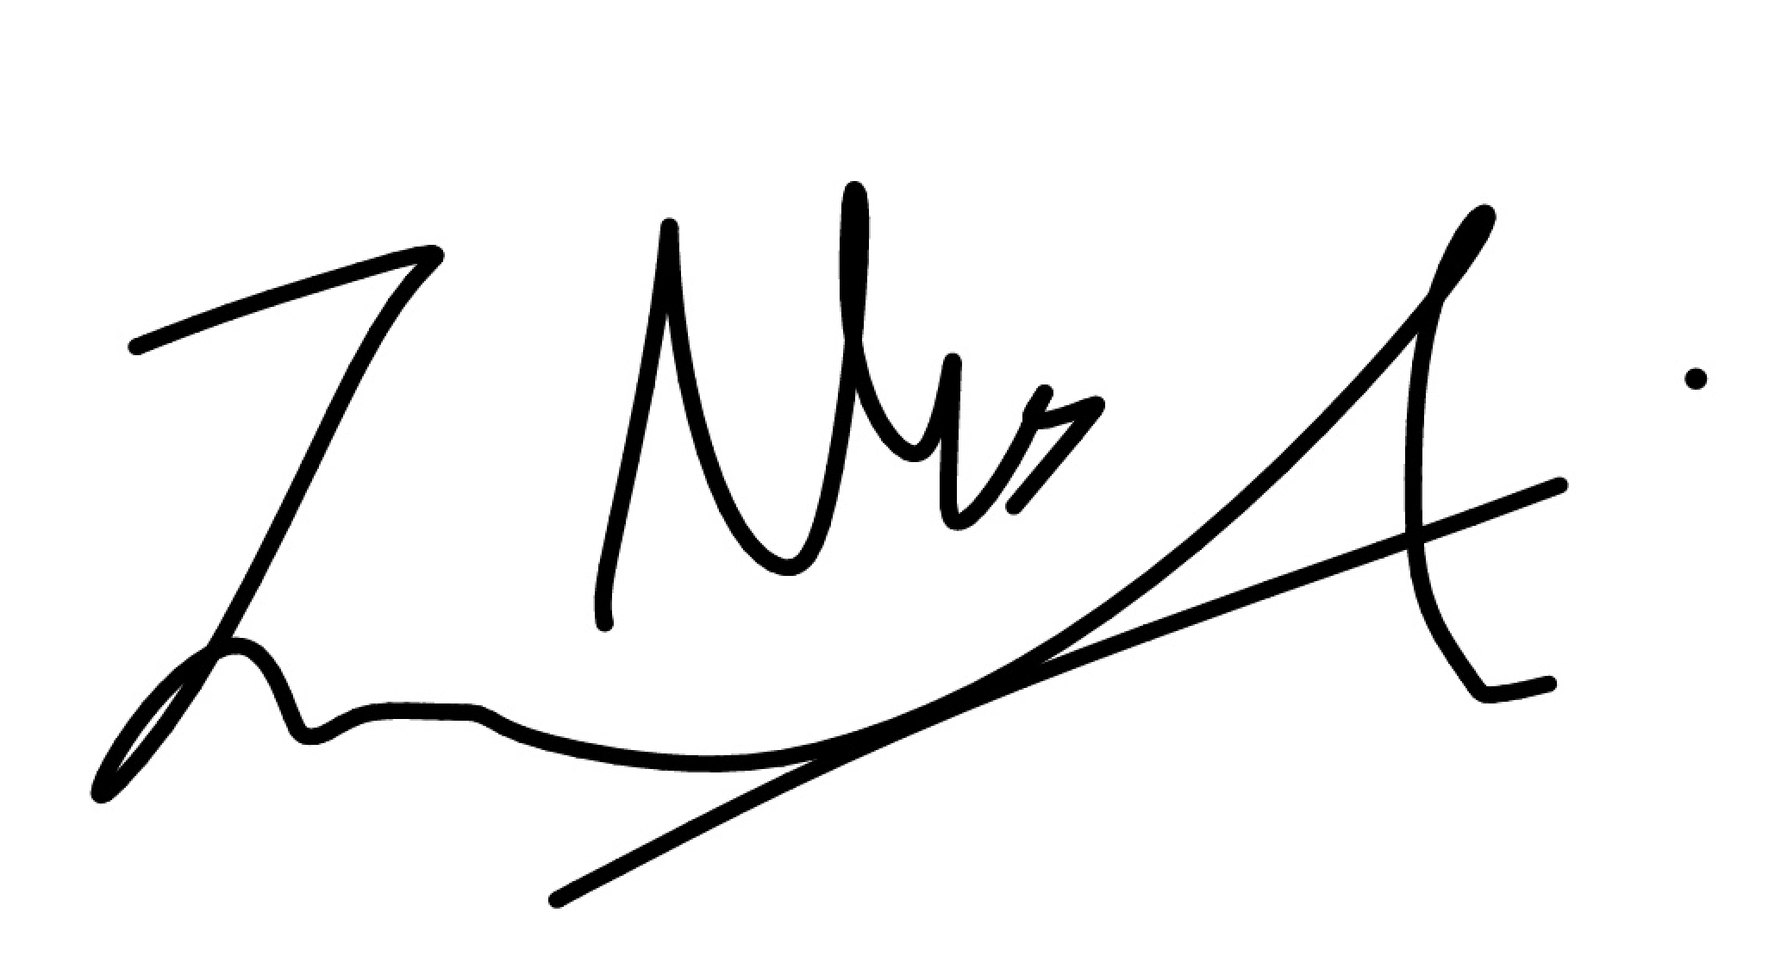
Date: | 22/06/2020
Treasurer name: | Mohammad Ali Syed
Treasurer signature: | 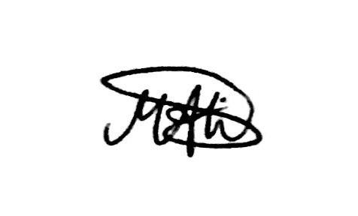
Date: | 22/06/2020

