The Constitution of Students’ Union UCL

Tea Society

Name

The name of the club/society shall be Students’ Union UCL Tea Society.

The club/society shall be affiliated to Students’ Union UCL.

Statement of Intent

The constitution, regulations, management and conduct of the club/society shall abide by all Students’ Union UCL policy, and shall be bound by the Students’ Union UCL Memorandum & Articles of Association, Byelaws, Club and Society Regulations and the club and society procedures and guidance – laid out in the ‘how to guides’.

The club/society stresses that it abides by Students’ Union UCL Equal Opportunities Policies, and that club/society regulations pertaining to membership of the club/society or election to the club/society shall not contravene this policy.

The Club and Society Regulations can be found on the following webpage: http://studentsunionucl.org/content/president-and-treasurer-hub/rules-and-regulations.

The Society Committee

President

The president’s primary role is laid out in section 5.7 of the Club and Society Regulations.

Treasurer

The treasurer’s primary role is laid out in section 5.8 of the Club and Society Regulations.

Welfare Officer

The welfare officer’s primary role is laid out in section 5.9 of the Club and Society Regulations.

Additional Committee Members

Social Secretary

The Social Secretary of the UCL Tea Society role involves planning and organizing social events, fostering member engagement, assisting the president in executing the society's vision, promoting events, ensuring smooth event execution, gathering feedback, and providing support to the president in their duties.

Social Media Manager

The Social Media Manager of the UCL Tea Society is responsible for creating engaging content, scheduling posts, interacting with followers, promoting events, analyzing performance metrics, and collaborating with other society members to align social media efforts with organizational goals.

Captain

The role of the captain in the UCL Tea Society involves providing leadership, organizing tea-related events, sharing tea knowledge, collaborating with other committee members, building community among members, and representing the society within and outside the university.

Management of the club/society shall be vested in the club/society committee which will endeavour to meet regularly during term time (excluding UCL reading weeks) to organise and evaluate club/society activities.

The committee members shall perform the roles as described in section 5 of the Students’ Union UCL Club and Society Regulations.

Committee members are elected to represent the interests and well-being of club/society members and are accountable to their members. If club/society members are not satisfied by the performance of their representative officers they may call for a motion of no-confidence in line with the Students’ Union UCL Club and Society Regulations.

Terms, Aims and Objectives

The club/society shall hold the following as its aims and objectives.

The club/society shall strive to fulfil these aims and objectives in the course of the academic year as its commitment to its membership.

The core activities of the club/society shall be:

Cultural Immersion Through Tea: This series of events will explore different tea cultures from around the world, allowing members to immerse themselves in the rich heritage and traditions associated with tea-drinking practices. Each event will focus on a specific tea culture, such as Chinese Tea Culture (Wei Lu Zhu Cha), English Tea Culture (High Tea), Turkish Tea Culture (Çay Culture), and more.

In addition, the club/society shall also strive to organise other activities for its members where possible:

Tea and MBTI (Myers-Briggs Type Indicator) Socials: These social events will explore the intersection of personality psychology and tea preferences, allowing members to discover how their MBTI types influence their tea choices and brewing rituals.

TeaTime Study: This social event will provide members with stress-relief activities and information about the health benefits of tea during exam seasons. Members will have the opportunity to relax and unwind with tea while learning about its potential effects on mental and physical well-being. Meanwhile, We aim to offer a serene environment where participants indulge in focused self-study sessions accompanied by the soothing ritual of tea-drinking.

Tea Field Trip

Embark on a guided excursion to local tea houses and cultural centers, where participants will immerse themselves in the diverse world of tea cultures. Led by knowledgeable guides, this hands-on experience offers insights into traditional tea-making techniques, cultural rituals, and the significance of tea in different societies.

This constitution shall be binding on the club/society officers, and shall only be altered by consent of two-thirds majority of the full members present at a club/society general meeting. The Activities Executive shall approve any such alterations.

This constitution has been approved and accepted as the Constitution for the Students’ Union UCL Tea Society. By signing this document the president and treasurer have declared that they have read and abide by the Students’ Union UCL Club and Society Regulations.

President name: | Junliang Liu
President signature: | 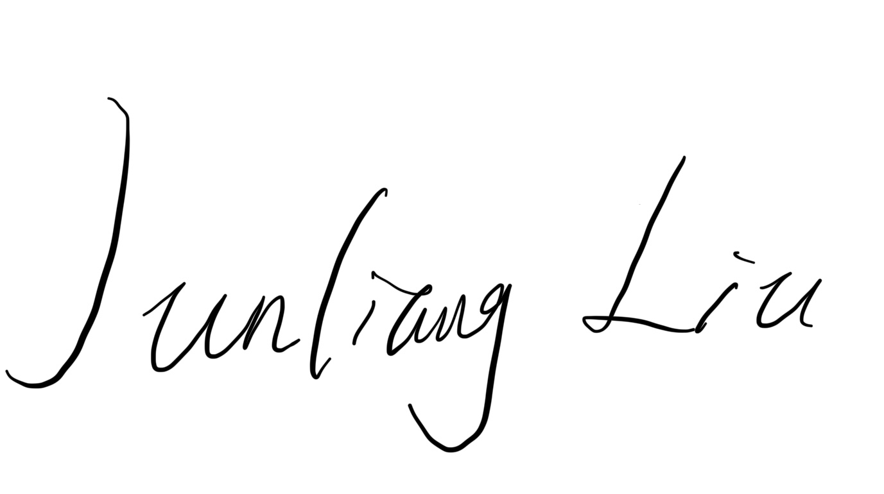
Date: | 06/04/2024
Treasurer name: | Yue Li
Treasurer signature:
Date: | 06/04/2024

