The Constitution of Students’ Union UCL

ENIGMA SOCIETY

Name

The name of the club/society shall be Students’ Union UCL Enigma Society

The club/society shall be affiliated to Students’ Union UCL.

Statement of Intent

The constitution, regulations, management and conduct of the club/society shall abide by all Students’ Union UCL policy, and shall be bound by the Students’ Union UCL Memorandum & Articles of Association, Byelaws, Club and Society Regulations and the club and society procedures and guidance – laid out in the ‘how to guides’.

The club/society stresses that it abides by Students’ Union UCL Equal Opportunities Policies, and that club/society regulations pertaining to membership of the club/society or election to the club/society shall not contravene this policy.

The Club and Society Regulations can be found on the following webpage: http://studentsunionucl.org/content/president-and-treasurer-hub/rules-and-regulations.

The Society Committee

President

The president’s primary role is laid out in section 5.7 of the Club and Society Regulations.
3.1.1. The President’s primary role is laid out in section 5.7 of the Club and Society Regulations.
3.1.2. Shall oversee and co-ordinate all society activities.
3.1.3. Shall ensure society milestones are met.
3.1.4. Shall be responsible for holding regular committee meetings.
3.1.5. Shall be jointly responsible with the Treasurer for producing Sponsorship Material and Performance Reports outlining the committee’s activities over the year.

Treasurer

The treasurer’s primary role is laid out in section 5.8 of the Club and Society Regulations.
3.2.1. The Treasurer’s primary role is laid out in section 5.8 of the Club and Society Regulations.
3.2.2. Shall be jointly responsible with the President for producing UCL Enigma’s Sponsorship Material and Performance Reports [see above 3.1.5].
3.2.3. Shall carry out the day to day financial duties of the society and is responsible to the union for
society finances to the membership.
3.2.4. Shall keep current accurate financial information. The Treasurer is responsible for all financial
transactions of the society ensuring that these are made through the Union Finance Department;
only the Treasurer, or in his/her absence the President, may authorise withdrawals or expenditure
from the society accounts.
3.2.5. Shall maintain a society account book.

Welfare Officer

The welfare officer’s primary role is laid out in section 5.9 of the Club and Society Regulations.
3.3.1. Shall be responsible for further developing this new role introduced by the Union.
3.3.2. Shall collaborate with Welfare Officers from other societies for demographic specific activities.
3.3.3. Shall be aware and participate in the Union campaigns relevant to the society.
3.3.4. Improve demographic representation in the society,
3.3.5. Shall be responsible for the implementation, organisation and administration of any additional
events, initiatives or projects that are implemented in the future in order to promote welfare of
society members.

Additional Committee Members

Social Media Manager

3.4.1 Shall be responsible for taking meeting minutes.

3.4.2 Shall be responsible for all social media accounts of the society.

3.4.3 Shall oversee email correspondence.

3.4.4 Shall be responsible for all formal and informal publicity for events organised by the society.

Events Manager

3.5.1 Shall be responsible for organising and executing academic and social events. These include but

are not limited to information and briefing sessions, Fresher's Fair, panels, talks, game nights, estimathons, workshops, networking events and socials.

Departmental Heads
3.6.1 Shall be responsible for the implementation, organisation and administration of all activities
relevant to their department i.e. Puzzles/Game Theory/Stochasticity/Quant.
3.6.2 These activities include, but are not limited to, organising relevant workshops, events and industrial outreach.
3.6.3 Shall report to the President.

Management of the club/society shall be vested in the club/society committee which will endeavour to meet regularly during term time (excluding UCL reading weeks) to organise and evaluate club/society activities.

The committee members shall perform the roles as described in section 5 of the Students’ Union UCL Club and Society Regulations.

Committee members are elected to represent the interests and well-being of club/society members and are accountable to their members. If club/society members are not satisfied by the performance of their representative officers they may call for a motion of no-confidence in line with the Students’ Union UCL Club and Society Regulations.

Terms, Aims and Objectives

The club/society shall hold the following as its aims and objectives.

The club/society shall strive to fulfil these aims and objectives in the course of the academic year as its commitment to its membership.

The core activities of the club/society shall be:
- Annual Cryptic Hunt
- Mystery Puzzle Event
- Estimathon
- Market Making Workshops
- Networking Events

In addition, the club/society shall also strive to organise other activities for its members where

possible:
- Discussion Groups
- Lecture based sessions
- Field trips
- Debates

This constitution shall be binding on the club/society officers, and shall only be altered by consent of two-thirds majority of the full members present at a club/society general meeting. The Activities Executive shall approve any such alterations.

This constitution has been approved and accepted as the Constitution for the Students’ Union UCL Enigma Society. By signing this document the president and treasurer have declared that they have read and abide by the Students’ Union UCL Club and Society Regulations.

President name: | Mehul Arora
President signature: | 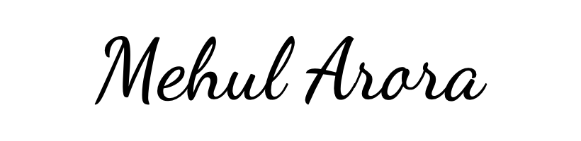
Date: | 11/02/2024
Treasurer name: | Manya Gureja
Treasurer signature:
Date: | 11/02/2024

