The Constitution of Students’ Union UCL

ADM Mathematics Society

Name

The name of the club/society shall be Students’ Union UCL ADM Mathematics Society.

The club/society shall be affiliated to Students’ Union UCL.

Statement of Intent

The constitution, regulations, management and conduct of the club/society shall abide by all Students’ Union UCL policy, and shall be bound by the Students’ Union UCL Memorandum & Articles of Association, Byelaws, Club and Society Regulations and the club and society procedures and guidance – laid out in the ‘how to guides’.

The club/society stresses that it abides by Students’ Union UCL Equal Opportunities Policies, and that club/society regulations pertaining to membership of the club/society or election to the club/society shall not contravene this policy.

The Club and Society Regulations can be found on the following webpage: http://studentsunionucl.org/content/president-and-treasurer-hub/rules-and-regulations.

The Society Committee

President

The president’s primary role is laid out in section 5.7 of the Club and Society Regulations.

Treasurer

The treasurer’s primary role is laid out in section 5.8 of the Club and Society Regulations.

Welfare Officer

The welfare officer’s primary role is laid out in section 5.9 of the Club and Society Regulations.

Additional Committee Members

Vice President:
The role of vice president is to support the president in fulfilling their role and coordinating other committee members, especially when the president is otherwise occupied.

Social Events Officer:
The role of social events officer is to plan, organise, and execute social events.
Academic Events Officer:
The role of academic events officer is to plan, organise, and execute academic events.
Marketing Officer:
The role of marketing officer is to publicise the society through social media, email, and other media.

Management of the club/society shall be vested in the club/society committee which will endeavour to meet regularly during term time (excluding UCL reading weeks) to organise and evaluate club/society activities.

The committee members shall perform the roles as described in section 5 of the Students’ Union UCL Club and Society Regulations.

Committee members are elected to represent the interests and well-being of club/society members and are accountable to their members. If club/society members are not satisfied by the performance of their representative officers they may call for a motion of no-confidence in line with the Students’ Union UCL Club and Society Regulations.

Terms, Aims and Objectives

The club/society shall hold the following as its aims and objectives.

The club/society shall strive to fulfil these aims and objectives in the course of the academic year as its commitment to its membership.

The core activities of the club/society shall be:

Social events: An annual ball, termly quizzes (Christmas and Pi Day).
Academic events: international mathematics competition participation, integration bee.

In addition, the club/society shall also strive to organise other activities for its members where possible:
Social: Pub nights, movie showings

Academic: careers talks, integration bees, events to celebrate diversity in maths.

This constitution shall be binding on the club/society officers, and shall only be altered by consent of two-thirds majority of the full members present at a club/society general meeting. The Activities Executive shall approve any such alterations.

This constitution has been approved and accepted as the Constitution for the Students’ Union UCL ADM Mathematics Society. By signing this document the president and treasurer have declared that they have read and abide by the Students’ Union UCL Club and Society Regulations.

President name: | Arghya Chakrabarty
President signature: | 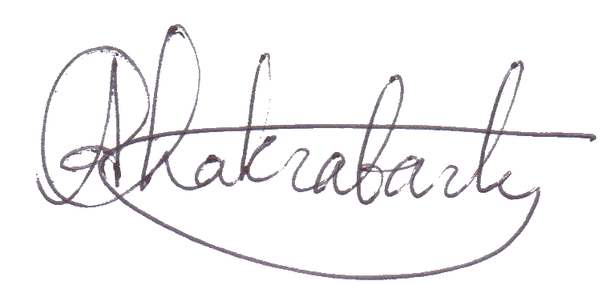
Date: | 28/09/2023
Treasurer name: | Ivan Majic
Treasurer signature:
Date: | 28/09/2023

