The Constitution of Students’ Union UCL

Era Journal

Name

The name of the club/society shall be Students’ Union UCL Era Journal

The club/society shall be affiliated to Students’ Union UCL.

Statement of Intent

The constitution, regulations, management and conduct of the club/society shall abide by all Students’ Union UCL policy, and shall be bound by the Students’ Union UCL Memorandum & Articles of Association, Byelaws, Club and Society Regulations and the club and society procedures and guidance – laid out in the ‘how to guides’.

The club/society stresses that it abides by Students’ Union UCL Equal Opportunities Policies, and that club/society regulations pertaining to membership of the club/society or election to the club/society shall not contravene this policy.

The Club and Society Regulations can be found on the following webpage: http://studentsunionucl.org/content/president-and-treasurer-hub/rules-and-regulations.

The Society Committee

President

The president’s primary role is laid out in section 5.7 of the Club and Society Regulations.

It is the responsibility of the President to maintain the core values of Era Journal, which are as

To provide a quasi-academic online and print publication, which fuses cultural integrity and artistic endeavours

To promote and nurture student talent at UCL

To ensure Era Journal’s content and membership are representative of and accessible to all of UCL’s student community

Treasurer

The treasurer’s primary role is laid out in section 5.8 of the Club and Society Regulations

The Treasurer will also act as Events Manager, and seek to establish Era Journal’s longevity and sustainability through both of these inextricably linked roles

Welfare Officer

The welfare officer’s primary role is laid out in section 5.9 of the Club and Society Regulations.

Additional Committee Members

Editor-in-Chief and Senior Editor will also be voted into their respective positions at the Society’s AGM. Additional committee members will be appointed after the AGM by the incoming and outgoing members.

All committee members, including additional committee members, will maintain Era Journal’s core values, as outlined in 3.2

Management of the club/society shall be vested in the club/society committee which will endeavour to meet regularly during term time (excluding UCL reading weeks) to organise and evaluate club/society activities.

The committee members shall perform the roles as described in section 5 of the Students’ Union UCL Club and Society Regulations.

Committee members are elected to represent the interests and well-being of club/society members and are accountable to their members. If club/society members are not satisfied by the performance of their representative officers they may call for a motion of no-confidence in line with the Students’ Union UCL Club and Society Regulations.

Terms, Aims and Objectives

The Era Journal shall hold the following as its aims and objectives.

The Era Journal shall strive to fulfil these aims and objectives in the course of the academic year as its commitment to its membership.

The core activities of the club/society shall be:

To maintain the integrity of the Society’s online journal

To produce two print publications per academic year

To carry out both of the above in accordance with the core values outlined in 3.2

In addition, the club/society shall also strive to organise other activities for its members where possible:

Host events to publicise Era Journal’s print editions and showcase university talent, artistic endeavours and original work, whilst raising money for the funding of Era Journal’s print editions.

This constitution shall be binding on the club/society officers, and shall only be altered by consent of two-thirds majority of the full members present at a club/society general meeting. The Activities Executive shall approve any such alterations.

This constitution has been approved and accepted as the Constitution for the Students’ Union UCL Era Journal. By signing this document the president and treasurer have declared that they have read and abide by the Students’ Union UCL Club and Society Regulations.

President name: | Thomas Coleman
President signature: | 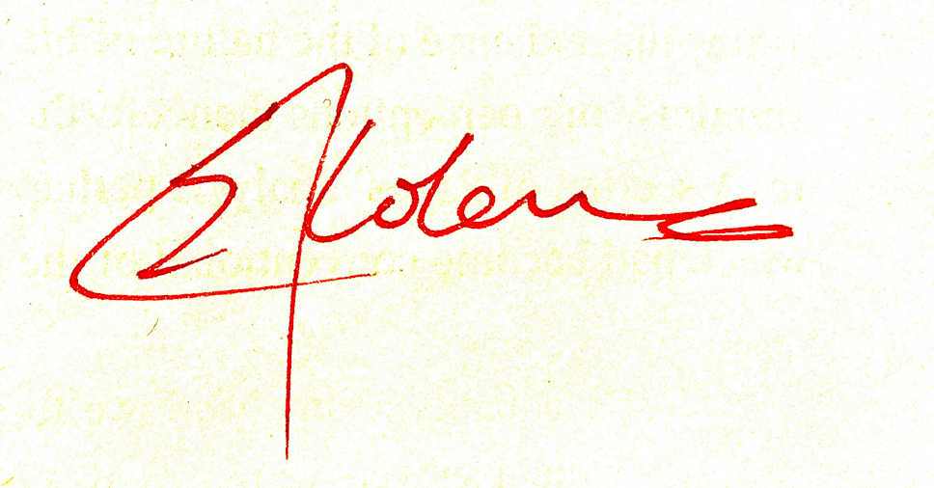
Date: | 30/06/2023
Treasurer name: | Samuel Newton
Treasurer signature: | 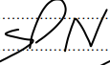
Date: | 30/06/2023

