The Constitution of Students’ Union UCL

UCL SPACE SOCIETY

Name

The name of the club/society shall be Students’ Union UCL Space Society.

The club/society shall be affiliated to Students’ Union UCL.

Statement of Intent

The constitution, regulations, management and conduct of the club/society shall abide by all Students’ Union UCL policy, and shall be bound by the Students’ Union UCL Memorandum & Articles of Association, Byelaws, Club and Society Regulations and the club and society procedures and guidance – laid out in the ‘how to guides’.

The club/society stresses that it abides by Students’ Union UCL Equal Opportunities Policies, and that club/society regulations pertaining to membership of the club/society or election to the club/society shall not contravene this policy.

The Club and Society Regulations can be found on the following webpage: http://studentsunionucl.org/content/president-and-treasurer-hub/rules-and-regulations.

The Society Committee

President

The president’s primary role is laid out in section 5.7 of the Club and Society Regulations.

The president should always be innovative and try to expand the society’s influence across UCL and the Space industry

Treasurer

The treasurer’s primary role is laid out in section 5.8 of the Club and Society Regulations.

The Treasurer should primarily care about the society’s financial security as well as ensuring that there is an increasing cash flow to enabling the society to enhance the quality of the events over the years and the benefits it offers to its members.

Welfare Officer

The welfare officer’s primary role is laid out in section 5.9 of the Club and Society Regulations.

The welfare officer has to remain active all year long as a duty to the members and the committee by being at the initiative of his/her own activities (approved by the Committee and the Student Union if not written in the society’s constitution)

Additional Committee Members

Additional Committee Role Title

A description of specific tasks carried out by the additional committee role should be briefly outlined.

Secretary: In charge of organising the committee meetings, doing a track record, doing surveys, as well as managing the writing/sending of newsletter 1 to 2 times a week and ensuring things go smoothly.
Event officers: Responsible for organising the events and managing them in person to ensure the constitution is respected. They are the ones in charge of it and should make sure rules are respected and risks considered.
Communication officers: ensure that the society is active and well represented on social media (Twitter, Facebook, Instagram, Linkedin): Two posts a week minimum on each of those.
Website Manager: Keep the website updated and improve the number of visitors as well as the society’s visibility using data analysis and coding to automate systems and tasks needed.
Director of External Relationships: In charge of managing the society relationships with the external and UCL organisms. Should keep a record of discussions and collaborations as well as contacts into a Data Base (e.g. HubSpot) to ensure a continuity over the years.

Management of the club/society shall be vested in the club/society committee which will endeavour to meet regularly during term time (excluding UCL reading weeks) to organise and evaluate club/society activities.

The committee members shall perform the roles as described in section 5 of the Students’ Union UCL Club and Society Regulations.

Committee members are elected to represent the interests and well-being of club/society members and are accountable to their members. If club/society members are not satisfied by the performance of their representative officers they may call for a motion of no-confidence in line with the Students’ Union UCL Club and Society Regulations.

Terms, Aims and Objectives

The club/society shall hold the following as its aims and objectives.

The club/society shall strive to fulfil these aims and objectives in the course of the academic year as its commitment to its membership.

The core activities of the club/society shall be:

Stargazing nights, Career events, Socials, Talks, Hackathons, Building a rocket, Academic Learning workshops, Movie nights, Economics, Philosophy and Research events related, etc.

In addition, the club/society shall also strive to organise other activities for its members where possible:

Entrepreneurship and Innovation workshops, Trip to visit space industry sites, Observation trips, More practical workshops, etc.

This constitution shall be binding on the club/society officers, and shall only be altered by consent of two-thirds majority of the full members present at a club/society general meeting. The Activities Executive shall approve any such alterations.

This constitution has been approved and accepted as the Constitution for the Students’ Union UCL Space Society. By signing this document the president and treasurer have declared that they have read and abide by the Students’ Union UCL Club and Society Regulations.

President name: | Shourya Shrivastava
President signature:
Date: | 23/06/2023
Treasurer name: | Ehi Robinson
Treasurer signature: | 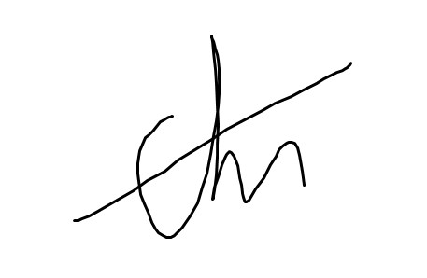
Date: | 23/06/2023

