The Constitution of Students’ Union UCL

Science Magazine Society

Name

The name of the club/society shall be Students’ Union UCL Science Magazine.

The club/society shall be affiliated to Students’ Union UCL.

Statement of Intent

The constitution, regulations, management and conduct of the club/society shall abide by all Students’ Union UCL policy, and shall be bound by the Students’ Union UCL Memorandum & Articles of Association, Byelaws, Club and Society Regulations and the club and society procedures and guidance – laid out in the ‘how to guides’.

The club/society stresses that it abides by Students’ Union UCL Equal Opportunities Policies, and that club/society regulations pertaining to membership of the club/society or election to the club/society shall not contravene this policy.

The Club and Society Regulations can be found on the following webpage: http://studentsunionucl.org/content/president-and-treasurer-hub/rules-and-regulations.

The Society Committee

President

The president’s primary role is laid out in section 5.7 of the Club and Society Regulations.

Treasurer

The treasurer’s primary role is laid out in section 5.8 of the Club and Society Regulations.

Welfare Officer

The welfare officer’s primary role is laid out in section 5.9 of the Club and Society Regulations.

Additional Committee Members

Vice-President

The Vice president is responsible for acquiring sponsorships outside the university from firms and institutions, alongside this they must support other committee members, specifically the president, treasurer and welfare officer.

Social Secretary

To organise social events for the society with the help of the President and Treasurer. Overlook social media with the IT and graphic design officer.

IT and Graphic Design officer

To create and maintain the website, upload articles when new ones are written, help the social secretary with social media.

Chief editor

Proofread all articles, ensures all sources are suitable and reliable. Delegate articles to be checked for accuracy with appropriate subject specialised editor. Often articles will be between several sciences, hence multiple editors will have to check certain articles. Will attend Libel training and ensure articles do not contain libel.

Physics editor

This editor will ensure all Physics is accurate in any Physics related articles written by society members. They will also write Physics articles on occasion for the society.

Chemistry editor

This editor will ensure all Chemistry is accurate in any Chemistry related articles written by society members. They will also write Chemistry articles on occasion for the society.

Biology editor

This editor will ensure all Biology is accurate in any Biology related articles written by society members. They will also write Biology articles on occasion for the society.

Technology editor

3.11 This editor will ensure all Computer Science/Engineering is accurate in any Technology related articles written by society members. They will also write Technology articles on occasion for the society.

3.12 Management of the club/society shall be vested in the club/society committee which will endeavour to meet regularly during term time (excluding UCL reading weeks) to organise and evaluate club/society activities.

3.13 The committee members shall perform the roles as described in section 5 of the Students’ Union UCL Club and Society Regulations.

3.14 Committee members are elected to represent the interests and well-being of club/society members and are accountable to their members. If club/society members are not satisfied by the performance of their representative officers they may call for a motion of no-confidence in line with the Students’ Union UCL Club and Society Regulations.

Terms, Aims and Objectives

The club/society shall hold the following as its aims and objectives.

The club/society shall strive to fulfil these aims and objectives in the course of the academic year as its commitment to its membership.

The core activities of the club/society shall be:

An online magazine consisting of regular articles and newsletters, with a termly supplementary physical magazine and visual media such as informational interviews.

In addition, the club/society shall also strive to organise other activities for its members where possible:

Pub crawl between 3 pubs around Bloomsbury where we will have students meet each other and discuss their interests in science and socialise with other students outside of their course. It will also help students explore Bloomsbury in the safety of older students who know the area well.

Picnic Social, casual social in Welcome Week for students to meet and socialise, who may have not wanted to attend the pub crawl to be inclusive of those who do not drink alcohol or wish to be in a pub environment.

Science quiz, a social at the start of term 2 to help encourage students to learn about sciences outside of their discipline and socialise with other students interested in science.

A formal ball to commemorate the achievements of the society members and success of the society.

This constitution shall be binding on the club/society officers, and shall only be altered by consent of two-thirds majority of the full members present at a club/society general meeting. The Activities Executive shall approve any such alterations.

This constitution has been approved and accepted as the Constitution for the Students’ Union UCL Science Magazine Society. By signing this document the president and treasurer have declared that they have read and abide by the Students’ Union UCL Club and Society Regulations.

President name: | Imogen Canell
President signature: | 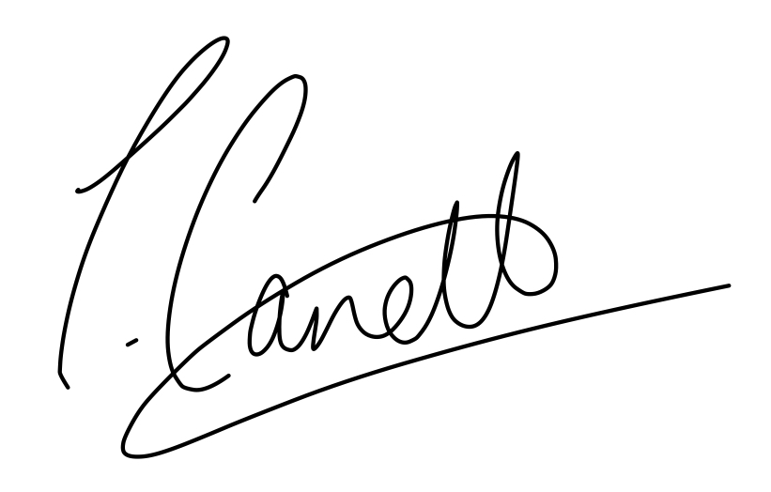
Date: | 23/06/2023
Treasurer name: | Maleeha Mughal
Treasurer signature:
Date: | 23/06/2023

