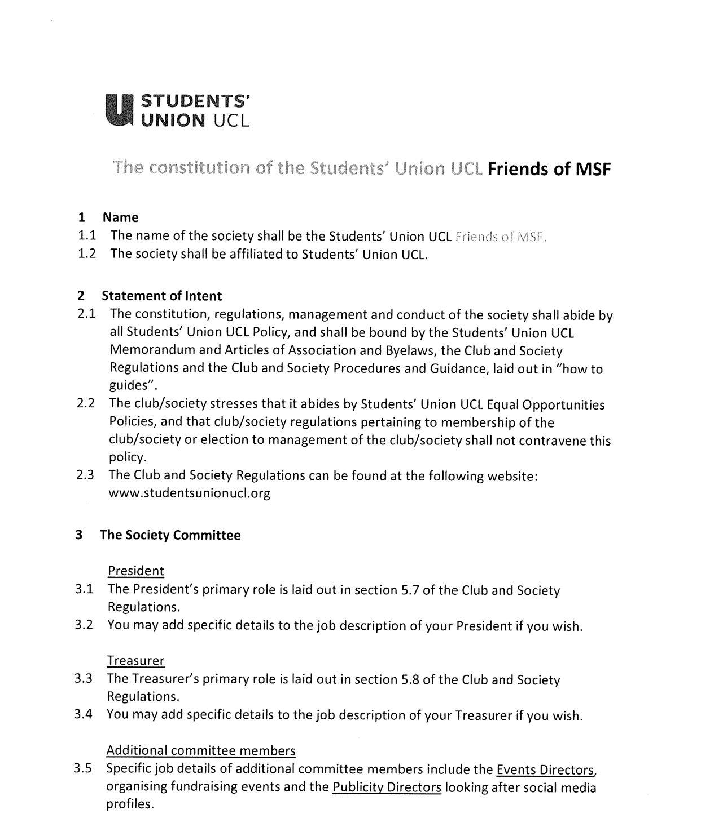
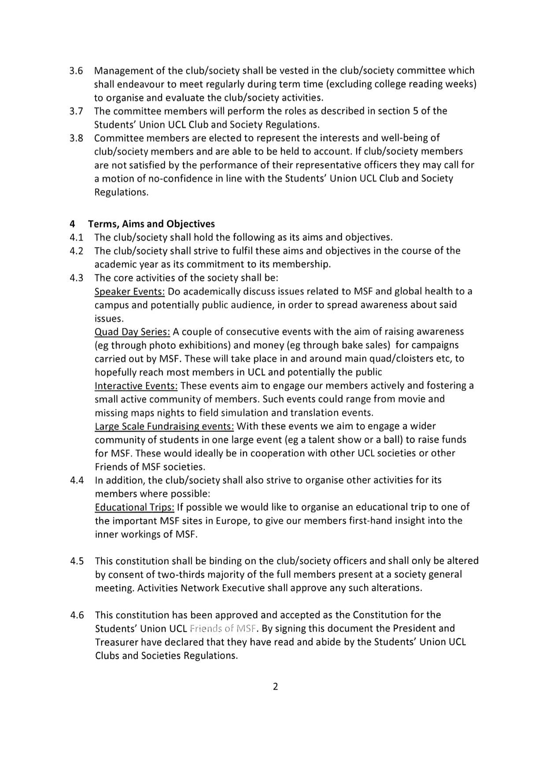

President name: Emil Lecointe
Date: 17^{th June} 2023
Treasurer name: Srishruthi Thirumalai
Date: 17th June 2023

