The Constitution of Students’ Union UCL

Esperanto and Endangered Languages

Name

The name of the club/society shall be Students’ Union UCL Esperanto and Endangered Languages Society.

The club/society shall be affiliated to Students’ Union UCL.

Statement of Intent

The constitution, regulations, management and conduct of the club/society shall abide by all Students’ Union UCL policy, and shall be bound by the Students’ Union UCL Memorandum & Articles of Association, Byelaws, Club and Society Regulations and the club and society procedures and guidance – laid out in the ‘how to guides’.

The club/society stresses that it abides by Students’ Union UCL Equal Opportunities Policies, and that club/society regulations pertaining to membership of the club/society or election to the club/society shall not contravene this policy.

The Club and Society Regulations can be found on the following webpage: http://studentsunionucl.org/content/president-and-treasurer-hub/rules-and-regulations.

The Society Committee

President

The president’s primary role is laid out in section 5.7 of the Club and Society Regulations.

Treasurer

The treasurer’s primary role is laid out in section 5.8 of the Club and Society Regulations.

Welfare Officer

The welfare officer’s primary role is laid out in section 5.9 of the Club and Society Regulations.

Additional Committee Members

Any additional committee positions you have should be outlined in your constitution below.

Social Secretary - Helps to organise events and promote on social media accounts
Vice President- Ensures everything is running smoothly and assists the president and represents the president when they are not there

Chair – Usually the President/Vice President/other committee member from previous year, helps with the transition of the committees and running of the society and helps the president
Language classes coordinator - Ensures that the language classes are running smoothly and helps recruit teachers, ensures teachers are getting paid and helps sort out problems, etc.
Media officer – creates graphic for social media, helps with graphics for Youtube videos, helps with graphics for lessons/events if needed
Esperanto officer – Helps with the running of Esperanto lessons and events, writes/translates emails and other texts in Esperanto for engagement, assists with Bookclub events if in Esperanto
Conlanging Officers (x2) – Run the conlanging sessions and help with translation etc
Head of magazine – Runs the magazine aspect of the society
Magazine editors (x2) – Help out with the running of the magazine
Diversity and inclusion officer – Helps ensure that events are accessible, helps ensure that events are done sensitively and appropriately, ensures that there is diversity in the languages being taught
Language teachers – depending on the year – teach the specific language

Management of the club/society shall be vested in the club/society committee which will endeavour to meet regularly during term time (excluding UCL reading weeks) to organise and evaluate club/society activities.

The committee members shall perform the roles as described in section 5 of the Students’ Union UCL Club and Society Regulations.

Committee members are elected to represent the interests and well-being of club/society members and are accountable to their members. If club/society members are not satisfied by the performance of their representative officers they may call for a motion of no-confidence in line with the Students’ Union UCL Club and Society Regulations.

Terms, Aims and Objectives

The club/society shall hold the following as its aims and objectives.

The club/society shall strive to fulfil these aims and objectives in the course of the academic year as its commitment to its membership.

The core activities of the club/society shall be:

Language Classes for Esperanto
Language Classes for endangered/constructed languages (to vary each year), including languages such as Cornish, Faroese, Polari, Occitan, Shanghainese etc.
Talks/discussions about Esperanto and endangered languages
Taster sessions of endangered and constructed languages
Conlanging sessions, where members will create and teach their own constructed language(s)
Magazine publishing – creating a termly magazine filled with language articles
Socials (such as speed friendings, movie nights, quiz/Kahoot sessions, picnics, pub socials etc)
Talks from academics etc about endangered languages

In addition, the club/society shall also strive to organise other activities for its members where possible:
Collabs with other societies/organisations/unis
Study sessions and study tips

Learn a language together – where members will choose a language and learn it together
Fundraisers and information sessions to spread awareness and help make change
Trips to bookshops/museums
Trips to places where endangered languages are spoken
Bonding/social trips and activities (e.g. ice-skating, picnics)
Bi-termly bookclub
Annual karaoke night
Talks and discussions about language related things (e.g. differing dialects)

This constitution shall be binding on the club/society officers, and shall only be altered by consent of two-thirds majority of the full members present at a club/society general meeting. The Activities Executive shall approve any such alterations.

This constitution has been approved and accepted as the Constitution for the Students’ Union UCL Esperanto and Endangered Languages Society. By signing this document the president and treasurer have declared that they have read and abide by the Students’ Union UCL Club and Society Regulations.

President name: | Danilo Paganelli
President signature: | 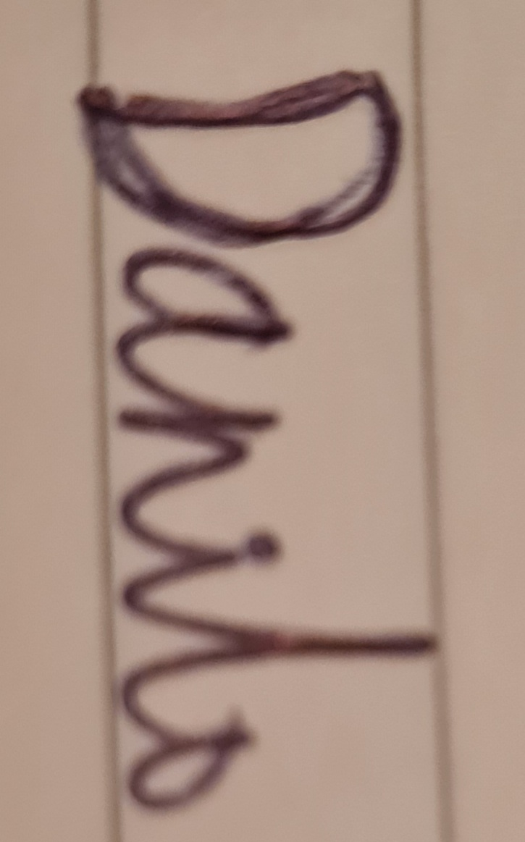
Date: | 28/06/2023
Treasurer name: | Alex Bhandarkar
Treasurer signature:
Date: | 28/06/2023

