The Constitution of Students’ Union UCL

Sexpression

Name

The name of the club/society shall be Students’ Union UCL Sexpression.

The club/society shall be affiliated to Students’ Union UCL.

Statement of Intent

The constitution, regulations, management and conduct of the club/society shall abide by all Students’ Union UCL policy, and shall be bound by the Students’ Union UCL Memorandum & Articles of Association, Byelaws, Club and Society Regulations and the club and society procedures and guidance – laid out in the ‘how to guides’.

The club/society stresses that it abides by Students’ Union UCL Equal Opportunities Policies, and that club/society regulations pertaining to membership of the club/society or election to the club/society shall not contravene this policy.

The Club and Society Regulations can be found on the following webpage: http://studentsunionucl.org/content/president-and-treasurer-hub/rules-and-regulations.

The Society Committee

President

The president’s primary role is laid out in section 5.7 of the Club and Society Regulations.

Treasurer

The treasurer’s primary role is laid out in section 5.8 of the Club and Society Regulations.

Welfare Officer

The welfare officer’s primary role is laid out in section 5.9 of the Club and Society Regulations.

.

Additional Committee Members

Training officer

Ensure all session leaders have had required training to teach sessions before going into schools
- Organise and coordinate session leader training

Child protection officer
- Attend national child protection training and deliver training to session leaders before they teach in schools
- Check and coordinate DBS checks
- Point of contact for incident reporting

Events officer

Arrange events: speaker events, socials, campaigns, drives

Schools leads

Timetable and organise volunteers for teaching sessions in schools (or to UCL clubs and societies)

Inclusivity officer
- Ensures that all events and aspects of the society are inclusive and accessible.

Outreach

Communicates with members through the newsletter and emails

Graphic design lead

Creates posts for the social media accounts
- Monitors the social media accounts.

Management of the club/society shall be vested in the club/society committee which will endeavour to meet regularly during term time (excluding UCL reading weeks) to organise and evaluate club/society activities.

The committee members shall perform the roles as described in section 5 of the Students’ Union UCL Club and Society Regulations.

Committee members are elected to represent the interests and well-being of club/society members and are accountable to their members. If club/society members are not satisfied by the performance of their representative officers they may call for a motion of no-confidence in line with the Students’ Union UCL Club and Society Regulations.

Terms, Aims and Objectives

The club/society shall hold the following as its aims and objectives.

The club/society shall strive to fulfil these aims and objectives in the course of the academic year as its commitment to its membership.

The core activities of the club/society shall be:
- Training weekend or evening sessions for UCL student volunteers to learn RSE content to teach in secondary schools in future years.
- Deliver Relationship and Sex Education to 11-18 year olds in London secondary schools
- Offer training as an SSC for medical students, and any subject where SSC options are available.

In addition, the club/society shall also strive to organise other activities for its members where possible:
- Speaker events and discussions on topics relevant to sexual health.
- Social events such as pub quizzes and discussion groups.
- Facilitate consent workshops for UCL students and societies.

This constitution shall be binding on the club/society officers, and shall only be altered by consent of two-thirds majority of the full members present at a club/society general meeting. The Activities Executive shall approve any such alterations.

This constitution has been approved and accepted as the Constitution for the Students’ Union UCL Sexpression. By signing this document the president and treasurer have declared that they have read and abide by the Students’ Union UCL Club and Society Regulations.

President name: | India Deans-Smith
President signature: | 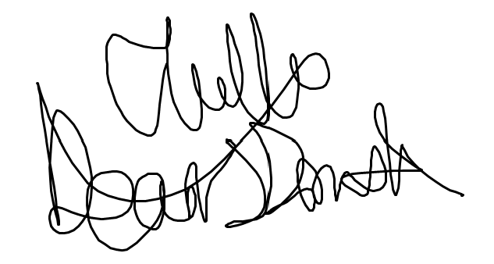
Date: | 19/6/22
Treasurer name:
Treasurer signature:
Date:

