The Constitution of Students’ Union UCL

International Relations Society

Name

The name of the club/society shall be Students’ Union UCL International Relations Society.

The club/society shall be affiliated to Students’ Union UCL.

Statement of Intent

The constitution, regulations, management and conduct of the club/society shall abide by all Students’ Union UCL policy, and shall be bound by the Students’ Union UCL Memorandum & Articles of Association, Byelaws, Club and Society Regulations and the club and society procedures and guidance – laid out in the ‘how to guides’.

The club/society stresses that it abides by Students’ Union UCL Equal Opportunities Policies, and that club/society regulations pertaining to membership of the club/society or election to the club/society shall not contravene this policy.

The Club and Society Regulations can be found on the following webpage: http://studentsunionucl.org/content/president-and-treasurer-hub/rules-and-regulations.

The Society Committee

President

The president’s primary role is laid out in section 5.7 of the Club and Society Regulations.

Treasurer

The treasurer’s primary role is laid out in section 5.8 of the Club and Society Regulations.

Welfare Officer

The welfare officer’s primary role is laid out in section 5.9 of the Club and Society Regulations.

Additional Committee Members

Additional Committee Members
    - General Manager
- To assist in managing the administrative affairs of the society.
    - Academic events director
- To organise academic events related to international relations and affairs for members
    - Social events director
- To organise regular social events for society members. To also ensure that social events are inclusive for everyone.
    - Secretary
- To schedule committee meetings, including AGM, and to record minutes during these meetings. Secretary is also to ensure that committee members are present during these meetings.
    - First-Year Rep
- To represent and advocate the views of first year students. To encourage first year student participation in the society and increase communication between first year student members and the committee. To provide assistance to other committee members, e.g. academic and social events directors, when organising large-scale events.
    - Circum Mundum Editor-in-Chief

To oversee the society’s journal, Circum Mundum, through delegating, editing and approving its publications by working with a team of columnists and cartoonists.

Management of the club/society shall be vested in the club/society committee which will endeavour to meet regularly during term time (excluding UCL reading weeks) to organise and evaluate club/society activities.

The committee members shall perform the roles as described in section 5 of the Students’ Union UCL Club and Society Regulations.

Committee members are elected to represent the interests and well-being of club/society members and are accountable to their members. If club/society members are not satisfied by the performance of their representative officers they may call for a motion of no-confidence in line with the Students’ Union UCL Club and Society Regulations.

Terms, Aims and Objectives

The club/society shall hold the following as its aims and objectives.

The club/society shall strive to fulfil these aims and objectives in the course of the academic year as its commitment to its membership.

The core activities of the club/society shall be:
    - Speaker events at UCL on topics related to International Relations and political affairs
    - Panel discussions involving professors and students
    - Social events for members
    - Joint events with related societies

In addition, the club/society shall also strive to organise other activities for its members where possible:
    - Visits to prominent think tanks, academic journals, embassies, and relevant government departments in the UK
    - Dinner events with leading academics and practitioners in the realm of international relations
    - Annual charity dinner

This constitution shall be binding on the club/society officers and shall only be altered by consent of two-thirds majority of the full members present at a club/society general meeting. The Activities Zone shall approve any such alterations.

This constitution has been approved and accepted as the Constitution for the Students’ Union UCL International Relations Society. By signing this document the president and treasurer have declared that they have read and abide by the Students’ Union UCL Club and Society Regulations.

President name: | Abdulaziz Al-Marri
President signature: | 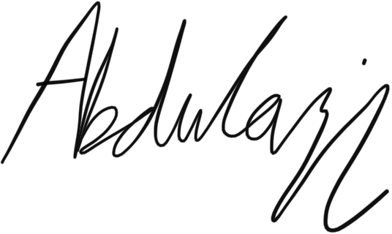
Date: | 30/06/2022
Treasurer name: | Chiara Aylett
Treasurer signature: | 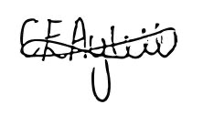
Date: | 30/06/2022

