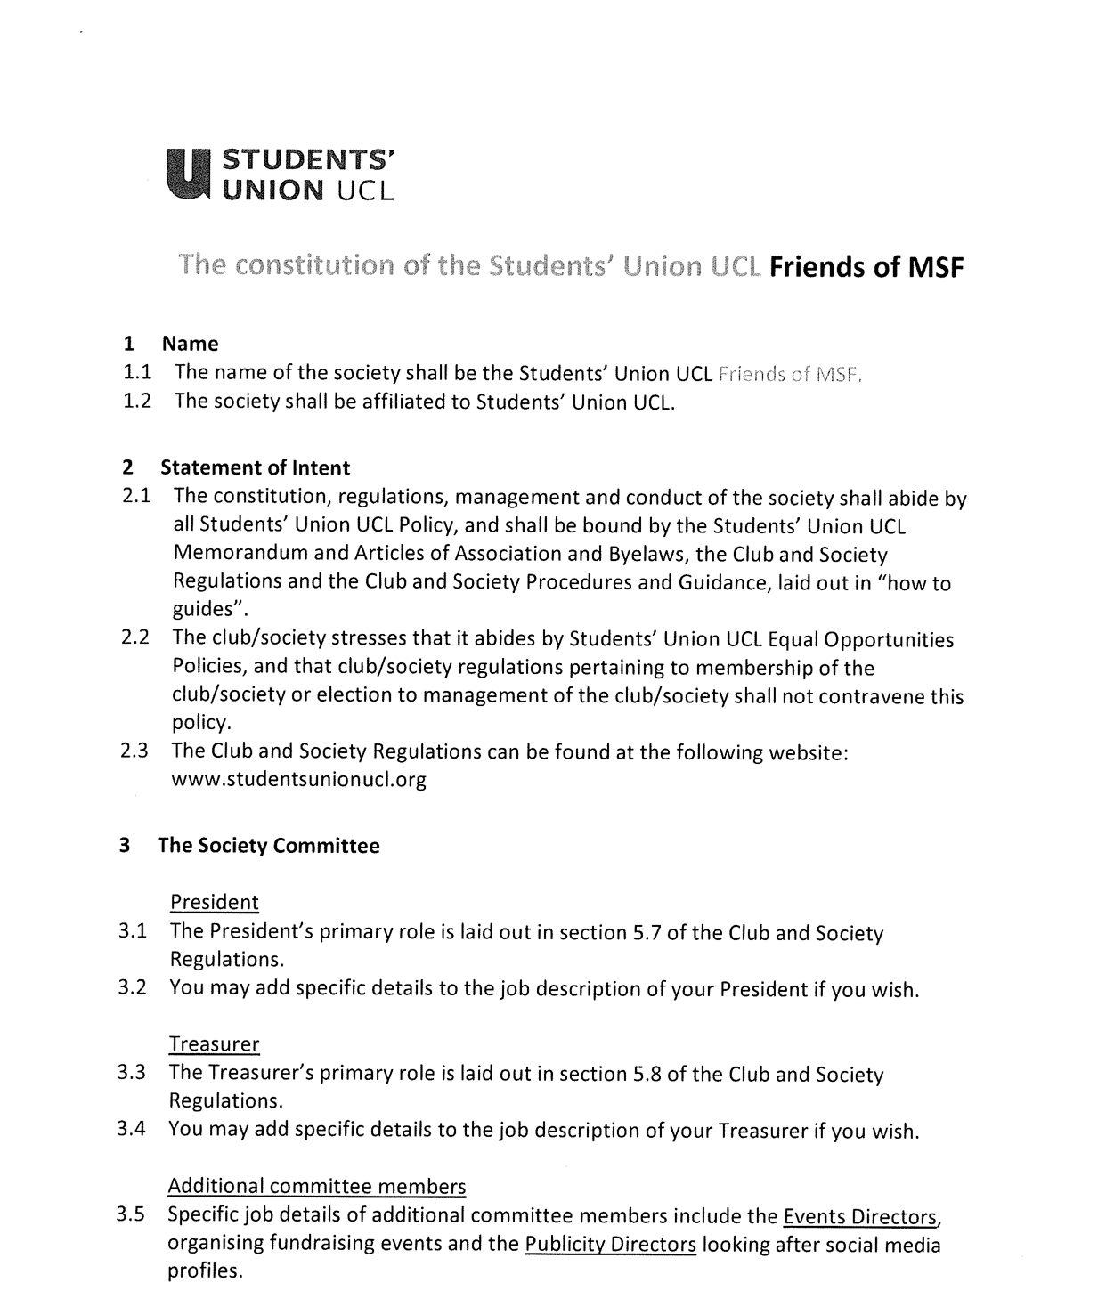
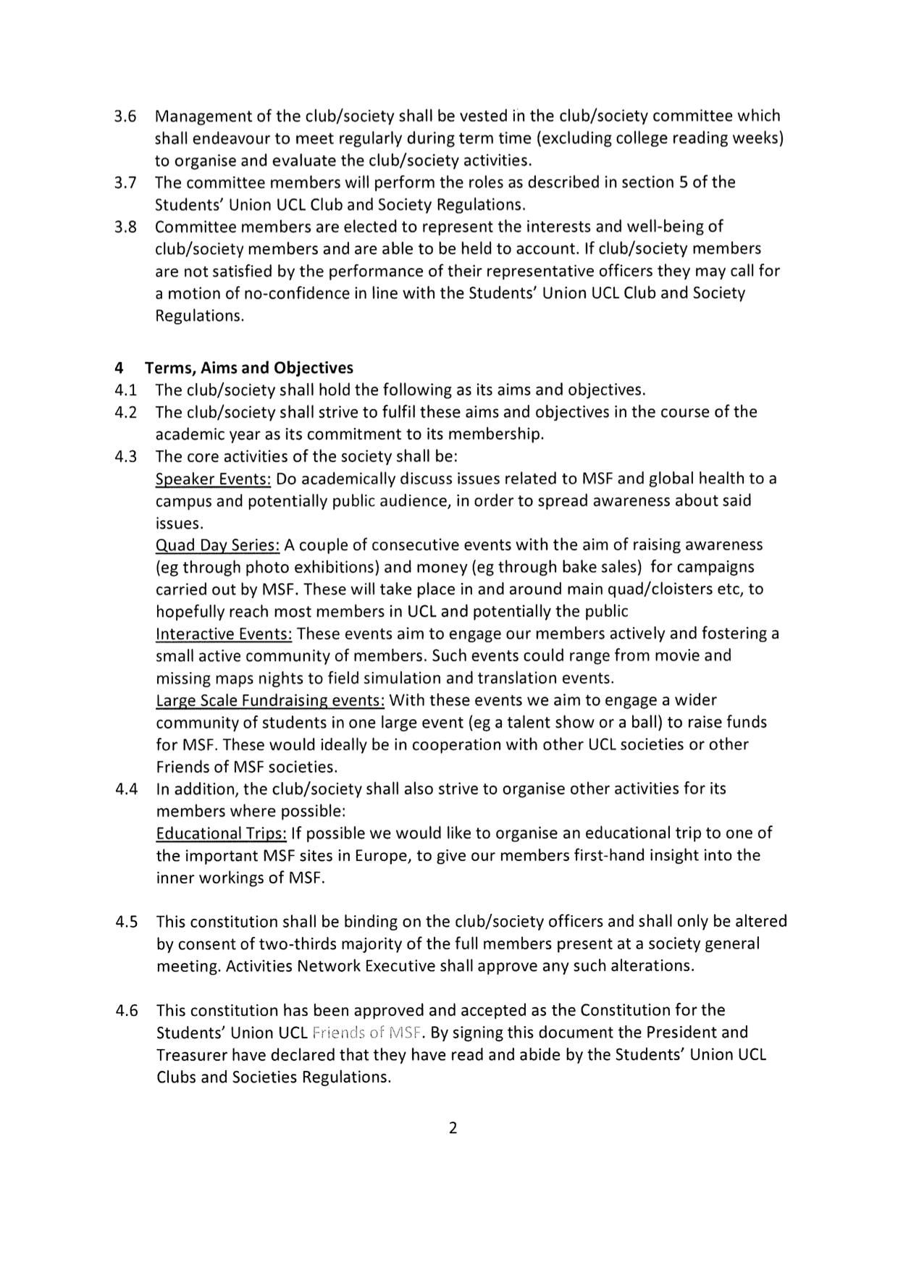

President name: Nicole Robinson
Date: 1st July 2022
Treasurer name: Telma Martins Viveiros
Date: 1st July 2022

