The Constitution of Students’ Union UCL

RUMS Men’s Football CLUB

Name

The name of the club/society shall be Students’ Union UCL RUM’S MEN’S FOOTBALL CLUB

The club/society shall be affiliated to Students’ Union UCL.

Statement of Intent

The constitution, regulations, management and conduct of the club/society shall abide by all Students’ Union UCL policy, and shall be bound by the Students’ Union UCL Memorandum & Articles of Association, Byelaws, Club and Society Regulations and the club and society procedures and guidance – laid out in the ‘how to guides’.

The club/society stresses that it abides by Students’ Union UCL Equal Opportunities Policies, and that club/society regulations pertaining to membership of the club/society or election to the club/society shall not contravene this policy.

The Club and Society Regulations can be found on the following webpage: http://studentsunionucl.org/content/president-and-treasurer-hub/rules-and-regulations.

The Society Committee

President

The president’s primary role is laid out in section 5.7 of the Club and Society Regulations.

Treasurer

The treasurer’s primary role is laid out in section 5.8 of the Club and Society Regulations.

Welfare Officer

The welfare officer’s primary role is laid out in section 5.9 of the Club and Society Regulations.
3.3.2 Along with the President, shall check up on members who don’t seem themselves or seem to be struggling

Additional Committee Members
3.4 Social Secretaries
3.4.1 Shall organise Sports Night and other social events throughout the year
3.4.2 Shall aid the President in organising Fresher Tour and NAMS tour
3.4.3 Shall aim to fully integrate all members of the club into socials, by organising a wide range of activities
3.5 Educational Secretaries
3.5.1 Shall organise tutorials on most preclinical modules as well as OSCE practise to both clinical and preclinical members.
3.5.2 Shall pair bsc students with older members who did the same bsc to provide advice from their past experience
3.6 Volunteering Secretary
3.6.1 Shall maintain the clubs volunteering links
3.6.2 Shall keep the rest of the club informed on the volunteering schemes in place
3.6.3 Shall recruit members of the club into the volunteering schemes in place 3
3.7 Team Captains
3.7.1 Shall run trials at the start of the season with the help of the president
3.7.2 Shall run weekly training sessions for their teams and encourage as many people as possible to turn up to training
3.7.3 Shall reschedule and fixtures which are cancelled due to weather or player unavailability
3.8 Management of the club/society shall be vested in the club/society committee which shall endeavour to meet regularly during term time (excluding college reading weeks) to organise and evaluate the club/society activities.
3.9 The committee members will perform the roles as described in section 5 of the Students’ Union UCL Club and Society Regulations.
3.10 Committee members are elected to represent the interests and wellbeing of club/society members and are able to be held to account. If club/society members are not satisfied by the performance of their representative officers they may call for a motion of no-confidence in line with the Students’ Union UCL Club and Society Regulations.
4 Terms, Aims and Objectives
4.1 The club/society shall hold the following as its aims and objectives:
4.1.1 Aim 1 To enter 4 teams into BUCs and LUSL competitions, with each able to consistently have sufficient players to meet the fixture demands
4.1.2 Aim 2 To compete in the United Hospitals Cup and the National Association of Medical Schools (NAMS) tournament
4.1.3 Aim 3 To provide a welcoming social environment both for current members and incoming members by organising several club and team socials throughout the year
4.1.4 Aim 4 To organise a tour to another medical school in the UK to help integrate new member into the club
4.1.5 Aim 5 To organise the annual Johns’ Cup 1st year vs 2nd year match
4.1.6 Aim 6 To restart the formerly annual ‘Presidents’ Day’ which brings together the whole club, involves a Doctors vs Students match, a BBQ and a social in the evening
4.1.7 Aim 7 Provide the opportunity for members to buy RUMS FC kit and merchandise
4.1.8 Aim 8 Maintain the activity of the clubs Instagram/ Twitter/ Facebook pages and send out weekly emails to keep members up to date with club activities
4.1.9 Aim 9 Maintain the volunteering with UCL academy with the potential to expand our links 4.1.10 Aim 10 To continue the charity football tournament between RUMS clubs, which proved successful last year
4.1.11 Aim 11 To provide regular tutorials for our pre clinical students as well as OSCE practise for clinical members closer
4.1.12 Aim 12 To organise weekly training at a convenient time and location to boost turnout
4.1.13 Aim 13 To increase membership by 20%
4.2 The club/society shall strive to fulfil these aims and objectives in the course of the academic year as its commitment to its membership.
4.3 The core activities of the society shall be:
4.3.1 Football matches twice a week for our 4 teams
4.3.2 Weekly training sessions
4.3.3 Competing in the United Hospitals Cup
4.3.4 Trials at the beginning of the year
4.4 In addition, the club/society shall also strive to organise other activities for its members where possible:
4.4.1 A football tour at the start of the year
4.4.2 Competing in the National Association Medical Schools Association (NAMS) tournament 4.4.3 John’s cup (see description above)
4.4.4 President’s Day (see description above)
4.4.5 Weekly Wednesday Sports Nights 5
4.4.6 Regular club and team meals
4.4.7 Volunteering opportunities
4.4.8 Charity football tournament
4.4.9 Multiple educational events throughout the year
4.5 This constitution shall be binding on the club/society officers and shall only be altered by consent of two-thirds majority of the full members present at a society general meeting. Activities Network Executive shall approve any such alterations.
4.6 This constitution has been approved and accepted as the Constitution for the Students’ Union UCL RUMS Men’s Football Club. By signing this document, the President and Treasurer have declared that they have read and abide by the Students’ Union UCL Clubs and Societies Regulations.

President name: | Casper Carlsson Metcalf
President signature:
Date: | 2/08/2022
Treasurer name: | Liam Patel
Treasurer signature: | 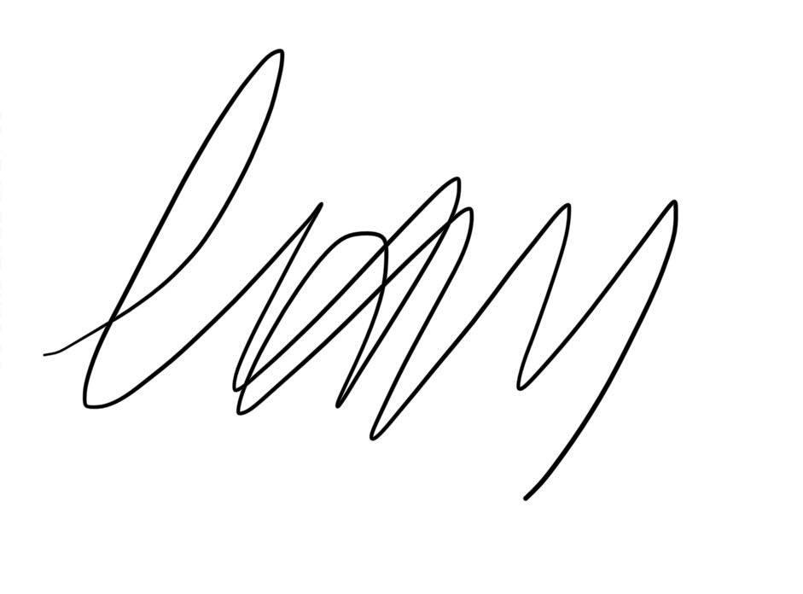
Date: | 2/08/2022

