The Constitution of Students’ Union UCL

DANCE SOCIETY

Name

The name of the club/society shall be Students’ Union UCL Dance Society.

The club/society shall be affiliated to Students’ Union UCL.

Statement of Intent

The constitution, regulations, management and conduct of the club/society shall abide by all Students’ Union UCL policy, and shall be bound by the Students’ Union UCL Memorandum & Articles of Association, Byelaws, Club and Society Regulations and the club and society procedures and guidance – laid out in the ‘how to guides’.

The club/society stresses that it abides by Students’ Union UCL Equal Opportunities Policies, and that club/society regulations pertaining to membership of the club/society or election to the club/society shall not contravene this policy.

The Club and Society Regulations can be found on the following webpage: http://studentsunionucl.org/content/president-and-treasurer-hub/rules-and-regulations.

The Society Committee

President

The president’s primary role is laid out in section 5.7 of the Club and Society Regulations.

Treasurer

The treasurer’s primary role is laid out in section 5.8 of the Club and Society Regulations.

Welfare Officer

The welfare officer’s primary role is laid out in section 5.9 of the Club and Society Regulations.

Additional Committee Members

Vice President. The Vice President’s primary role is to assist and aid the President whenever necessary.

Liaison Officer. The Liaison officer is to be the first point of contact of Dance Society for all our professional teachers outside UCL. This includes communication relating to invoices.

Social Secretary. The Social Secretary is responsible for organising all socials, which we aim to provide once a fortnight.

Competitions Coordinator. The Competitions Coordinator is in charge of organising the competition team and for planning the logistics for attending external competitions. This includes organising transport, liaising with host universities, and overseeing all competition team activity.

Bloomsbury Producer. The Bloomsbury Producer is responsible for producing the annual production that takes place in the Bloomsbury Theatre. They also are responsible for putting together a production team for the event.

Management of the club/society shall be vested in the club/society committee which will endeavour to meet regularly during term time (excluding UCL reading weeks) to organise and evaluate club/society activities.

The committee members shall perform the roles as described in section 5 of the Students’ Union UCL Club and Society Regulations.

Committee members are elected to represent the interests and well-being of club/society members and are accountable to their members. If club/society members are not satisfied by the performance of their representative officers they may call for a motion of no-confidence in line with the Students’ Union UCL Club and Society Regulations.

Terms, Aims and Objectives

The club/society shall hold the following as its aims and objectives.

The club/society shall strive to fulfil these aims and objectives in the course of the academic year as its commitment to its membership.

The core activities of the club/society shall be:

To put on classes, for beginners and experienced dancers in Jazz, Ballet, Contemporary, Tap, Hip-hop, Street and Break dance on a weekly basis throughout term time.

4.3.2 To host workshops in particular styles and choreography, given by professionals in terms 1 and 2 and to be student-led in term 3.
4.3.3 To produce a Bloomsbury Theatre production in term 2, for which auditions will be used to cast the show.

4.3.4 To produce a Freshers’ show, a Leavers’ Show, a Triple Bill Charity Show, a 24 Hour Charity Show, a Class Showcase and a Season Finale.
4.3.5 To provide fortnightly socials for members.

4.3.6 To produce an inter-university Dance competition, TranscenDance.
4.3.7 To put together a competition team, by which members are selected for through auditions, which competed at 2 external inter-university competitions.

4.3.8 To offer volunteering opportunities to our members; Dance It! In term 1, where members teach different dance styles in youth centres/schools and then the Bloomsbury workshop in term 2, where the society partners with an organisation or community centre and teaches snippets of our Bloomsbury choreography.

4.3.9 To offer opportunities for new members and dancers, through taster days.

In addition, the club/society shall also strive to organise other activities for its members where possible:

These are the activities that you would like to carry out every academic year if you can. The Union will support these activities but not fund them.

This constitution shall be binding on the club/society officers and shall only be altered by consent of two-thirds majority of the full members present at a club/society general meeting. The Activities Executive shall approve any such alterations.

This constitution has been approved and accepted as the Constitution for the Students’ Union UCL Dance Society. By signing this document the president and treasurer have declared that they have read and abide by the Students’ Union UCL Club and Society Regulations.

President name: | Emma Bosson McEvaddy
President signature: | 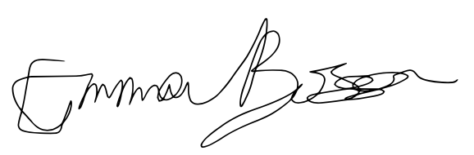
Date: | 30/06/2022
Treasurer name: | Sophie Xu-Tang
Treasurer signature: | 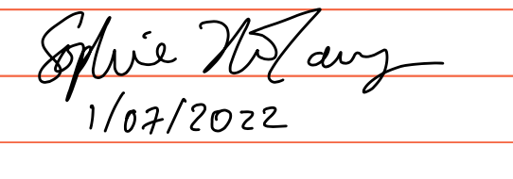
Date:

