The Constitution of Students’ Union UCL

Cancer Charities Alliance Society

Name

The name of the club/society shall be Students’ Union UCL Cancer Charities Alliance Society.

The club/society shall be affiliated to Students’ Union UCL.

Statement of Intent

The constitution, regulations, management and conduct of the club/society shall abide by all Students’ Union UCL policy, and shall be bound by the Students’ Union UCL Memorandum & Articles of Association, Byelaws, Club and Society Regulations and the club and society procedures and guidance – laid out in the ‘how to guides’.

The club/society stresses that it abides by Students’ Union UCL Equal Opportunities Policies, and that club/society regulations pertaining to membership of the club/society or election to the club/society shall not contravene this policy.

The Club and Society Regulations can be found on the following webpage: http://studentsunionucl.org/content/president-and-treasurer-hub/rules-and-regulations.

The Society Committee

President

The president’s primary role is laid out in section 5.7 of the Club and Society Regulations.
- External communications
- Organise overall plan for the year
- Support the rest of the committee

Treasurer

The treasurer’s primary role is laid out in section 5.8 of the Club and Society Regulations.

Welfare Officer

The welfare officer’s primary role is laid out in section 5.9 of the Club and Society Regulations.

Additional Committee Members
Events Officer
· Support the president and committee in organising events, lead the events team who will support the officer with organising and planning events
Publicity Officer
· Support the Events officer and team in planning and publicising events, support all teams and the president and wider committee with the monthly newsletter
Medical Officer
· Acts as a key touchpoint between the CCA and UCL Medical School, Supports the education of both medical and non-medical students on issues related to cancer, being creative and trying to find ways to collaborate with either institution and their staff and student body
Cancer Institute Representative
· Acts as a key touchpoint between the CCA and Cancer Institute, supports the education of both medical and non-medical students on issues related to cancer, being creative and trying to find ways to collaborate with either institution and their staff and student body
Academic Officer
· Leads the academic team to hold educational events such as lectures, conferences and campaigns
Volunteering Officer
· Finds volunteering opportunities related to cancer, public health and caring for society members to get involved with, supports the president with reaching out to charities and other external groups to further the aims of the society
Campaigns Officer
· Lead the Campaigns team in engaging with policy groups and campaigning for early diagnosis, intervention and better-quality treatment for cancer patients
· Support the president on different cancer awareness campaigns and think of ways to engage with the UCL student body to promote the effectiveness of such campaigns
Freshers Representative
· Coordinate with other officers to organise academic, volunteering and fundraising events
· Support freshers or anyone new to the society by organising events which increase their sense of belonging to the society
· Acts as a touchpoint between freshers and the society and delivers their opinions to the committee

Management of the club/society shall be vested in the club/society committee which will endeavour to meet regularly during term time (excluding UCL reading weeks) to organise and evaluate club/society activities.

The committee members shall perform the roles as described in section 5 of the Students’ Union UCL Club and Society Regulations.

Committee members are elected to represent the interests and well-being of club/society members and are accountable to their members. If club/society members are not satisfied by the performance of their representative officers they may call for a motion of no-confidence in line with the Students’ Union UCL Club and Society Regulations.

Terms, Aims and Objectives

The club/society shall hold the following as its aims and objectives.

The club/society shall strive to fulfil these aims and objectives in the course of the academic year as its commitment to its membership.

The core activities of the club/society shall be:
- Introduce volunteering opportunities that involve helping in finding advocacy programs such as the National Cancer Institute and Macmillan Cancer Support to promote mental health and wellbeing.
- To improve understanding of cancer among students by educating them about the importance of cancer screening and early detection, as well as other cancer-related issues through social platforms.
- Create a cancer community group (e.g., cancer awareness roadshow) to raise awareness on campus offering an in-depth and confidential chat with healthcare professionals about cancer prevention.
- Get involved in fundraising events and social events such as bake sales, selling second-hand clothing and other used items such as books, where 100% of the profits from each sale will be donated to local cancer charities.
- Organise conferences or talks in collaboration with departments at the Institute of Cancer Research and other professional researchers to tackle cancer-related issues, treatment, diagnosis, and even the molecular biology of cancer.

In addition, the club/society shall also strive to organise other activities for its members where possible:

This constitution shall be binding on the club/society officers, and shall only be altered by consent of two-thirds majority of the full members present at a club/society general meeting. The Activities Executive shall approve any such alterations.

This constitution has been approved and accepted as the Constitution for the Students’ Union UCL Cancer Charities Alliance Society. By signing this document, the president and treasurer have declared that they have read and abide by the Students’ Union UCL Club and Society Regulations.
President name: | Ekta Ramesh
President signature:
Date: | 25th August 2022
Treasurer name: | Lavlyn Mendoza
Treasurer signature: | 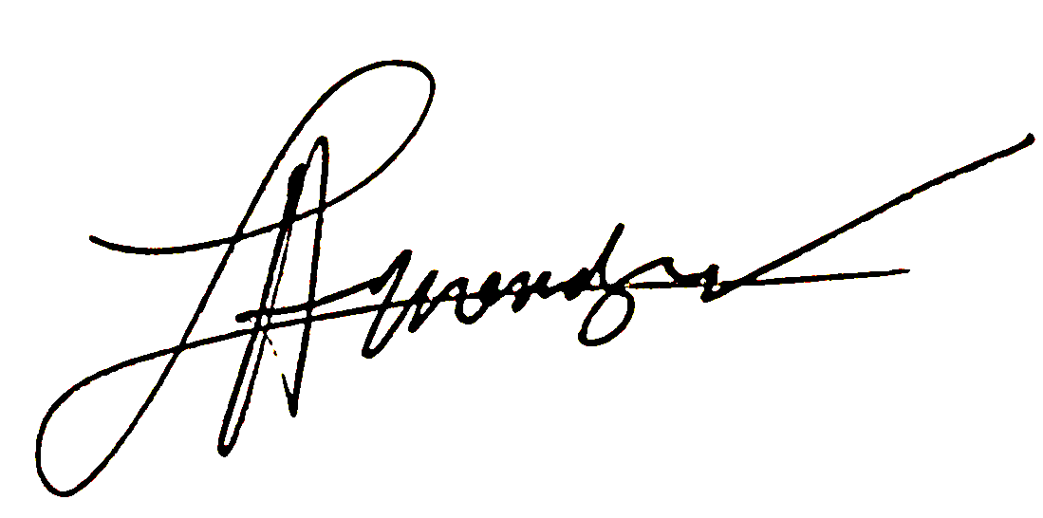
Date: | 25th August 2022

