The Constitution of Students’ Union UCL

Caledonian Society

Name

The name of the club/society shall be Students’ Union UCL Caledonian Society.

The club/society shall be affiliated to Students’ Union UCL.

Statement of Intent

The constitution, regulations, management and conduct of the club/society shall abide by all Students’ Union UCL policy, and shall be bound by the Students’ Union UCL Memorandum & Articles of Association, Byelaws, Club and Society Regulations and the club and society procedures and guidance – laid out in the ‘how to guides’.

The club/society stresses that it abides by Students’ Union UCL Equal Opportunities Policies, and that club/society regulations pertaining to membership of the club/society or election to the club/society shall not contravene this policy.

The Club and Society Regulations can be found on the following webpage: http://studentsunionucl.org/content/president-and-treasurer-hub/rules-and-regulations.

The Society Committee

President

The president’s primary role is laid out in section 5.7 of the Club and Society Regulations.
3.1.2. Take charge of finding coaching or leading regular practices within academic year.
3.1.3. Plan the practices per term on what dances/exercises are to be covered. Attending the majority of society events.
3.1.4. Explore opportunities of expanding the club.
3.1.5. Encourage contact with other local reeling societies.
3.1.6. Running the committee meetings and assigning minutes to be done by a member of the committee each week.
3.1.7. In charge of delegating jobs to all other committee members and ensuring their individual roles are completed to a good standard.
3.1.8. To organise all room booking for core activities including the committee meetings.
3.1.9. Look to encourage other committee members or confident members of the society to lead sessions, calling the reels, helping the next generation of the society.
3.1.10. Must oversee and assist the treasurer in setting budgets, allocating them and ensuring they are kept to.
3.1.11. For the benefit of the club and its runnings, in its first few years, for this role the future candidate should be selected from the existing committee.
3.1.12. Oversea the PR officers in sending out at least termly email updates to members.

Treasurer

The treasurer’s primary role is laid out in section 5.8 of the Club and Society Regulations.
3.2.2. Look into sponsorship opportunities for the club.
3.2.3. Take charge of membership charges.
3.2.4. Actively looking for grants and extra funding from the union.
3.2.5. Creates detailed budgets for events such as the Christmas and Summer Dances.
3.2.6. Keeps track of spending and maintaining records.
3.2.7. Assists the President with administrative and logistical tasks.
3.2.8. Collects memberships and subscriptions.

Welfare Officer

The welfare officer’s primary role is laid out in section 5.9 of the Club and Society Regulations.

To be a point of contact for any members with problems in the club.

Take part in any union campaigns including Pride in Societies

Complete all welfare training specified by the union.

Direct members to appropriate services when required, e.g. UCL Mental Health and Wellbeing.

To work with the social secretary on organising events which promote the society as being inclusive to all UCL students.

Encourage membership to all UCL/affiliate students, facilitating anyone that would like to join.

Perform health and safety assessments for social events.

If this role is not assigned at the AGM it can be added onto to any existing role. (excluding the President and Treasurer).

Additional Committee Members

Any additional committee positions you have should be outlined in your constitution below.

Events Coordinator

Primary organiser of both the Christmas and Summer Ball.

Explores and plans venue options for the Balls.

Acquires band or live music for these events.

Worth alongside social secretary seeking members to attend other university balls.

Social Secretary

Organise social events outside of practices throughout the academic year.

Responsible for providing equipment needed for practices and social events.

To research volunteering opportunities for the club members throughout the year.

Arrange social tour to another reeling society ball.

Schedule calendar for social events with other societies e.g. Dance.

To work directly with the PR and Outreach Officer on promoting organised events.

To work with the Welfare Officer on organising events which promote the society as being inclusive to all UCL students.

To work with the Treasurer on budgeting for social events.

Liaise with society members.

Be the point of contact about any enquiries concerning practises and other events.

PR and Outreach Officer

Manage social media accounts.

In charge of any promotional activity for the club.

Design/or seeks designer for promotional materials such as leaflets, Facebook graphics etc.

To work directly with the social secretary on promotion for all social events.

Work along with Welfare & Diversity Officer to help membership uptake.

Actively promote volunteering opportunities for the society.

Management of the club/society shall be vested in the club/society committee which will endeavour to meet regularly during term time (excluding UCL reading weeks) to organise and evaluate club/society activities.

The committee members shall perform the roles as described in section 5 of the Students’ Union UCL Club and Society Regulations.

Committee members are elected to represent the interests and well-being of club/society members and are accountable to their members. If club/society members are not satisfied by the performance of their representative officers they may call for a motion of no-confidence in line with the Students’ Union UCL Club and Society Regulations.

Terms, Aims and Objectives

The club/society shall hold the following as its aims and objectives.

Encourage membership throughout the year. Taking part in Give it a Go weeks both in term 1 and 2.

To create a friendly social atmosphere for all members to be a part of.

Teach/learn an appropriate number of dances for any member to be able to attend the Summer Ball.

Help any member of the society advance and reach their full potential in all aspects of the club, dancing or leadership.

The club/society shall strive to fulfil these aims and objectives in the course of the academic year as its commitment to its membership.

The core activities of the club/society shall be:

The reeling practices which will happen on a at least a fortnightly basics on UCL property during term 1 and 2.

Two annual reeling balls within the academic calendar.

A social tour joint with another university society reeling event.

In addition, the club/society shall also strive to organise other activities for its members where possible:

Volunteering opportunities for the club members to take part in.

Partake in interclub events with other Caledonian Reeling societies.

This constitution shall be binding on the club/society officers, and shall only be altered by consent of two-thirds majority of the full members present at a club/society general meeting. The Activities Executive shall approve any such alterations.

This constitution has been approved and accepted as the Constitution for the Students’ Union UCL Caledonian Society. By signing this document the president and treasurer have declared that they have read and abide by the Students’ Union UCL Club and Society Regulations.

President name: | Magnus Cameron
President signature: | 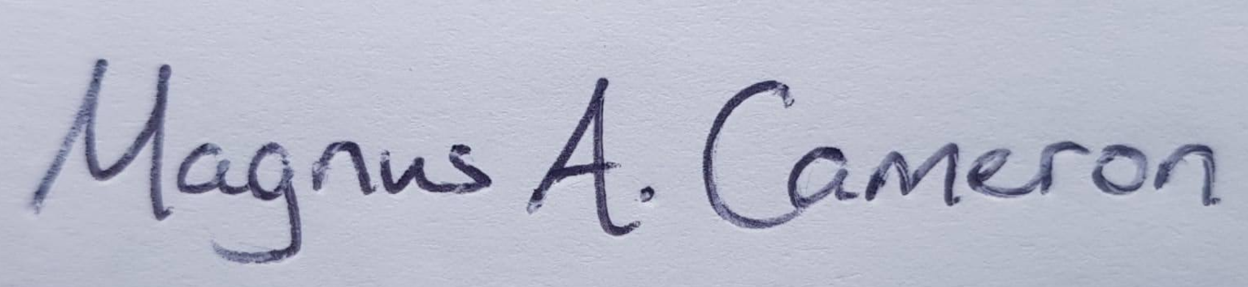
Date: | 01/07/22
Treasurer name: | Heather Tweedie
Treasurer signature:
Date: | 01/07/22

