The Constitution of Students’ Union UCL

AUSTRIAN SOCIETY

Name

The name of the club/society shall be Students’ Union UCL Austrian Society.

The club/society shall be affiliated to Students’ Union UCL.

Statement of Intent

The constitution, regulations, management and conduct of the club/society shall abide by all Students’ Union UCL policy, and shall be bound by the Students’ Union UCL Memorandum & Articles of Association, Byelaws, Club and Society Regulations and the club and society procedures and guidance – laid out in the ‘how to guides’.

The club/society stresses that it abides by Students’ Union UCL Equal Opportunities Policies, and that club/society regulations pertaining to membership of the club/society or election to the club/society shall not contravene this policy.

The Club and Society Regulations can be found on the following webpage: http://studentsunionucl.org/content/president-and-treasurer-hub/rules-and-regulations.

The Society Committee

President

The president’s primary role is laid out in section 5.7 of the Club and Society Regulations.

Treasurer

The treasurer’s primary role is laid out in section 5.8 of the Club and Society Regulations.

Welfare Officer

The welfare officer’s primary role is laid out in section 5.9 of the Club and Society Regulations.

Additional Committee Members

Additional elected committee roles this year include the Social Officer and Chairman. Additional positions can, but do not have to be filled every year, depending on the planned activities and need for additional committee members. These positions don’t have to be elected, they can be recruited by the elected committee as First Year Representatives.

The position as the Chairman is responsible for advising the committee and ideally sharing his or her experience from the previous year. It is intended to be filled by the President or Treasurer of the previous year and the outgoing committee is advised to state that during the election process. However, following UCLU regulations, every member of the society can run for this position too.

The Social Officer is responsible for organising the social events of our society, such as dinners or gatherings. This includes coming up with ideas for events, filling out the respective UCLU forms and making sure that events are held to the satisfaction of our members and the Union.

Management of the club/society shall be vested in the club/society committee which will endeavour to meet regularly during term time (excluding UCL reading weeks) to organise and evaluate club/society activities.

The committee members shall perform the roles as described in section 5 of the Students’ Union UCL Club and Society Regulations.

Committee members are elected to represent the interests and well-being of club/society members and are accountable to their members. If club/society members are not satisfied by the performance of their representative officers they may call for a motion of no-confidence in line with the Students’ Union UCL Club and Society Regulations.

Terms, Aims and Objectives

The club/society shall hold the following as its aims and objectives.

Connect Austrians at UCL and other British universities as well as students interested in Austria.

Introduce non-Austrian students to different aspects of the Austrian culture.

The club/society shall strive to fulfil these aims and objectives in the course of the academic year as its commitment to its membership.

The core activities of the club/society shall be:

Regular social events so that Austrians and students interested in Austria get the opportunity to meet and connect. In the context of these events, traditional Austrian dishes and drinks should be available.

Meet other Austrian Societies in and around London (e.g., LSE, Cambridge, Oxford).

Hold academic and business talks on campus.

Organise trips to cultural venues, such as art galleries and exhibitions with a connection to Austria.

Offer different events where students can experience and learn something about the Austrian culture. These events can include (but are not restricted to) dancing classes, language classes and cooking sessions.

In addition, the club/society shall also strive to organise other activities for its members where possible:

Sell mulled wine and Christmas biscuits at the Christmas Market in the UCL Main Quad.

This constitution shall be binding on the club/society officers, and shall only be altered by consent of two-thirds majority of the full members present at a club/society general meeting. The Activities Executive shall approve any such alterations.

This constitution has been approved and accepted as the Constitution for the Students’ Union UCL Austrian Society. By signing this document the president and treasurer have declared that they have read and abide by the Students’ Union UCL Club and Society Regulations.
President name: | Mirriam Domocos
President signature: | 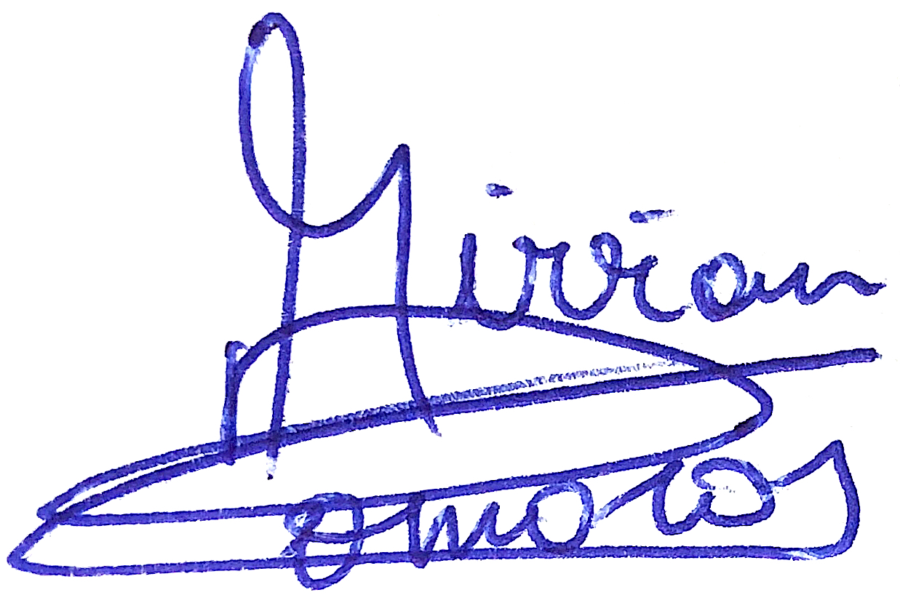
Date: | 20.06.2022
Treasurer name: | Christian Partik
Treasurer signature:
Date: | 25.06.2022

