THE CONSTITUTION OF THE UNIVERSITY COLLEGE LONDON VEGETARIAN AND VEGAN SOCIETY

Name
  - The name of the society shall be the University College London Union (UCL) Vegetarian and Vegan Society.
  - The society shall be affiliated to Students’ Union UCL.

Statement of Intent

The constitution, regulations, management and conduct of the club/society shall abide by all Students’ Union UCL policy, and shall be bound by the Students’ Union UCL Memorandum & Articles of Association, Byelaws, Club and Society Regulations and the club and society procedures and guidance – laid out in the ‘how to guides’.

The club/society stresses that it abides by Students’ Union UCL Equal Opportunities Policies, and that club/society regulations pertaining to membership of the club/society or election to the club/society shall not contravene this policy.

The Club and Society Regulations can be found on the following webpage: http://studentsunionucl.org/content/president-and-treasurer-hub/rules-and-regulations.

The Society Committee
  - President
    - The President’s primary role is laid out in section 5.7 of the Club and Society Regulations.

Treasurer
    - The Treasurer’s primary role is laid out in section 5.8 of the Club and Society Regulations.

Welfare officer

The welfare officer’s primary role is laid out in section 5.9 of the Club and Society Regulations.

Social Media Officer
    - Monitor and run the society’ social media accounts.

Vice-President
    - Envision, plan and organise events related to veganism, vegetarianism, animal rights and environmentalism as laid out in 4.3.

Newsletter Officer
    - Managing the mailing list to keep members informed of our events.

Social Secretary
    - Help other committee members in planning and organising events by taking on miscellaneous tasks that do not fall in any of the other positions.
  - Management of the society shall be vested in the Society Committee which shall endeavour to meet regularly during term time (excluding college reading weeks) to organise and evaluate the Society’s activities.
  - The Committee members will perform the roles as described in section 5 of the Students’ Union UCL Club and Society Regulations document.
  - Committee members are elected to represent the interests and well-being of club/society members and are accountable to their members. If club/society members are not satisfied by the performance of their representative officers they may call for a motion of no-confidence in line with the Students’ Union UCL Club and Society Regulations.
Committee members are elected to represent the interests and well-being of Society members and are able to be held to account. If Society members are not satisfied by the

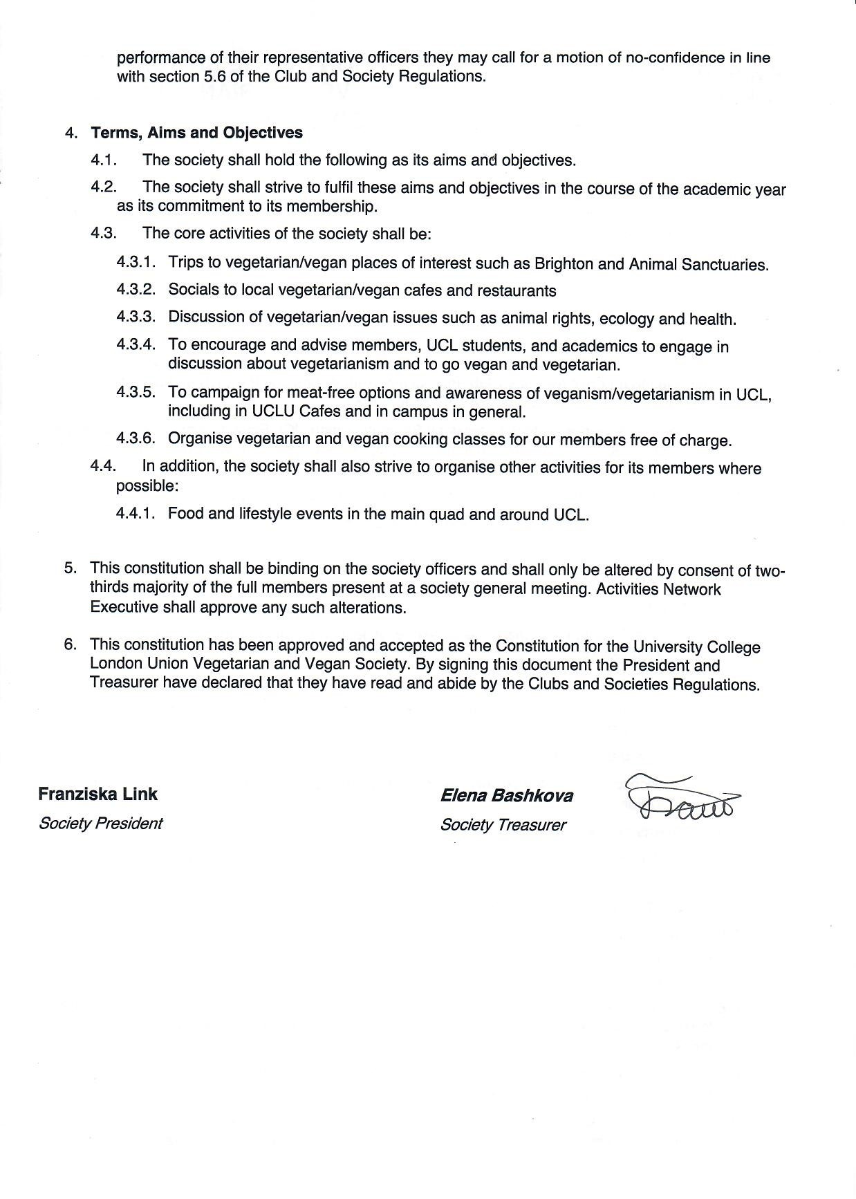
President name: | Elena Bashkova
President signature:
Date: | 29/6/2021
Treasurer name: | Aryan Shah Kenia
Treasurer signature:
Date: | 29/6/2021

