The Constitution of Students’ Union UCL

Ultimate Frisbee Club

Name

The name of the club/society shall be Students’ Union UCL Ultimate Frisbee Club.

The club/society shall be affiliated to Students’ Union UCL.

Statement of Intent

The constitution, regulations, management and conduct of the club/society shall abide by all Students’ Union UCL policy, and shall be bound by the Students’ Union UCL Memorandum & Articles of Association, Byelaws, Club and Society Regulations and the club and society procedures and guidance – laid out in the ‘how to guides’.

The club/society stresses that it abides by Students’ Union UCL Equal Opportunities Policies, and that club/society regulations pertaining to membership of the club/society or election to the club/society shall not contravene this policy.

The Club and Society Regulations can be found on the following webpage: http://studentsunionucl.org/content/president-and-treasurer-hub/rules-and-regulations.

The Society Committee

President

The president’s primary role is laid out in section 5.7 of the Club and Society Regulations. Additionally, they shall:

Represent the club and shall be responsible for making sure that the club is run according to its constitution, the Students’ Union UCL Club and Society regulations, Good Practice Guidelines, and Standing Orders of Students’ Union UCL.

Call General Meetings of the club, and organise proper elections for the following year’s committee, in accordance with Club and Society Regulations.

Be the primary point of communication between the Union and the club members. It is therefore required that s/he attends the relevant Union Committees.

Treasurer

The treasurer’s primary role is laid out in section 5.8 of the Club and Society Regulations. Additionally, they shall:

Carry out the day to day financial duties of the club, and is responsible to the union for club finances to the membership.

Keep current accurate financial information. The Treasurer is responsible for all financial transactions of the club ensuring that these are made through the Union Finance Department; only the Treasurer, or in his/her absence the President, may authorise withdrawals or expenditure from the club accounts.

Maintain a club account book.

Arrange the club kit order.

Welfare Officer

The welfare officer’s primary role is laid out in section 5.9 of the Club and Society Regulations. Additionally, they shall:

Exist as the point of contact for welfare adversities experienced by their membership base and to represent all minority communities within their club/society; overcome retrospective disengagement, tackle the bespoke barriers to accessibility of respective core club/society activity and develop a strong and progressive culture of inclusivity throughout the Union.

Additional Committee Members

Captains

The captains are responsible for running the men’s, women’s and mixed teams.

Shall communicate to the teams when and where practices are.

Shall devise training and development plans (in combination with the coaches).

Shall make decisions on which tournaments to attend.

Shall lead the teams on the pitch.

Shall be responsible for team selection (in combination with the coaches).

Shall report to the club on performances in games and training sessions.

The Social Secretary

The social secretary shall be responsible for organising social events for club members.

The Communications Officer

The communications officer shall:

Manage weekly emails, handle all other information to be distributed to the club.

Shall maintain the website and be responsible for sourcing and uploading all content.

Shall be responsible for all publicity for the club.

The Community Outreach Officer

The community outreach officer shall:

Proactively seek means to volunteering for the society (either through The Volunteering Service (TVS) or individually).

Oversee and govern the project(s) itself.

Write short summaries on the activity for publication.

Record the hours, projects and volunteers engaged throughout the year

Management of the club/society shall be vested in the club/society committee which will endeavour to meet regularly during term time (excluding UCL reading weeks) to organise and evaluate club/society activities.

The committee members shall perform the roles as described in section 5 of the Students’ Union UCL Club and Society Regulations.

Committee members are elected to represent the interests and well-being of club/society members and are accountable to their members. If club/society members are not satisfied by the performance of their representative officers they may call for a motion of no-confidence in line with the Students’ Union UCL Club and Society Regulations.

Terms, Aims and Objectives

The club/society shall hold the following as its aims and objectives.

The club/society shall strive to fulfil these aims and objectives in the course of the academic year as its commitment to its membership.

The club will strive to instil in its members a sense of the importance of the spirit of the game: “highly competitive play is encouraged but never at the expense of mutual respect between players, adherence to the agreed-upon rules of the game or the basic joy of play.” (WFDF Rules of Play)

The core activities of the club/society shall be:
Weekly fitness and skills training sessions to be held at least twice a week (outdoors) and once a week (indoors) in terms 1 and 2. Additionally, the club will represent STUDENTS’ UNION UCL in a wide range of competitive Ultimate Frisbee tournaments.

In addition, the club/society shall also strive to organise other activities for its members where possible:
activities representing celebrated cultural events including but not limited to Christmas and Chinese New Year.

This constitution shall be binding on the club/society officers, and shall only be altered by consent of two-thirds majority of the full members present at a club/society general meeting. The Activities Executive shall approve any such alterations.

This constitution has been approved and accepted as the Constitution for the Students’ Union UCL Ultimate Frisbee Club. By signing this document the president and treasurer have declared that they have read and abide by the Students’ Union UCL Club and Society Regulations.

President name: | Joseph Lee
President signature: | 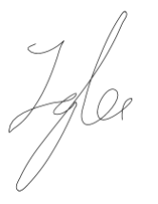
Date: | 23/06/21
Treasurer name: | Rohan Tandon
Treasurer signature: | 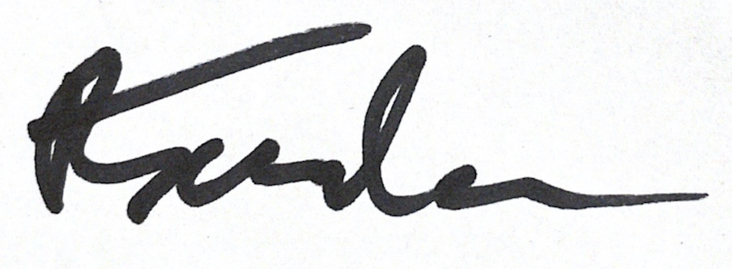
Date: | 25/06/21

