The Constitution of Students’ Union UCL

RUMS Rugby Club

Name

The name of the club/society shall be Students’ Union UCL RUMS Rugby Club.

The club/society shall be affiliated to Students’ Union UCL.

Statement of Intent

The constitution, regulations, management and conduct of the club/society shall abide by all Students’ Union UCL policy, and shall be bound by the Students’ Union UCL Memorandum & Articles of Association, Byelaws, Club and Society Regulations and the club and society procedures and guidance – laid out in the ‘how to guides’.

The club/society stresses that it abides by Students’ Union UCL Equal Opportunities Policies, and that club/society regulations pertaining to membership of the club/society or election to the club/society shall not contravene this policy.

The Club and Society Regulations can be found on the following webpage: http://studentsunionucl.org/content/president-and-treasurer-hub/rules-and-regulations.

The Society Committee

President

The president’s primary role is laid out in section 5.7 of the Club and Society Regulations.

The President shall be referred to as the Club Captain.

Treasurer

The treasurer’s primary role is laid out in section 5.8 of the Club and Society Regulations.

Welfare and Volunteering Secretary

The welfare officer’s primary role is laid out in section 5.9 of the Club and Society Regulations.
3.3.2 To lead the Club’s welfare needs in the interests of all its members
3.3.3 To be the primary organiser of volunteering and fundraising

Additional Committee Members

Fixture Secretary

Shall carry out the organisation of referees for all rugby games
3.3.2. Shall organise dates for rugby games included in BUCS or UH cup

Team Captains

The captains of the 3 teams.

Old Boy’s Secretary

To create and maintain an Old Boys Directory

To Send out monthly updates to members of the Old Boys Directory

Education Officer

    - To organise and run tutorial sessions for all years at Medical School offering exam advice and revision assistance

Social Media Secretary

    - Alongside the President, regularly update and maintain the club’s social media accounts
    - Reach out to new members using social media channels to aid recruitment of new members

Social Secretary

    - The role to be shared between two members, one preferably from first or second year to help integrate new students into the club

To organise a wide range of socials for the club, catering for all members.

Kit Secretary

    - To maintain the first aid kits and tape bags for all teams

To liaise with the President to organise new kit when required

Management of the club/society shall be vested in the club/society committee which will endeavour to meet regularly during term time (excluding UCL reading weeks) to organise and evaluate club/society activities.

The committee members shall perform the roles as described in section 5 of the Students’ Union UCL Club and Society Regulations.

Committee members are elected to represent the interests and well-being of club/society members and are accountable to their members. If club/society members are not satisfied by the performance of their representative officers they may call for a motion of no-confidence in line with the Students’ Union UCL Club and Society Regulations.

Terms, Aims and Objectives

The club/society shall hold the following as its aims and objectives.

The club/society shall strive to fulfil these aims and objectives in the course of the academic year as its commitment to its membership.

The core activities of the club/society shall be:

Playing Rugby in BUCS & UH Competitions

Training sessions during the season, primarily at Chiswick RFC

Holding an annual exhibition fixture with Parisian University Paris Sciences et Lettres

Socialising together as a club on a Wednesday night

In addition, the club/society shall also strive to organise other activities for its members where possible:

4.4.1. Rugby tour to take part in Oktoberfest 7s

RUMS Rugby are against the merger proposed by BUCS, and will continue to campaign against any such actions. Should such a merger occur, we would continue to exist as a separate entity from UCL Rugby, and will hold an EGM to discuss our participation in future leagues

This constitution shall be binding on the club/society officers, and shall only be altered by consent of two-thirds majority of the full members present at a club/society general meeting. The Activities Executive shall approve any such alterations.

This constitution has been approved and accepted as the Constitution for the Students’ Union UCL RUMS Rugby Club. By signing this document the president and treasurer have declared that they have read and abide by the Students’ Union UCL Club and Society Regulations.

President name: | Andrew Morrish
President signature: | 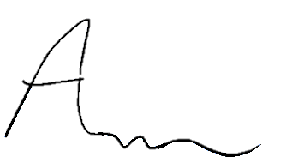
Date: | 24/06/21
Treasurer name: | Christopher Savvas
Treasurer signature: | 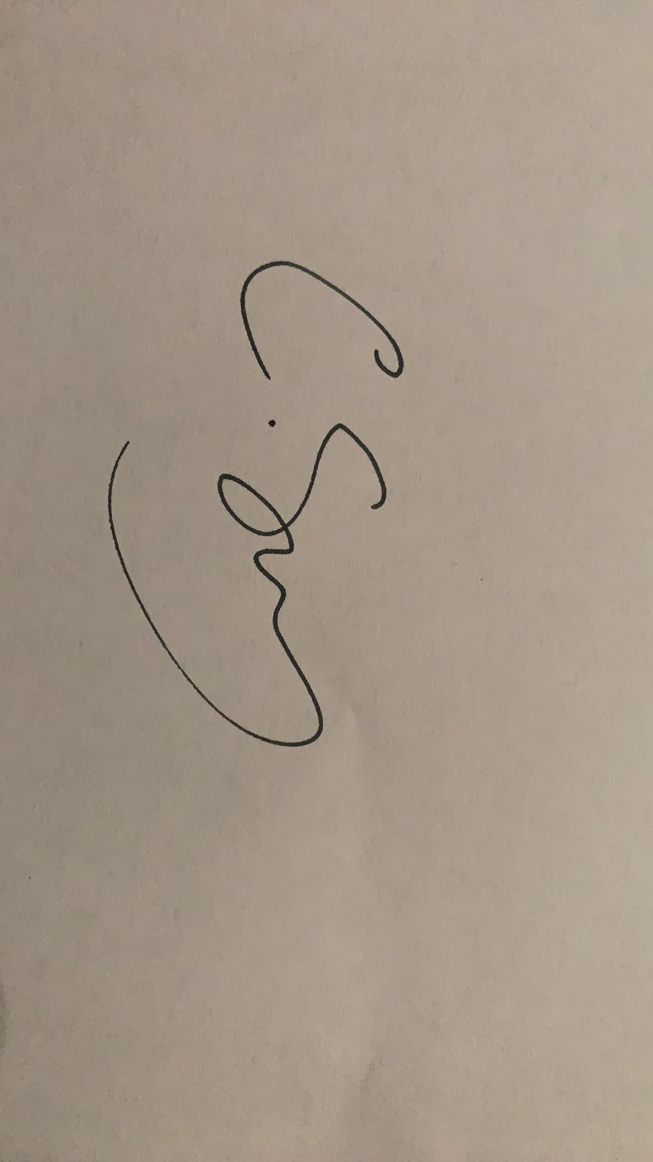
Date: | 24/06/21

