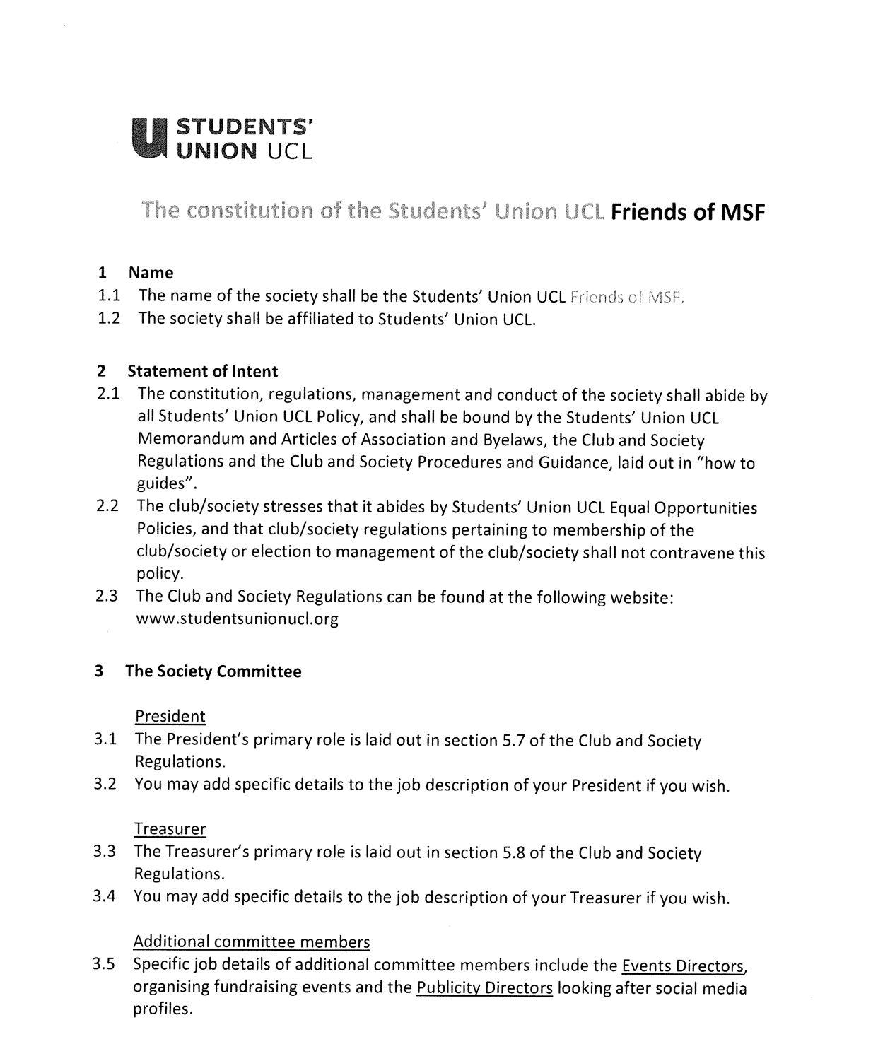
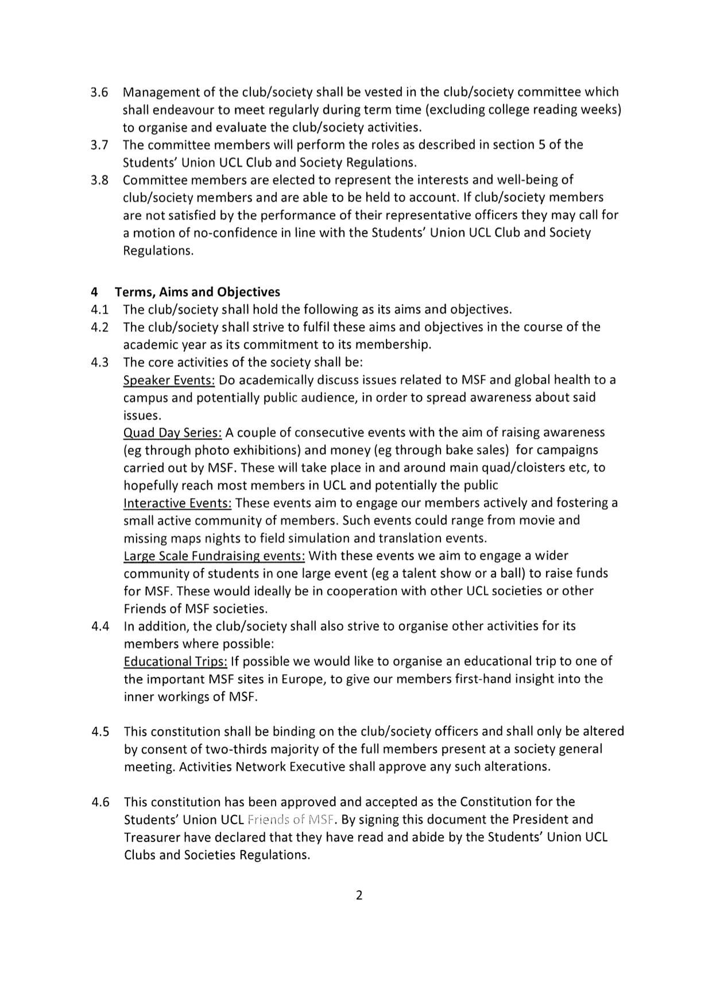

President name: Samuel Titmuss
Date: 23rd June 2021
Treasurer name: Ayesha Saleem
Date: 23rd June 2021

