TeamUCL Access Statement

Box Clever Sports

Contents
- Venue Statement & underground travel
- Bus, Taxi, Uber Travel, Parking
- Features of the venue and contact information

Venue Statement

Thank you for taking an interest in our club. We are committed to making UCL an inclusive community and supporting all disabled students taking part in our activity. The Welfare Officer of every sports club has been trained in Disability Inclusion and Etiquette Training. We have completed this form to try and support you joining the TeamUCL community.

If any of this information is unclear or you would like more information on other venues or activities are club get up to, please email teamucl@ucl.ac.uk.

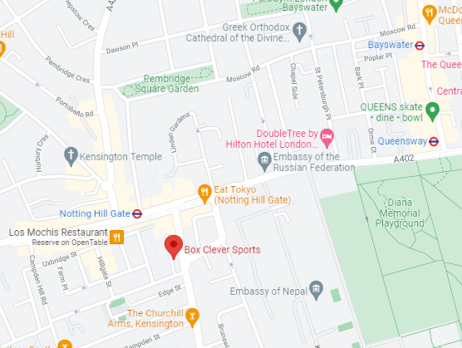

Travel
Box Clever Sports is easily accessible using all modes of transport. Click here for the Tfl Accessible Tube Map

Underground
Unfortunately, few of the underground or mainline railway stations around Box Clever Sports are fully wheelchair accessible.
However, some ambulant disabled supporters/visitors may be able to use them.
• Notting Hill Gate (Central Line, Circle Line, District Line) is the nearest tube station and is around a 3 minute walk from the facility.
• Bayswater (Circle Line, District Line) is around a 15 minute walk from the facility.
• Queensway (Central Line) is around a 10 minute walk from the facility.

Buses
All Transport for London (TFL) bus routes are wheelchair accessible and have clearly marked priority seats for people with limited mobility. On most buses the wheelchair ramp is positioned at the exit door and there is one wheelchair user place on each bus. The main bus routes that stop close to Box Clever Sports are the 27, 18, 205, 30, 94, 148, which are located close to Euston station.
Taxis
All London Style ’Black Cabs’ are wheelchair accessible and can provide a suitable alternative to the bus or car. Black cabs can be hailed (stopped) in the street however you may prefer to book a cab to travel to or from the facility.
There are several cab companies operating in London including,
Computer Cab: Tel: 020 8033 9918
The London Black Cab Company: 078 8534 9994
London Black Taxis: 020 3984 4515/ 020 3004 4953
Uber Taxis also provide Wheelchair Accessible Vehicles (WAV). To book Download the Uber app and create your account (unless you already have one) then choose the ‘uberWAV’ option on the slider at the bottom of the screen and follow the instructions. If you would prefer to book a mini cab, then there are several companies in Camden including.
Full information on bus taxi and tube travel in London for disabled people can be found at https://tfl.gov.uk/transport-accessibility/?cid=transportaccessibility

Parking
The facility is situated in a non-residential area with extensive parking restrictions. Blue Badge holders can park on Kensington Place, Kensington Park Road, and on Palace Gardens Terrace. Please check the Blue Badge parking signage carefully before parking.
You can look here for more information.

Features of the venue

Non accessible Toilets
There is a toilet cubicle as well as a separate shower room and changing room.

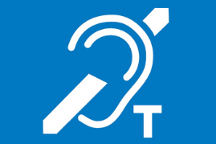
Hearing Induction Loop
There is no hearing induction loop.

BSL User at training/Venue
None.

Vigilant coaches
All the coaches at this venue are keen helpers for their students and have experience with members of all levels of capability. The coaches are happy to help with any issues a member is facing and would gladly teach 1:1 to aid in the progression of learning.

Contact
Box Clever Sports can be contacted by:
Address – 199-209 Kensington Church Street W8 7LX
Phone - +447415495829
Email: info@boxcleversports.com

