TeamUCL Access Statement Women’s Basketball Club

Contents
- Club Statement
- Travel to the venue
- Venue map
- Accessible features at the venue
- Additional information

Club Statement

Thank you for taking an interest in our club. We are committed to making UCL an inclusive community and supporting all disabled students taking part in our activity. Our Welfare Officer has been trained in Disability Inclusion and Etiquette Training. We have completed this form to try and support you joining us to take part in the sport we all love. Our club is a brilliant place to meet new people and create life long friendships.

If any of this information is unclear or you would like more information on other venues or activities are club get up to, please email me, the Club President.

We look forward to welcoming you into our club.
Kind regards,
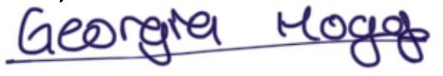__________________________________
Club President

Travel
Somers Town Community Sports Centre is easily accessible using all modes of transport. Click here for the Tfl Accessible Tube Map

Underground
One of the closest tube stations, Mornington Crescent, does not have step-free access, but Euston and King’s Cross St Pancras do.
• Euston station (Victoria Line and Northern Line) is around a nine minutes’ walk from the facility.
• King’s Cross St Pancras station (Circle, Metropolitan, Northern, Victoria, Hammersmith and City and Piccadilly Line) is around a ten minutes’ walk from the facility.

Buses
All Transport for London (TFL) bus routes are wheelchair accessible and have clearly marked priority seats for people with limited mobility. On most buses the wheelchair ramp is positioned at the exit door and there is one wheelchair user place on each bus. The main bus stops close to Somers Town are located on Crowndale Road, Eversholt Street and Pancras Road.
Several bus routes pass close to the facility including the 168 which goes from Bermondsey to Hampstead Heath, the 214 which goes from Moorgate to Highgate Village and the 46 which goes from Paddington to Barts Hospital.

Taxis
All London Style ’Black Cabs’ are wheelchair accessible and can provide a suitable alternative to the bus or car. Black cabs can be hailed (stopped) in the street however you may prefer to book a cab to travel to or from the facility.
There are several cab companies operating in London including,
Computer Cab: Tel: 020 8033 9918
The London Black Cab Company: 078 8534 9994
London Black Taxis: 020 3984 4515/ 020 3004 4953
Uber Taxis also provide Wheelchair Accessible Vehicles (WAV). To book Download the Uber app and create your account (unless you already have one) then choose the ‘uberWAV’ option on the slider at the bottom of the screen and follow the instructions. If you would prefer to book a mini cab, then there are several companies in the area including:
Camden Town Cab & Taxi Service: 020 8191 9526
Camden Mini Cabs: 020 3637 9984
Spotty Cars: 020 7383 3333
There are no designated drop off/pick up point outside the facility. However, suggested drop off/pick up points are on Eversholt Street, which is 0.2 miles away from the venue, or at the taxi rank outside London Euston station, which is 0.5 miles away.
Full information on bus taxi and tube travel in London for disabled people can be found at https://tfl.gov.uk/transport-accessibility/?cid=transportaccessibility

Parking
There is a car park with an 8-car capacity. There is also pay and display parking nearby.

Accessible features at the venue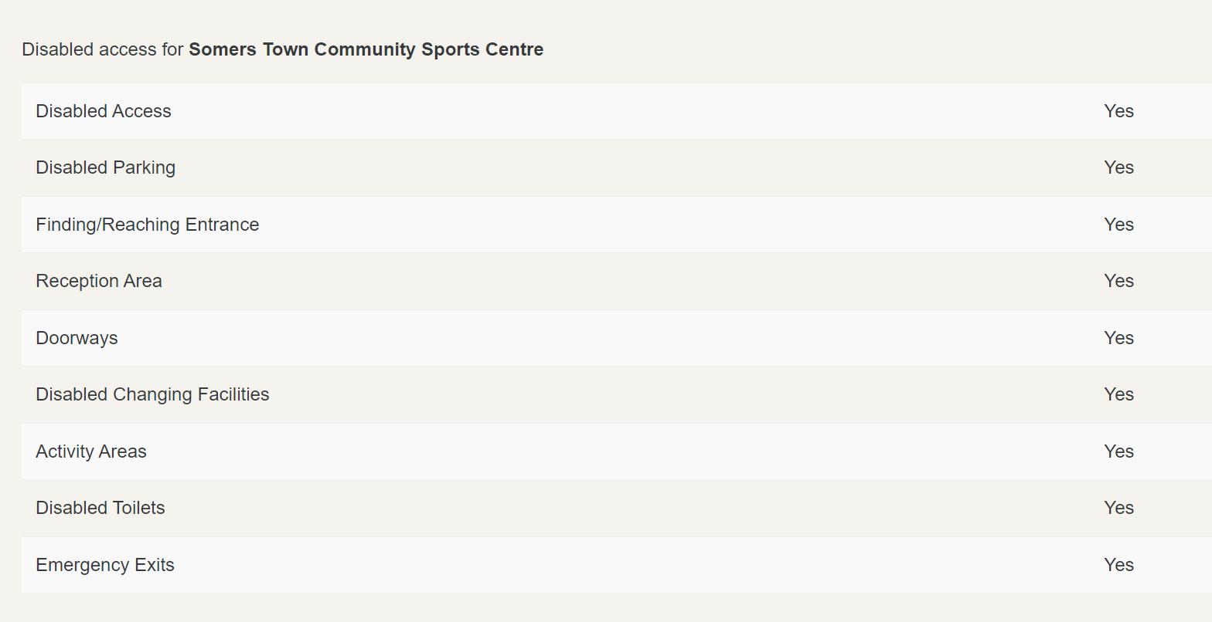

Accessible Toilets
Yes.

Non accessible Toilets
Yes.

Changing Places Toilet Facility

Yes.

Tactile Guidance Pathway

None.

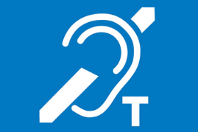
Hearing Induction Loop
None.

BSL User at training/Venue
None.

Contact
For more information about the venue, please contact:
email: stcsportscentre@aol.com
Telephone: 02074194365

