TeamUCL Access Statement

UCL Lightning Cheerleading Club

Contents
- Club Statement
- Travel to the venue
- Venue map
- Accessible features at the venue
- Additional information

Club Statement

Thank you for taking an interest in our club. We are committed to making UCL an inclusive community and supporting all disabled students taking part in our activity. Our Welfare Officer has been trained in Disability Inclusion and Etiquette Training. We have completed this form to try and support you joining us to take part in the sport we all love. Our club is a brilliant place to meet new people and create life long friendships.

If any of this information is unclear or you would like more information on other venues or activities are club get up to, please email me, the Club President.

We look forward to welcoming you into our club.
Kind regards,

__________________________________________
Club President

Travel
The UCL Academy is easily accessible using all modes of transport. Click here for the Tfl Accessible Tube Map

Underground
The closest tube station, Swiss Cottage, does not have step-free access, but Finchley Road station does.
Finchley road station (Jubilee Line and Metropolitan Line) is around an eleven minutes’ walk from the facility.

Buses
All Transport for London (TFL) bus routes are wheelchair accessible and have clearly marked priority seats for people with limited mobility. On most buses the wheelchair ramp is positioned at the exit door and there is one wheelchair user place on each bus. The main bus stops close to The UCL Academy are located on Adelaide Road, Finchley Road and the A41.
Several bus routes pass close to the facility including the 13 which goes from North Finchley to Victoria, the 46 from Paddington to Barts Hospital, the 113 from Edgware to Oxford Circus, the C11 from Brent Cross to Archway, the 268 from Finchley Road to Golders Green and the 31 from Camden Town to White City.

Taxis
All London Style ’Black Cabs’ are wheelchair accessible and can provide a suitable alternative to the bus or car. Black cabs can be hailed (stopped) in the street however you may prefer to book a cab to travel to or from the facility.
There are several cab companies operating in London including,
Computer Cab: Tel: 020 8033 9918
The London Black Cab Company: 078 8534 9994
London Black Taxis: 020 3984 4515/ 020 3004 4953
Uber Taxis also provide Wheelchair Accessible Vehicles (WAV). To book Download the Uber app and create your account (unless you already have one) then choose the ‘uberWAV’ option on the slider at the bottom of the screen and follow the instructions. If you would prefer to book a mini cab, then there are several companies in the area including:
Swiss Cottage Cars London: 020 8459 3838
Eagles Chauffeurs: 020 7486 8887
There are no designated drop off/pick up point outside the facility. However, suggested drop off/pick up points are along Finchley Road.
Full information on bus taxi and tube travel in London for disabled people can be found at https://tfl.gov.uk/transport-accessibility/?cid=transportaccessibility

Parking
Off street parking available.

Accessible features at the venue
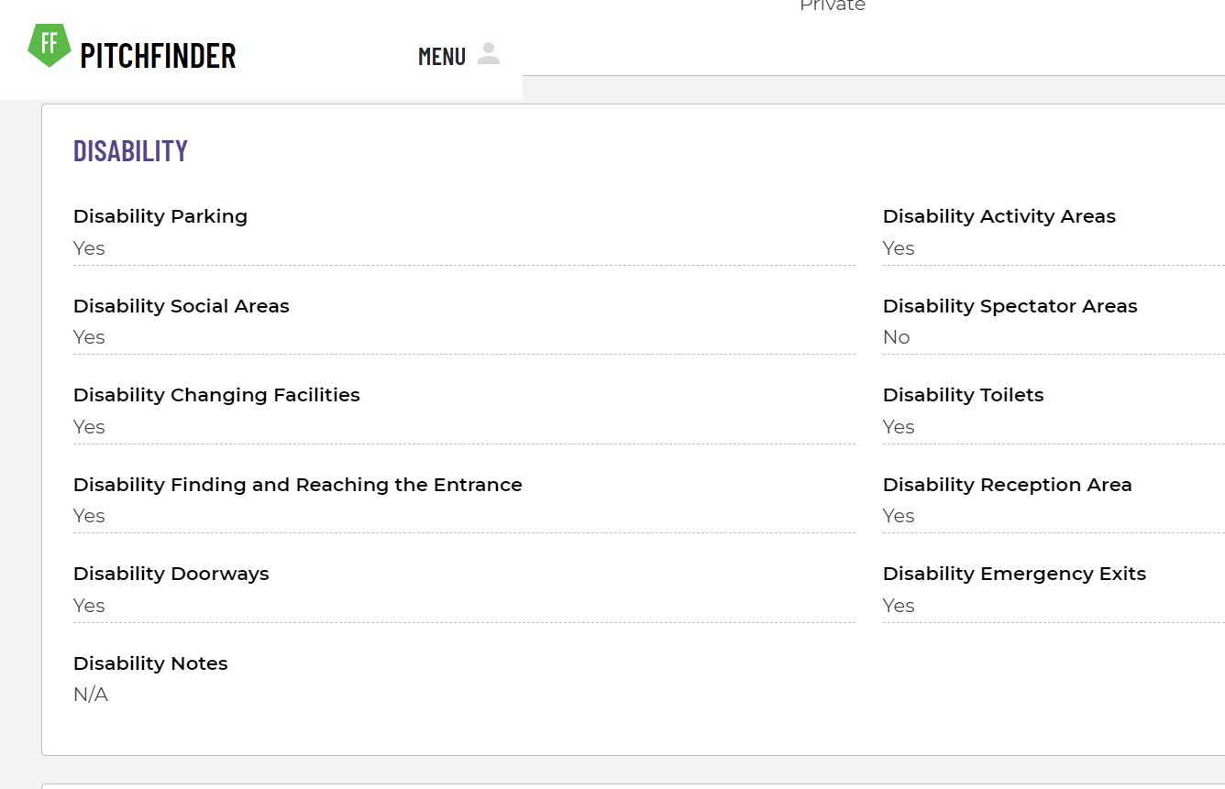

Accessible Toilets
Yes.

Non accessible Toilets
There are toilets, changing rooms and showers.

Changing Places Toilet Facility
Yes.

Tactile Guidance Pathway
None.

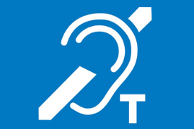
Hearing Induction Loop
None.

BSL User at training/Venue
None.

Contact
To find out more details about the venue please call: 02074493080

