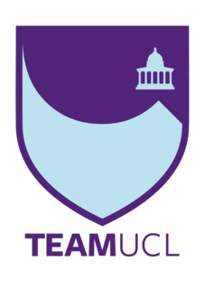

TeamUCL Access Statement

RUMS Boat Club

Contents
- Club Statement
- Travel to the venue
- Venue map
- Accessible features at the venue
- Additional information

Club Statement

Thank you for taking an interest in our club. We are committed to making UCL an inclusive community and supporting all disabled students taking part in our activity. Our Welfare Officer has been trained in Disability Inclusion and Etiquette Training. We have completed this form to try and support you joining us to take part in the sport we all love. Our club is a brilliant place to meet new people and create life long friendships.

If any of this information is unclear or you would like more information on other venues or activities are club get up to, please email me, the Club President.

We look forward to welcoming you into our club.
Kind regards,

___________________________________
Laura Dan, RUMS Boat Club President

Travel
Click here for the Tfl Accessible Tube Map

Underground
The nearest station to the University of London Boat House is Gunnersbury (District Line and Overground); however, this does not have step-free access and it around a 20 minutes’ walk from the venue.
Chiswick is the closest Main Line station which is around 10 minutes’ walk from the venue.

Buses
All Transport for London (TFL) bus routes are wheelchair accessible and have clearly marked priority seats for people with limited mobility. On most buses the wheelchair ramp is positioned at the exit door and there is one wheelchair user place on each bus. The main bus stops close to The UoL Boat House are on Sutton CT Road, Spencer Road and Bolton Road.
Two bus routes pass close to the facility including the 272 from Shepherds Bush to Chiswick and the E3 from Greenford Broadway to Chiswick, Edensor Road.
Taxis
All London Style ’Black Cabs’ are wheelchair accessible and can provide a suitable alternative to the bus or car. Black cabs can be hailed (stopped) in the street however you may prefer to book a cab to travel to or from the facility.
There are several cab companies operating in London including,
Computer Cab: Tel: 020 8033 9918
The London Black Cab Company: 078 8534 9994
London Black Taxis: 020 3984 4515/ 020 3004 4953
Uber Taxis also provide Wheelchair Accessible Vehicles (WAV). To book Download the Uber app and create your account (unless you already have one) then choose the ‘uberWAV’ option on the slider at the bottom of the screen and follow the instructions. If you would prefer to book a mini cab, then there are several companies in the area including:
Bloomfield Executive Cars: 020 8487 8800
Chiswick Park Cars: 020 8742 2020
There are no designated drop off/pick up point outside the facility. However, suggested drop off/pick up points are on Hartington Road and Grove Park Road which are outside the venue.
Full information on bus taxi and tube travel in London for disabled people can be found at https://tfl.gov.uk/transport-accessibility/?cid=transportaccessibility

Parking

Parking on streets around theboathouse is possible. There are parking restrictions between 10am and 12pm each weekday.

Accessible features at the venue

Accessible Toilets
No.

Non accessible Toilets
The changing rooms and toilets are located on the first floor with access only via stairs. There are no accessible toilet facilities.

Changing Rooms

Yes.

Tactile Guidance Pathway

None.

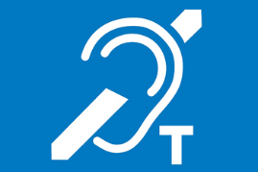
Hearing Induction Loop
None.

BSL User at training/Venue
None.

Contact
For further information about the facility please contact:
Phone – 0208 994 5928
Email – adminULBH@gmail.com

