TeamUCL Access Statement

Cycling Club - Regent´s Park

Contents
- Club Statement
- Travel to the venue
- Venue map
- Accessible features at the venue
- Additional information

Club Statement

Thank you for taking an interest in our club. We are committed to making UCL an inclusive community and supporting all disabled students taking part in our activity. Our Welfare Officer has been trained in Disability Inclusion and Etiquette Training. We have completed this form to try and support you joining us to take part in the sport we all love. Our club is a brilliant place to meet new people and create life long friendships.

If any of this information is unclear or you would like more information on other venues or activities are club get up to, please email me, the Club President.

We look forward to welcoming you into our club.
Kind regards,

__________________________________________
Club President

Travel
Regent’s Park ground is easily accessible using all modes of transport. Click here for the Tfl Accessible Tube Map

Location
South-East Entrance Gate, Regents Park:

3 St Andrews Pl

London

NW1 4LB

UK

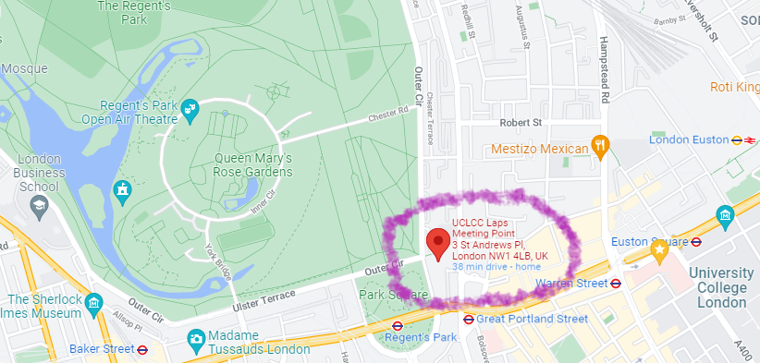

Underground
Unfortunately, few of the underground or mainline railway stations around Emirates Stadium are fully wheelchair accessible.
However, some ambulant disabled supporters/visitors may be able to use them.
• Regent’s Park station (Bakerloo Line) is the nearest tube station and is around a 4-minute walk from the meeting point.
• Great Portland Streat station (Metropolitan/ Circle/ Hammersmith & City Line) is around 4-minute walk from the meeting point.
• Warren Street station (Victoria and Northern Line) is around a 10-minute walk from the meeting point.
• London Euston is the nearest main line station (and Overground Line) and is wheelchair accessible. It is around 15 minute walk from the meeting point.

Buses
All Transport for London (TFL) bus routes are wheelchair accessible and have clearly marked priority seats for people with limited mobility. On most buses the wheelchair ramp is positioned at the exit door and there is one wheelchair user place on each bus. The main bus stops close to Regent’s Park meeting point are located at Albany Street, Marylebone Road, and Great Portland Street.
Several bus routes pass close to the meeting point, including:
- 88 From: Parliament - To: Omnibus Clapham
- 18 From: Sudbury & Harrow Road Station – To: Euston Station
- 27 From: Hammersmith St – To: Hartland Road
- 30 From: Portman Street/ Selfridges – To: Hackney Wick/ Trowbridge Road
- 205 From: Cleveland Terrace – To: Bow Church Station
- 453 From: Deptford Bridge Station – To: Great Central Station

Taxis
All London Style ’Black Cabs’ are wheelchair accessible and can provide a suitable alternative to the bus or car. Black cabs can be hailed (stopped) in the street however you may prefer to book a cab to travel to or from the facility.
There are several cab companies operating in London including,
Computer Cab: Tel: 020 8033 9918
The London Black Cab Company: 078 8534 9994
London Black Taxis: 020 3984 4515/ 020 3004 4953
Uber Taxis also provide Wheelchair Accessible Vehicles (WAV). To book Download the Uber app and create your account (unless you already have one) then choose the ‘uberWAV’ option on the slider at the bottom of the screen and follow the instructions. If you would prefer to book a mini cab, then there are several companies in Camden including.
There are no designated drop off/pick up point outside the meeting point. However, suggested drop off/ pick up points are near the Outer Circle, Park Square E – near the meeting point.
There is step free access all across the park.
Full information on bus taxi and tube travel in London for disabled people can be found at https://tfl.gov.uk/transport-accessibility/?cid=transportaccessibility

Parking
The facility is situated in a mainly residential area with extensive parking restrictions. Blue Badge holders can park in the surrounding roads in vacant residents parking bays. However, you should check to ensure the bay is not suspended due to event day parking restrictions around the stadium. Please ensure that your Blue Badge and clock are clearly displayed. There are also a number dedicated Blue Badge bays in the vicinity of the facility, however, please be aware that some of the bays in the area are specifically for the use of a designated Blue Badge holder. Please check the Blue Badge parking signage carefully before parking.
There are 3 specific designated accessible parking at the venue and these are located within Regent’s Park. They are distributed on a first come first served basis.
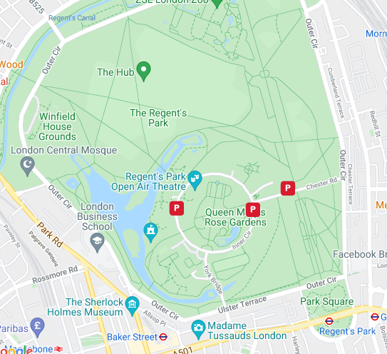
Blue Badge holders park free of charge, but are subject to 4 hours maximum stay Monday to Saturday. No parking between midnight and 9am. Parking inside Regent’s Park is available from 9am – 6:30pm.
The furthest disabled parking is 0.6 miles from the meeting point. The postcode for electronic device users is NW1 4NR, but please note this is for guidance only as the park covers a large area.

Accessible features at the venue

Accessible Toilets
There are 6 wheelchair accessible toilets located around the park, in public toilets and in selected cafes (Espresso Bar and The Hub). All are fitted with RADAR locks to prevent abuse by non-disabled supporters. All supervising staff hold RADAR keys in case a disabled supporter/visitor does not have one with them.
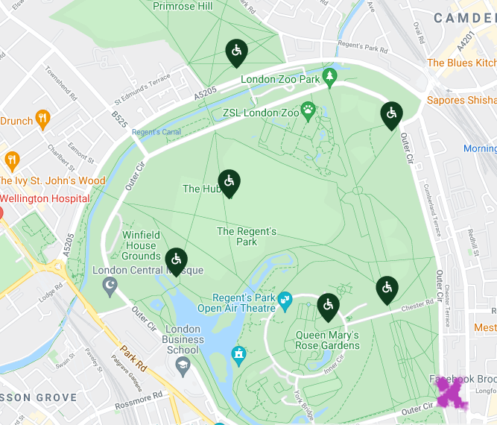
All the wheelchair accessible toilets are unisex and the toilet doors all open outwards. Either a left or right transfer space is available in every wheelchair accessible toilet along with colour contrasted grab rails.
The wash hand basins all have lever type mixer taps. The wheelchair accessible toilets are also fitted with appropriate height mirrors, hand dryers and coat hooks and pull cord emergency alarms.

Non accessible Toilets
There are standard male & female toilets next to all the entrances on the ground and first floor. Every standard toilet block contains one cubicle suitable for ambulant disabled supporters.

Changing Places Toilet Facility
Unfortunately, there are no changing facilities available at Regent’s Park.

Tactile Guidance Pathway
Unfortunately, there are no Tactile Guidance Pathways available at Regent’s Park.

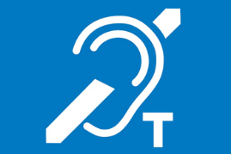
Hearing Induction Loop
Unfortunately, there is no Hearing Induction Loop available at Regent’s Park.

BSL User at training/Venue
None.

Contact
Address:
Regent's Park Office
The Store Yard
Inner Circle
Regent's Park
London
NW1 4NR
Phone +44 (0)300 061 2300 (9.30am to 5.00pm Monday to Friday excluding Bank Holidays)
Email: General Enquiries regents@royalparks.org.uk

