TeamUCL Access Statement

Cycling Club – Lee Valley Velodrome

Contents
- Club Statement
- Travel to the venue
- Venue map
- Accessible features at the venue
- Additional information

Club Statement

Thank you for taking an interest in our club. We are committed to making UCL an inclusive community and supporting all disabled students taking part in our activity. Our Welfare Officer has been trained in Disability Inclusion and Etiquette Training. We have completed this form to try and support you joining us to take part in the sport we all love. Our club is a brilliant place to meet new people and create lifelong friendships.

If any of this information is unclear or you would like more information on other venues or activities are club get up to, please email me, the Club President.

We look forward to welcoming you into our club.
Kind regards,

__________________________________________
Club President

Travel
Lee Valley Velodrome ground is easily accessible using all modes of transport. Click here for the Tfl Accessible Tube Map

Underground
Unfortunately, few of the underground or mainline railway stations around Emirates Stadium are fully wheelchair accessible.
However, some ambulant disabled supporters/visitors may be able to use them.
• Stratford International and Stratford station (Central Line, Jubilee Line, DLR, and London Overground) are the nearest tube station and mainline station. They are situated in the same location and are around a 20-minute walk from the facility.
Note: There is lift access to from street level to all platforms.

Buses
All Transport for London (TFL) bus routes are wheelchair accessible and have clearly marked priority seats for people with limited mobility. On most buses the wheelchair ramp is positioned at the exit door and there is one wheelchair user place on each bus. There is not a bus stop within 150m (164yds) of the venue.
The nearest bus stop to the facility stadium is Cobham Academy (Stops V and Y).
Several bus routes to this bus stop include the 97 which goes from Chingford Station to Stratford City Bus Station, and the 308 which goes from Woodbine Place to Lea Bridge Roundabout and the N205 which goes from Cleveland Terrace to Drapers Field.

Taxis
All London Style ’Black Cabs’ are wheelchair accessible and can provide a suitable alternative to the bus or car. Black cabs can be hailed (stopped) in the street however you may prefer to book a cab to travel to or from the facility.
There are several cab companies operating in London including,
Computer Cab: Tel: 020 8033 9918
The London Black Cab Company: 078 8534 9994
London Black Taxis: 020 3984 4515/ 020 3004 4953
Uber Taxis also provide Wheelchair Accessible Vehicles (WAV). To book Download the Uber app and create your account (unless you already have one) then choose the ‘uberWAV’ option on the slider at the bottom of the screen and follow the instructions. If you would prefer to book a mini cab, then there are several companies in Camden including.
There is no designated drop off/pick up point outside the facility. However, there is free parking in front of the venue.
Step-free access is available all around the facility with double doors automatically opening at a width of 275cm(9ft) wide.
Full information on bus taxi and tube travel in London for disabled people can be found at https://tfl.gov.uk/transport-accessibility/?cid=transportaccessibility

Parking
The facility is situated in a mainly residential area with extensive parking restrictions. Blue Badge holders can park in the surrounding roads in vacant residents parking bays. However, you should check to ensure the bay is not suspended due to event day parking restrictions around the stadium. Please ensure that your Blue Badge and clock are clearly displayed. There are also a number dedicated Blue Badge bays in the vicinity of the facility, however, please be aware that some of the bays in the area are specifically for the use of a designated Blue Badge holder. Please check the Blue Badge parking signage carefully before parking.
There are 10+ amount of specific designated accessible parking at the venue and these are located in the car park in front of the venue. They are distributed on a first come first served basis, and do not need to be booked in advance.
The nearest designated bay is 20m (21yds 2ft) metres from the venue. The furthest designated bay is 72m (78yds 2ft) from the main entrance. The route from the car park to the entrance is accessible to a wheelchair user unaided.

Accessible features at the venue

Accessible Toilets
There are 3 wheelchair accessible toilets and accessible showers located inside the facility. All are fitted with RADAR locks to prevent abuse by non-disabled supporters. All supervising staff hold RADAR keys in case a disabled supporter/visitor does not have one with them.
All the wheelchair accessible toilets are unisex and the toilet doors all open outwards. The dimensions of the accessible toilet are 150cm x 250cm (4ft 11in x 8ft 2in). Either a left or right transfer space is available in every wheelchair accessible toilet along with colour contrasted grab rails.
The lateral transfer space is 80cm (2ft 7in). The wash hand basins all have lever type mixer taps. The wheelchair accessible toilets are also fitted with appropriate height mirrors, hand dryers and coat hooks and pull cord emergency alarms.
Toilets are not fitted with Stoma bins.
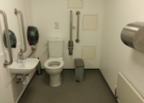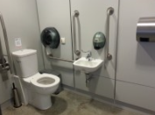

Non accessible Toilets
There are standard male & female toilets next to all the entrances on the ground and first floor. Every standard toilet block contains one cubicle suitable for ambulant disabled supporters.
Toilets are not fitted with Stoma bins.
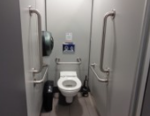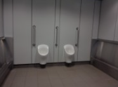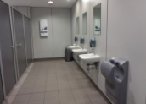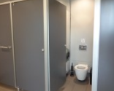

Changing Places Toilet Facility
The Changing Places Toilet (CPT) is located on the concourse with level access.
It is available to any disabled person in the facility and it is fitted with a RADAR lock. The dimensions of the CPT facility are 260cm x 370cm (8ft 6in x 12ft 2in). The facility includes a fixed height changing bench (length 180cm- 5ft 11in), with shower attachment and a powered overhead hoist which covers all areas of the facility. The toilet in the CPT facility is peninsular. The transfer space on the left as you face the toilet is 75cm (2ft 6in) and on the right is 250cm (8ft 2in). Colour contrasted wall mounted and drop-down grab rails are fitted around the toilet. The facility also includes a sink, a privacy screen, non-slip flooring and a pull cord emergency alarm. Please note that slings are not provided by the facility.
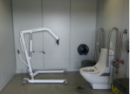

Tactile Guidance Pathway
There are Tactile Guidance Pathways that our blind and visually impaired members can use to navigate their way around the facility. Unfortunately, there are no Tactile Guidance Pathways in this facility.

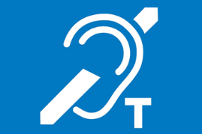
Hearing Induction Loop
There is a hearing induction loop which is situated in the main reception. These are indicated by signage.

BSL User at training/Venue
None.

Vision Impairments
Documents can be requested in braille and in large print.

More information available at: https://www.accessable.co.uk/venues/lee-valley-velopark#0409b5dd-ffc1-4640-a7fc-466b01a8d44a

Contact
Email: General Enquiries
Velopark@leevalleypark.org.uk

