TeamUCL Access Statement

RUMS Tennis Club

Contents
- Club Statement
- Travel to the venue
- Venue map
- Accessible features at the venue
- Additional information

Club Statement

Thank you for taking an interest in our club. We are committed to making UCL an inclusive community and supporting all disabled students taking part in our activity. Our Welfare Officer has been trained in Disability Inclusion and Etiquette Training. We have completed this form to try and support you joining us to take part in the sport we all love. Our club is a brilliant place to meet new people and create life-long friendships!

If any of this information is unclear or you would like more information on other venues or activities are club get up to, please email me, the Club President.

We look forward to welcoming you into our club.
Kind regards,

Laurie Fripp
Club President
laurie.fripp.18@ucl.ac.uk

Travel
Parliament Hill Tennis Courts are easily accessible using all modes of transport. Click here for the Tfl Accessible Tube Map

Underground/ Overground

• Gospel Oak station (Overground) is the nearest tube station and is around a three minute walk from the facility.
• Kentish Town station (Northern Line) is around a fifteen minutes’ walk from the facility.
• Tufnell park (Northern Line) is around a twenty minutes’ walk and has step-free access with 2 operating lifts.

Buses
All Transport for London (TFL) bus routes are wheelchair accessible and have clearly marked priority seats for people with limited mobility. On most buses the wheelchair ramp is positioned at the exit door and there is one wheelchair user place on each bus. The main bus stops close to Parliament Hill Tennis Courts are located on Highgate Road, at the stops Parliament Hill Fields and William Ellis School.
Several bus routes pass close to the facility stadium including the 88 which goes from Clapham Common to Parliament Hill, the 214 which goes from Finsbury Square to Highgate Village and the C11 which goes from Brent Cross Shopping Centre to Archway.

Taxis
All London Style ’Black Cabs’ are wheelchair accessible and can provide a suitable alternative to the bus or car. Black cabs can be hailed (stopped) in the street however you may prefer to book a cab to travel to or from the facility.
There are several cab companies operating in London including,
Computer Cab: Tel: 020 8033 9918
The London Black Cab Company: 078 8534 9994
London Black Taxis: 020 3984 4515/ 020 3004 4953
Uber Taxis also provide Wheelchair Accessible Vehicles (WAV). To book Download the Uber app and create your account (unless you already have one) then choose the ‘uberWAV’ option on the slider at the bottom of the screen and follow the instructions.
The entrance on highgate road, gives step-free access to the East side of the facility.
Full information on bus taxi and tube travel in London for disabled people can be found at https://tfl.gov.uk/transport-accessibility/?cid=transportaccessibility

Parking
The facility is situated in a mainly residential area with extensive parking restrictions. Blue Badge holders can park in the surrounding roads in vacant residents parking bays. Please ensure that your Blue Badge and clock are clearly displayed. There are also a number dedicated Blue Badge bays in the vicinity of the facility, however, please be aware that some of the bays in the area are specifically for the use of a designated Blue Badge holder. Please check the Blue Badge parking signage carefully before parking.
There are extensive accessible parking spaces found at the Parliament Hill Lido car park which can be accessed from Gordon House Road.

Accessible features at the venue

Accessible Toilets
There are wheelchair accessible toilets located close to the facility in the public toilet block at Parliament Hill Fields. All are fitted with RADAR locks to prevent abuse by non-disabled supporters. The RADAR key can be obtained from the office information window if required.
All the wheelchair accessible toilets are unisex and the toilet doors all open outwards. The dimensions of the accessible toilet are 180cm x 235cm (5ft 11in x 7ft 9in). A left transfer space is available in every wheelchair accessible toilet along with colour contrasted grab rails.
The lateral transfer space is 1.28m. The wash hand basins all have lever type mixer taps. The wheelchair accessible toilets are also fitted with appropriate height mirrors, hand dryers and coat hooks and pull cord emergency alarms.
Toilets are fitted with Stoma bins.
Toilets are approximately 90m from court entrances.

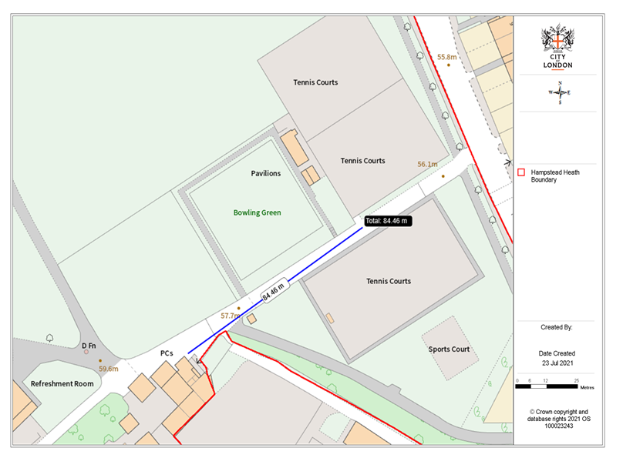
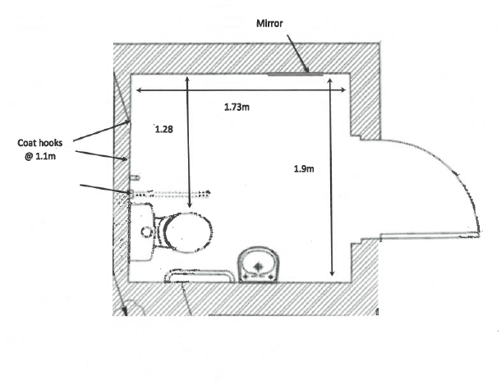

Non accessible Toilets
There are standard male & female toilets in the public toilet block. Every standard toilet block contains one cubicle suitable for ambulant disabled supporters.
Toilets are fitted with Stoma bins.

Changing Places Toilet Facility
There are currently no changing places toilet facilities on site at Parliament Hill tennis courts, however there are courtside seating areas where belongings can be left.

Tactile Guidance Pathway
Unfortunately, there are currently no Tactile Guidance Pathways.

BSL User at training/Venue
None.

Contact
The Disability Liaison Team can be contacted by:
Phone 020 7619 5050 (9.30am to 5.00pm Monday to Friday excluding Bank Holidays)
RUMS Tennis contacts:
President: Laurie Fripp – laurie.fripp.18@ucl.ac.uk
Welfare Officer: Chloe White – chloe.white.18@ucl.ac.uk

