The constitution of the Students’ Union UCL

MEDICAL SOCIETY

Name

The name of the society shall be the Students’ Union UCL Medical Society.

The society shall be affiliated to Students’ Union UCL.

Statement of Intent

The constitution, regulations, management and conduct of the society shall abide by all Students’ Union UCL Policy, and shall be bound by the Students’ Union UCL Memorandum and Articles of Association and Byelaws, the Club and Society Regulations and the Club and Society Procedures and Guidance, laid out in “how to guides”.

The club/society stresses that it abides by Students’ Union UCL Equal Opportunities Policies, and that club/society regulations pertaining to membership of the club/society or election to management of the club/society shall not contravene this policy.

The Club and Society Regulations can be found at the following website:

www.studentsunionucl.org

The Society Committee

President

The President’s primary role is laid out in section 5.7 of the Club and Society Regulations.

Treasurer

The Treasurer’s primary role is laid out in section 5.8 of the Club and Society Regulations.

Additional committee members

Specific job details of additional committee members
Secretary – manage the communications between the central and subsection committees.
Vice President – act as a supporting role to the president
Publicity officer – manage publicity of all events
Welfare – manage the welfare of the committee and society members

Management of the club/society shall be vested in the club/society committee which shall endeavour to meet regularly during term time (excluding college reading weeks) to organise and evaluate the club/society activities.

The committee members will perform the roles as described in section 5 of the Students’ Union UCL Club and Society Regulations.

Committee members are elected to represent the interests and well-being of club/society members and are able to be held to account. If club/society members are not satisfied by the performance of their representative officers they may call for a motion of no-confidence in line with the Students’ Union UCL Club and Society Regulations.

Terms, Aims and Objectives

The club/society shall hold the following as its aims and objectives.

The club/society shall strive to fulfil these aims and objectives in the course of the academic year as its commitment to its membership.

The core activities of the society shall be: talks, events and conferences to inspire and further interest in core medical specialties.

In addition, the club/society shall also strive to organise other activities for its members where possible: Conferences, and fundraisers.

This constitution shall be binding on the club/society officers and shall only be altered by consent of two-thirds majority of the full members present at a society general meeting. Activities Network Executive shall approve any such alterations.

This constitution has been approved and accepted as the Constitution for the Students’ Union UCL Medical Society. By signing this document the President and Treasurer have declared that they have read and abide by the Students’ Union UCL Clubs and Societies Regulations.

President name: | Amaani Ahmad
President signature: | 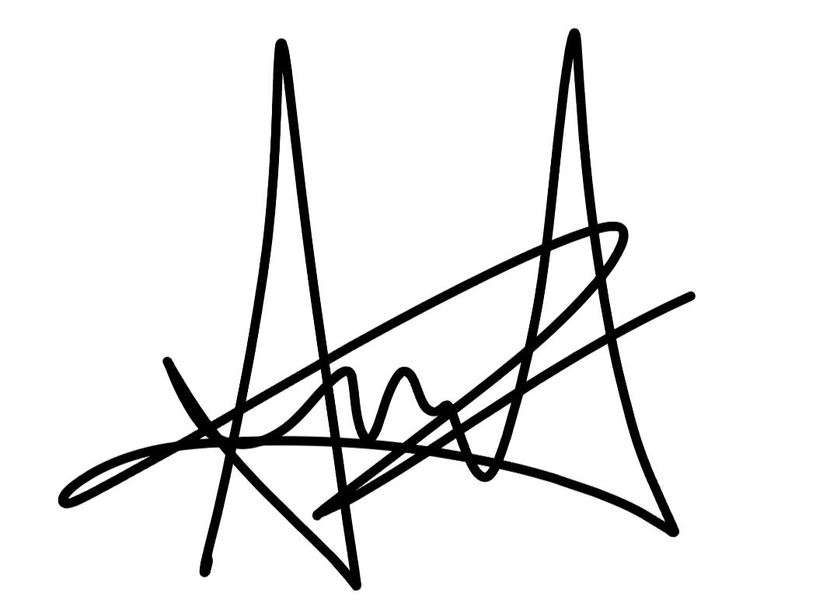
Date: | 27.06.23
Treasurer name: | Ayush Gupta
Treasurer signature: | 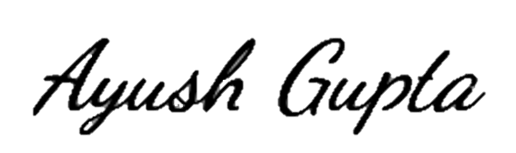
Date: | 29.06.23

