The Constitution of Students' Union UCL

Chilean Society

Name

The name of the society shall be Students' Union UCL Chilean Society.

The society shall be affiliated to Students' Union UCL.

Statement of Intent

The constitution, regulations, management and conduct of the society shall abide by all Students' Union UCL policies and shall be bound by the Students' Union UCL Memorandum & Articles of Association, Byelaws, Club and Society Regulations and the society procedures and guidance – laid out in the 'how to guides'.

The society stresses that it abides by Students' Union UCL Equal Opportunities Policies, and that society regulations pertaining to membership of the society or election to the society shall not contravene this policy.

The Society Regulations can be found on the following webpage: http://studentsunionucl.org/content/president-and-treasurer-hub/rules-and-regulations.

The Society Committee

President

The president's primary role is laid out in section 5.7 of the Society Regulations.

Treasurer

The treasurer's primary role is laid out in section 5.8 of the Society Regulations.

Welfare Officer

The welfare officer's primary role is laid out in section 5.9 of the Society Regulations.

Management of the society shall be vested in the society committee which will endeavour to meet regularly during term time (excluding UCL reading weeks) to organise and evaluate society activities.

The committee members shall perform the roles as described in section 5 of the Students' Union UCL Society Regulations.

Committee members are elected to represent the interests and well-being of society members and are accountable to their members. If society members are not satisfied by the performance of their representative officers, they may call for a motion of no-confidence in line with the Students' Union UCL Society Regulations.

Terms, Aims and Objectives

The Society aims to bring together all interested in Chilean culture, focusing on creating a community for Chilean students at UCL, a support network among its members and a platform for all students interested in issues related to Chile. With this purpose, it will promote cultural exchange and understanding through social and academic extracurricular activities. The society will facilitate the Chilean student community to pursue their interests in fields such as academic development and exchange, economics, culture, public policy, and politics.

The society shall strive to fulfil these aims and objectives in the course of the academic year as its commitment to its membership.

The core activities of the society shall be:
- Online informative talks: Educational or informational presentations delivered online. They will cover various topics, from academic subjects to cultural activities.
- Outdoor leisure activities: Social and cultural activities intended to unite people in an informal, relaxed environment. They can include things like picnics, hikes, sports or cultural activities.
- Indoor leisure activities: Activities take place indoors and are designed to be fun and engaging. They can include things like board games, trivia nights or movie screenings.
- Academic activities: Face-to-face or hybrid educational events focusing on a specific topic or theme related to Chilean affairs. They can include lectures, panel discussions, workshops, or other presentations.

In addition, the society shall also strive to organise other activities for its members where possible:

This constitution shall be binding on the society officers and shall only be altered by consent of two-thirds majority of the full members present at a society general meeting. The Activities Executive shall approve any such alterations.

This constitution has been approved and accepted as the Constitution for the Students' Union UCL Chilean Society. By signing this document the president and treasurer have declared that they have read and abide by the Students' Union UCL Society Regulations.

President name: | Catalina Mellado
President signature: | 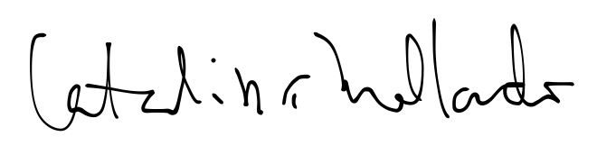
Date: | 14th of june, 2023
Treasurer name: | Javier Boncompte
Treasurer signature:
Date: | 14th of june, 2023

