UCL Men’s Rugby Club Access Document

Club Statement
Thank you for taking an interest in the UCL Men’s Rugby Club. We are committed to making UCLMRFC inclusive to all disabled students taking part in our activities.
Our Welfare Officer has been trained in Disability Inclusion and Etiquette Training. We have completed this form to support you joining the club.
If any of this information is unclear or you would like more information on other venues or activities within UCLMRFC, please email our 2021/2022 Welfare Officer using jacques.blagburn.19@ucl.ac.uk or teamucl@ucl.ac.uk.
Travel

Rugby training is held in Regent’s Park rugby pitches. They are accessible from all entrances and accessible using all modes of transport. For the TFL Accessible Tube Map, please use the link provided: https://tfl.gov.uk/transport-accessibility/wheelchair-access-and-avoiding-stairs

- Underground
All stations mentioned are a 10 minute walk away from the rugby pitches.

- Baker Street Station
Bakerloo, Jubilee, Metropolitan, Circle and Hammersmith & City lines.
This station has wheelchair access where you can get between the platform and street step-free, or change between lines step-free.

- Regent’s Park Station
Bakerloo line.
Step-free access is not available from this station.

- Great Portland Street Station
Circle, Hammersmith & City and Metropolitan lines.
Step-free access is not available from this station.

- Buses
All Transport for London (TFL) bus routes are wheelchair accessible and have clearly marked priority seats for people with limited mobility. On most buses the wheelchair ramp is positioned at the exit door and there is one wheelchair user place on each bus. The main bus routes that stop close to Regent’s Park are the 13, 18, 27, 30, 88, 113, 139, 189, 205, 274, 453.

- Taxis
All London Style ’Black Cabs’ are wheelchair accessible and can provide a suitable alternative to the bus or car. Black cabs can be hailed (stopped) in the street however you may prefer to book a cab to travel to or from the facility.
There are several cab companies operating in London including:
- Computer Cab: Tel: 020 8033 9918
- The London Black Cab Company: 078 8534 9994
- London Black Taxis: 020 3984 4515/ 020 3004 4953
- Uber Taxis also provide Wheelchair Accessible Vehicles (WAV). To book Download the Uber app and create your account (unless you already have one) then choose the ‘uberWAV’ option on the slider at the bottom of the screen and follow the instructions.
Full information on bus taxi and tube travel in London for disabled people can be found at https://tfl.gov.uk/transport-accessibility/?cid=transportaccessibility

Parking

The Regent’s Park car park is found at the north east entrance.

Charges for pay and display parking are:
- Monday to Saturday - £2.80 per hour (70p per 15 minutes, 4 hours maximum stay)
- Sundays and Public Holidays - £2.00 per hour (50p per 15 minutes, no maximum stay)
- National Blue Badge holders and motor cyclists park free of charge, but are subject to 4 hours maximum stay Monday to Saturday.

- Excess charge: £80; 50% reduction for payment within 14 days.
- No parking between midnight and 9am.
- No coaches or commercial vehicles are permitted within Regent's Park.
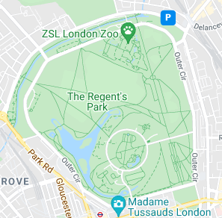
Accessible Parking
Regent’s Park have three disabled parking bays.
Blue badge car parking information is available at tfl.gov.uk/roadusers

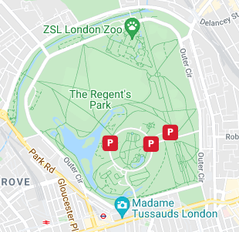

Accessible features at the venue

- Accessible Toilets
There are six wheelchair accessible toilets located inside the facility. All are fitted with RADAR locks to prevent abuse by non-disabled people. All staff hold RADAR keys in case a disabled visitor does not have one with them. All the wheelchair accessible toilets are unisex and the toilet doors all open outwards.
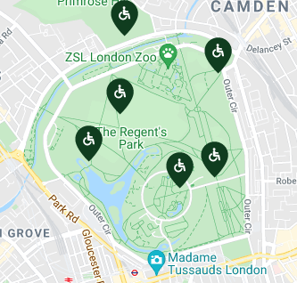
Hearing Induction Loop

There is no hearing induction loop.

BSL User at training/Venue

None.

Contact

- Regent’s Park Office: 0300 061 2300 (Monday to Friday 8.30 a.m. to 4 p.m.)

- Regent’s Park Postal address:
Friends of Regent’s Park & Primrose Hill
c/o The Park Office, The Storeyard
Inner Circle, Regent’s Park, London
NW1 4NR

